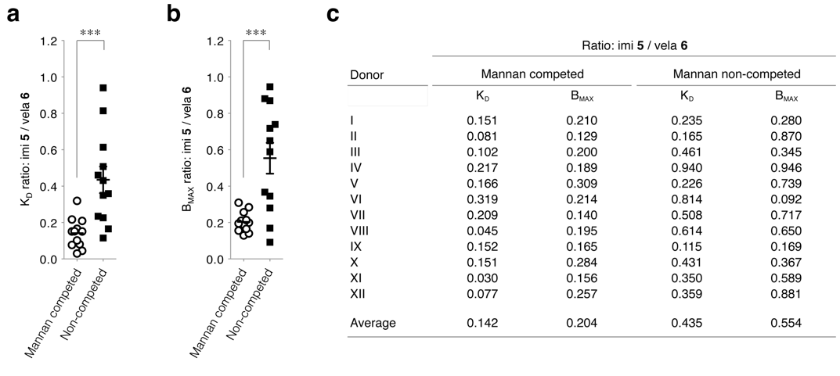
S1 Figure 7 | Mannan-competed and non-competed binding of imiglucerase and velaglucerase after separate incubation of macrophages with enzyme. (a) K_{D} observed with cells from twelve healthy donors. Expressed as ratio of imiglucerase/velaglucerase. Experiment performed in the presence and absence of mannan, for twelve healthy donors. (b) B_{MAX}, vide supra. (c) K_{D} and B_{MAX} observed for cells from each separate healthy donor. All data are average of duplicate analyses per donor, with Student t-test significance p < 0.001***.

