Supporting Information S2
Supplementary figures
Figures S3 to S16 shows the individual RT distributions. For each participant, top histograms show RTs in the instructed conditions. Bottom histograms show RTs in the free choice conditions.
To encourage preparation, the experimental design included a high proportion of instructed quick trials (see Methods in the main text). The RT distributions reflect this imbalance. A bimodal RT distribution is nevertheless evident in most participants for the instructed conditions.
Free choice conditions show more uniform distributions, with smaller values of bimodality, see main text. Importantly, this argues against the possibility that the observed ERP effects are simply due to differences in RTs. In particular, a more uniform distribution in the free choice conditions would have lead to smaller (and not larger, as we observe) ERP differences between quick and delayed conditions.

Figure S3

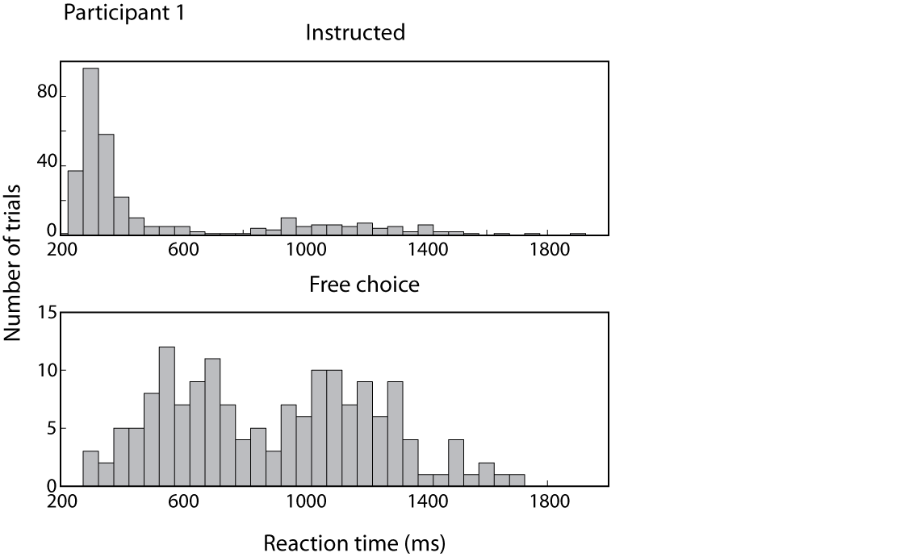

Figure S4
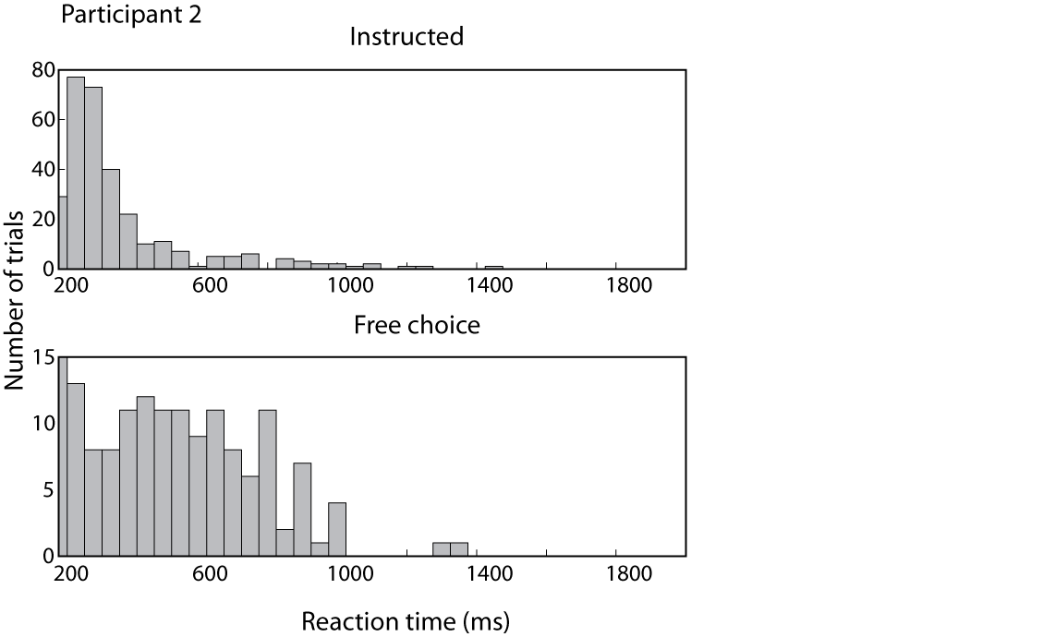
Figure S5
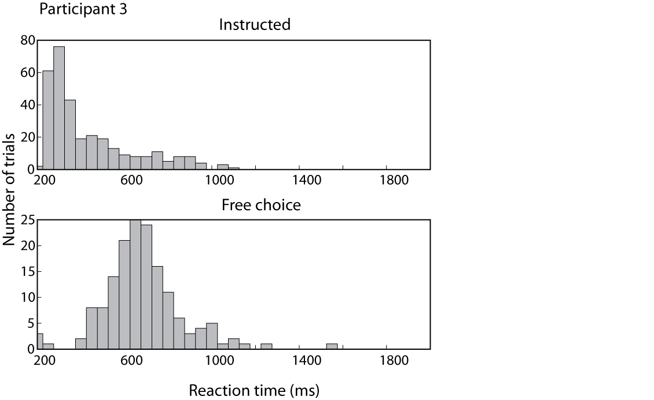

Figure S6
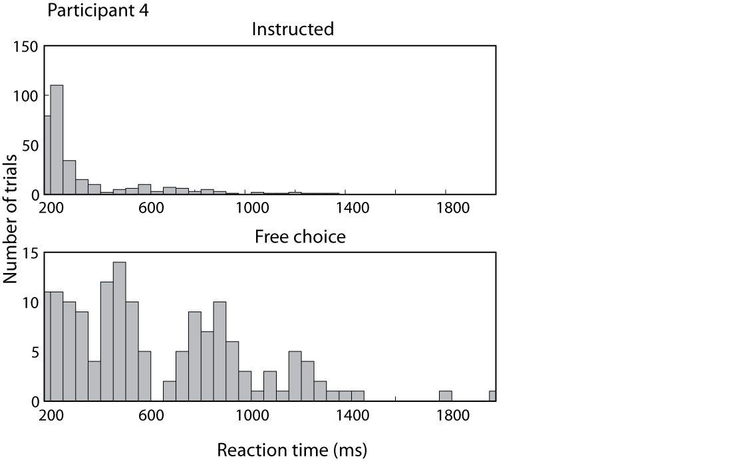
Figure S7
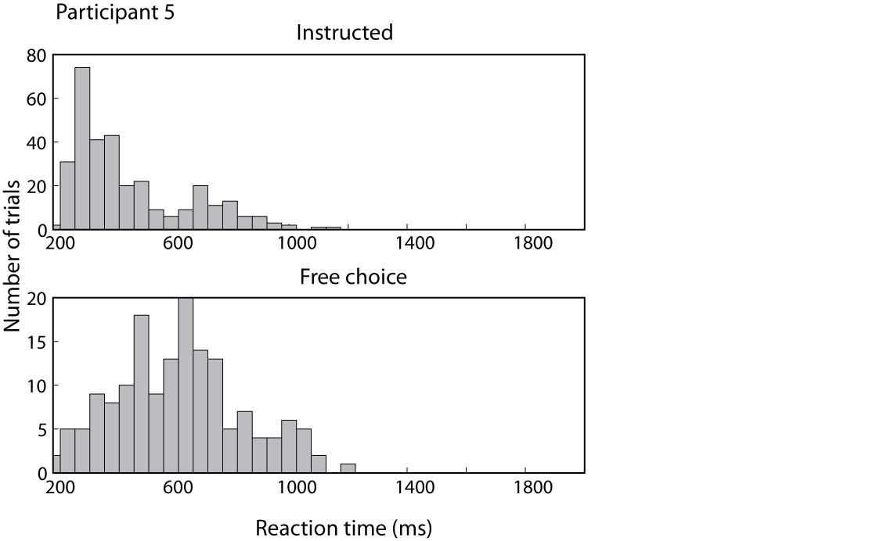

Figure S8
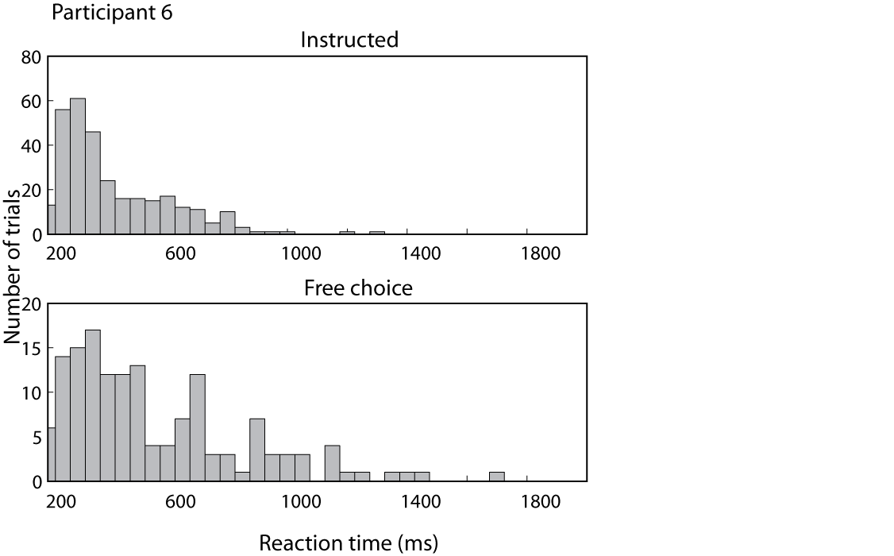
Figure S9
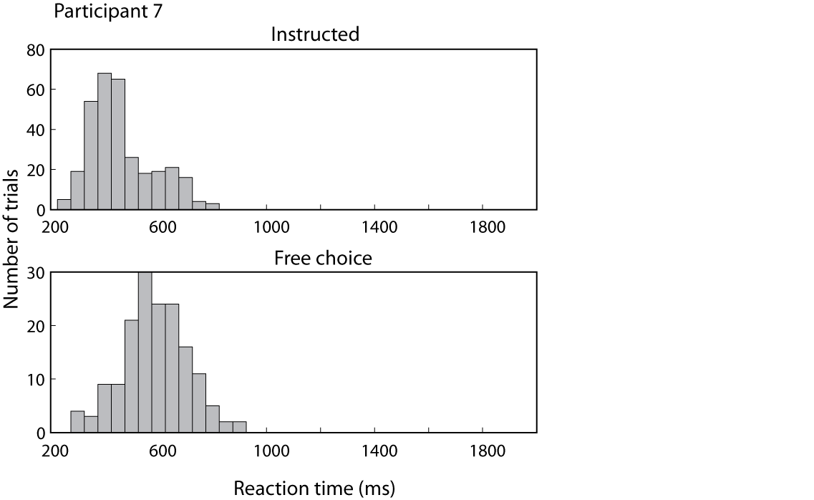

Figure S10
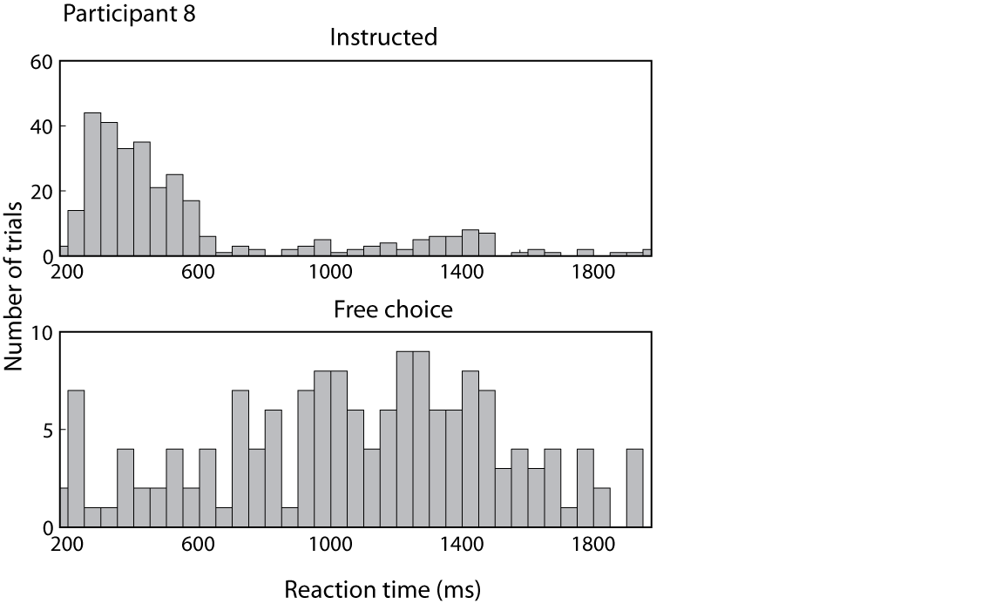

Figure S11
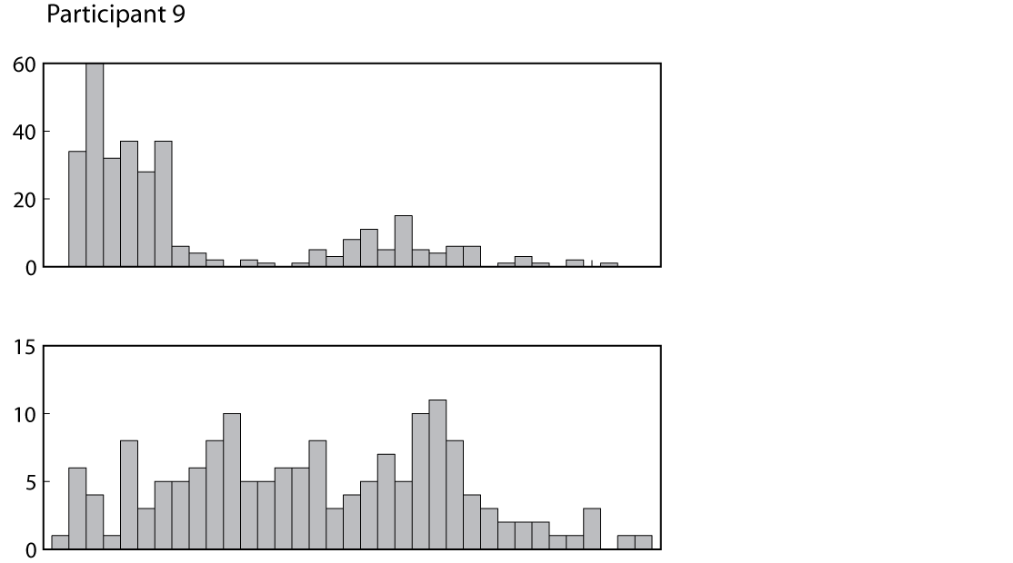

Figure S12
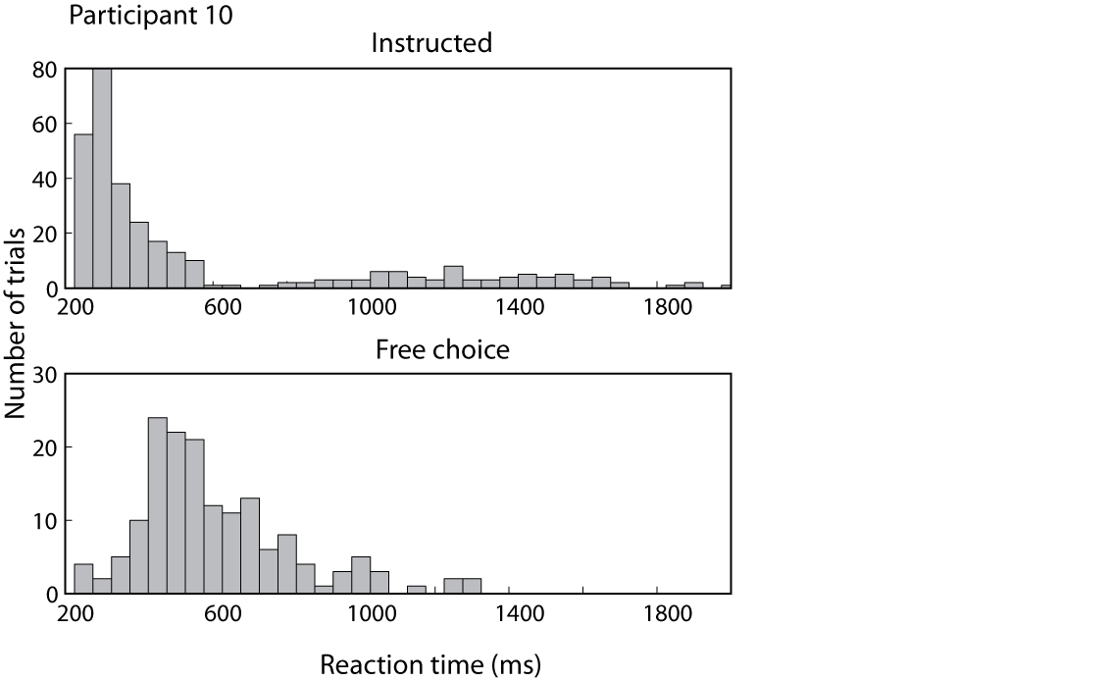
Figure S13

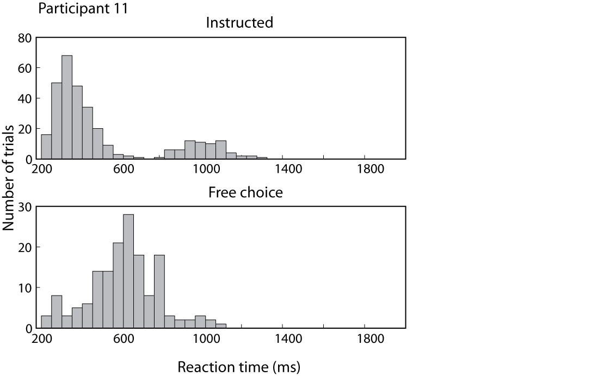
Figure S14
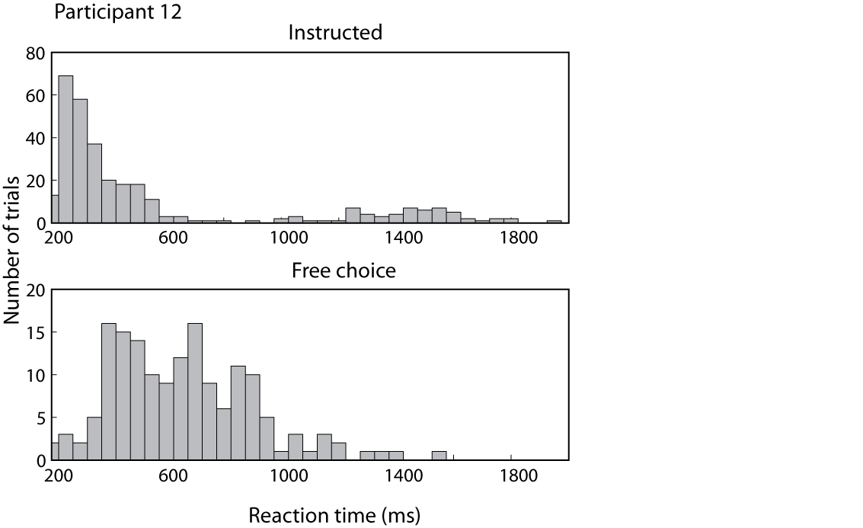

Figure S15
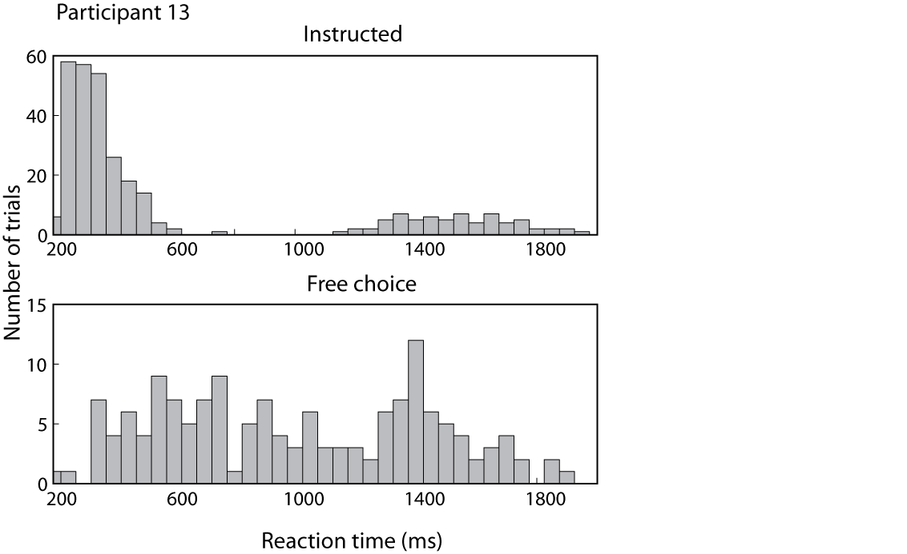

Figure S16

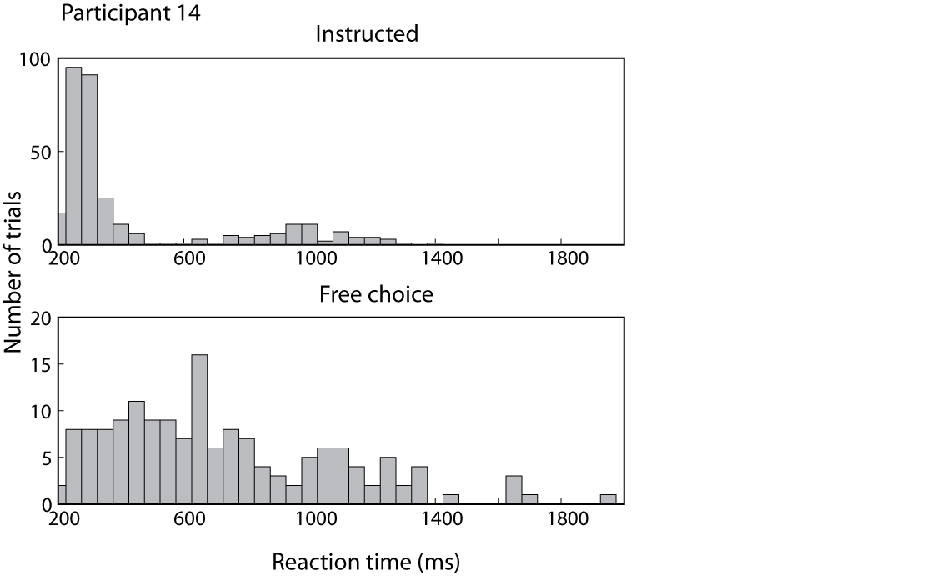
Figures S3 to S16: Individual RT distributions for each participant. Time bins represent 50 ms. Note that y axis values are different for each participant.

