Annexure-A

Patient Case Documentation Form

Patient Name: _______________________ Room #:_______ Admission Date: / / Discharge date: __________
Age: ______ Gender: _____ Ht: _______ Wt: ______ Case: Cardio Pulmonary GI DM Other: _________
IBW:______ kg: Crt. Cl ____ ml/min.

CC: ______________________________________________________________________________________________

HPI:______________________________________________________________________________________________________________________________________________________________________________________________________________________________________________________________________________________________________________________________________________________________________________________________________________________________________________________________________________________________________
PMH:_________________________________________________________________________________________________________________________________________________________________________________________________________________________________________________________________________________________________
FH:_________________________________________________________________________________________________________________________________________________________________________________________________
SH: Smoking _________________________________ EtOH:____________ Other: ____________________________
Allergies: _________________________________________________________________________________________
Home Rx: _________________________________________________________________________________________ ______________________________________________________________________________________________________________________________________________________________________________________________________________________________________________________________________________________________________
Hospital Course (include any pertinent labs): _____________________________________________________________
__________________________________________________________________________________________________________________________________________________________________________________________________________________________________________________________________________________________________________________________________________________________________________________________________________________________________________________________________________________________________________________________________________________________________________________________________________________________________________________________________________________________________________________________________________________________________________________________________________________________________________________________________________________________________________________________________________________________________________________________________________________________________________________________________________________________________________________________________________________________________________________________________________________________________________________________________________________________________________________________________________________________________________________________________________________________________________________________________________________________________________________________________________________________________________________________________________________________________________________________________________________________________________________________________
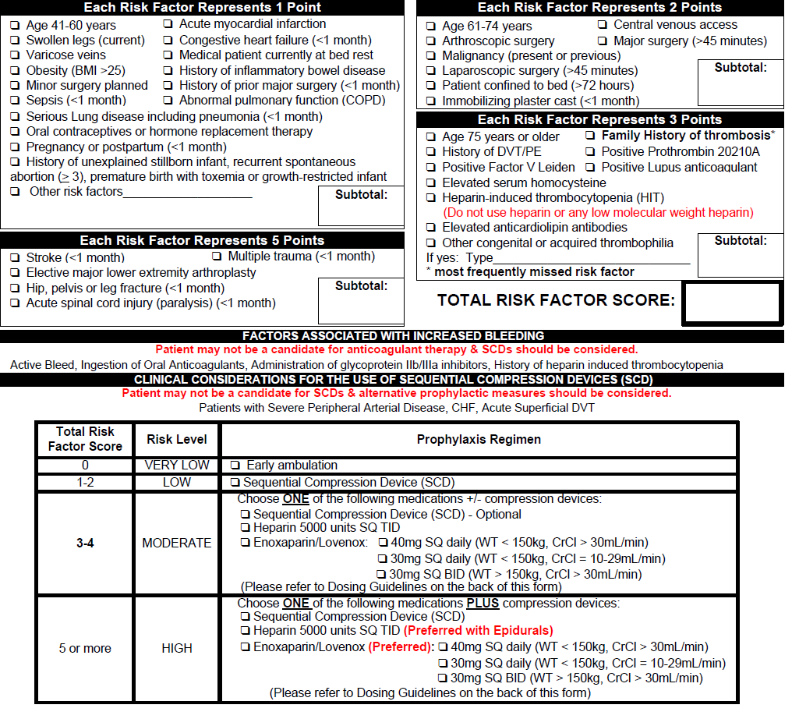

Current meds: _____________________________________ other medications during hospitalization: ____________
1. ______________________________________________ 1. _______________________________________________
2. ______________________________________________ 2. _______________________________________________
3. ______________________________________________ 3. _______________________________________________
4. ______________________________________________ 4. _______________________________________________
5. ______________________________________________ 5. _______________________________________________
6. ______________________________________________ 6. _______________________________________________
7. ______________________________________________ 7. _______________________________________________
8. ______________________________________________ 8. _______________________________________________
9. ______________________________________________ 9. _______________________________________________
10. _____________________________________________ 10. ______________________________________________
11. _____________________________________________11. _______________________________________________
12. _____________________________________________ 12. ______________________________________________
Overall assessment and Summary: __________________________________________________________________________________________________________________________________________________________________________________________________________________________________________________________________________________________________________________________________________________________________________________________________________________________________________________________________________________________________________________________________________________________________________________________________________________________________________________________________________________________________________________________________________________________________________________________________________________________________________________________________________________________________________________________________________________________________________________________________________________________________________________________________________________________________________________________________________________________________________________________________________________________________________________________________________________________________________________________

