S4 First Scenario Robustness Analysis

Figure: Own Scenario Shown First
United States | Italy
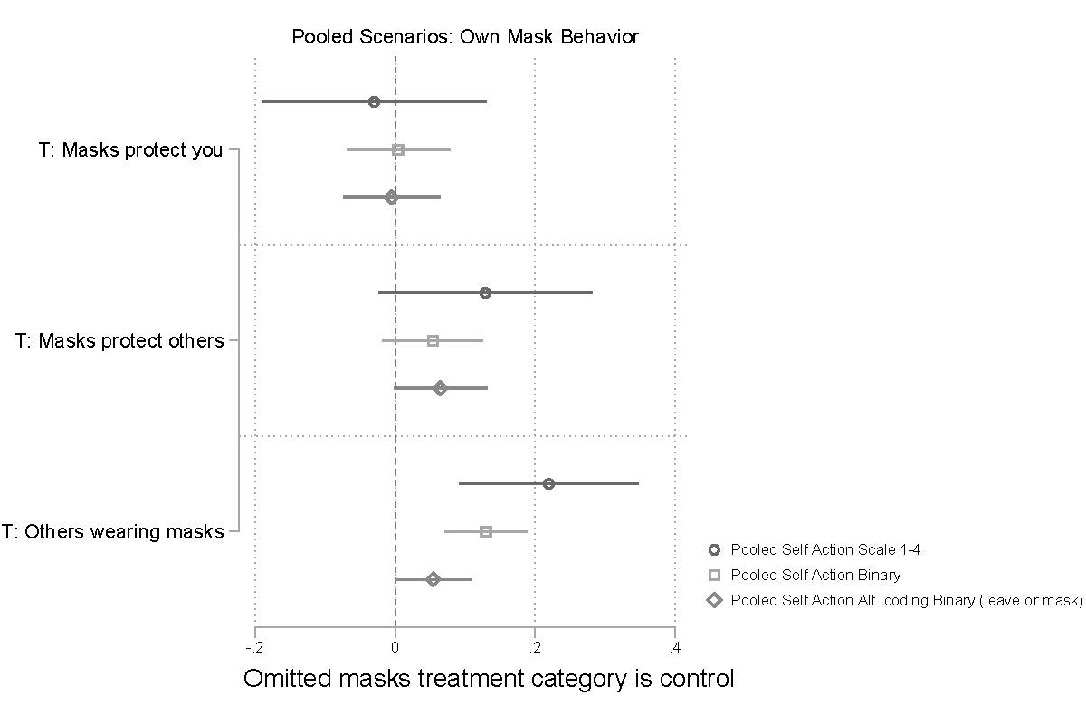 | 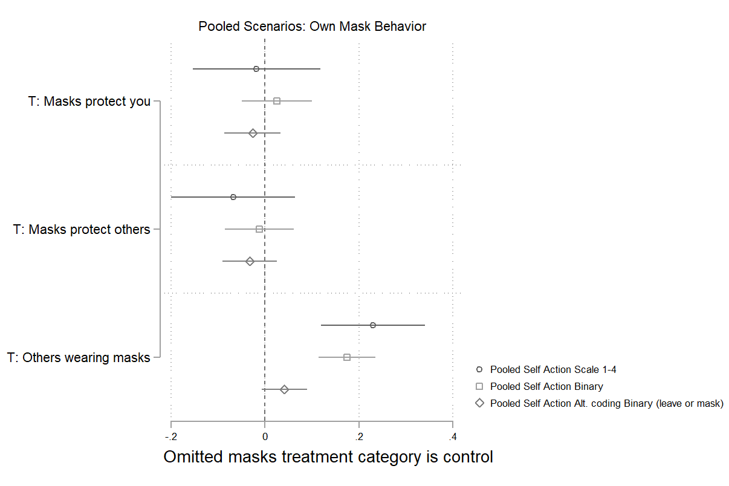

Effect of mask efficacy treatments and social norms treatment on reported OWN mask behavior for respondents who saw an OWN mask behavior scenario first. The figure displays OLS regression estimates with 95% confidence intervals. Models included covariates described above.

Figure: Other Scenario Shown First
United States | Italy
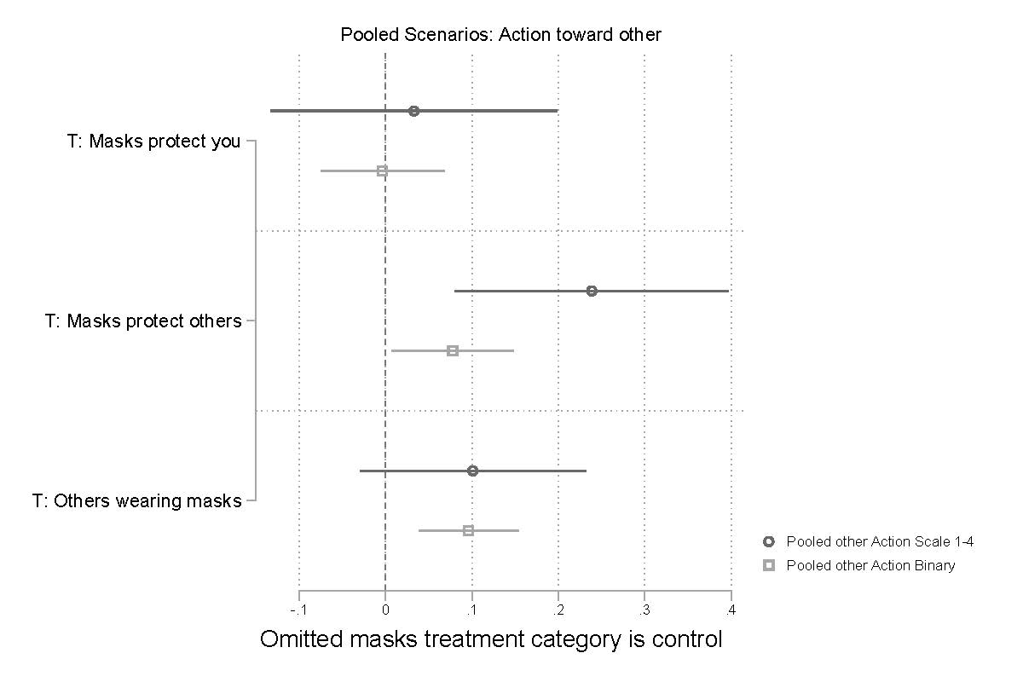 | 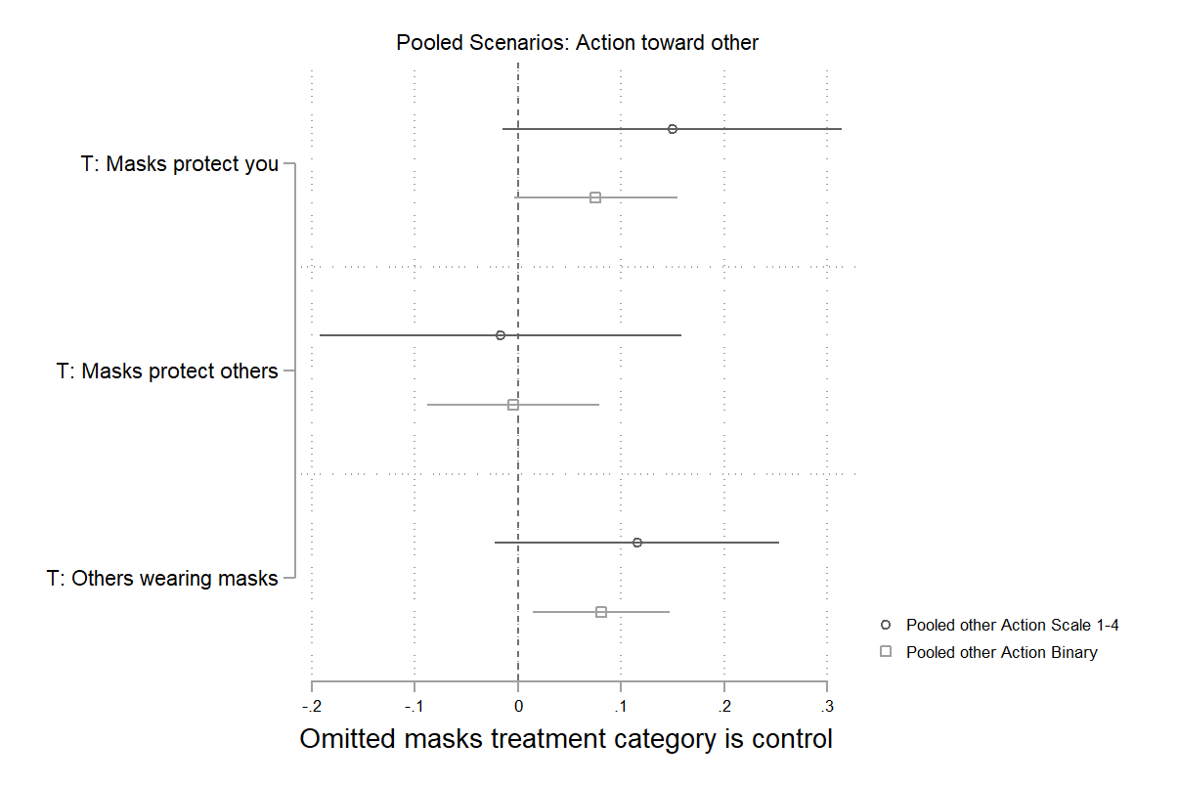

Effect of mask efficacy treatments and social norms treatment on reported OTHER mask behavior for respondents who saw an OTHER mask behavior scenario first. The figure displays OLS regression estimates with 95% confidence intervals. Models included covariates described above.

