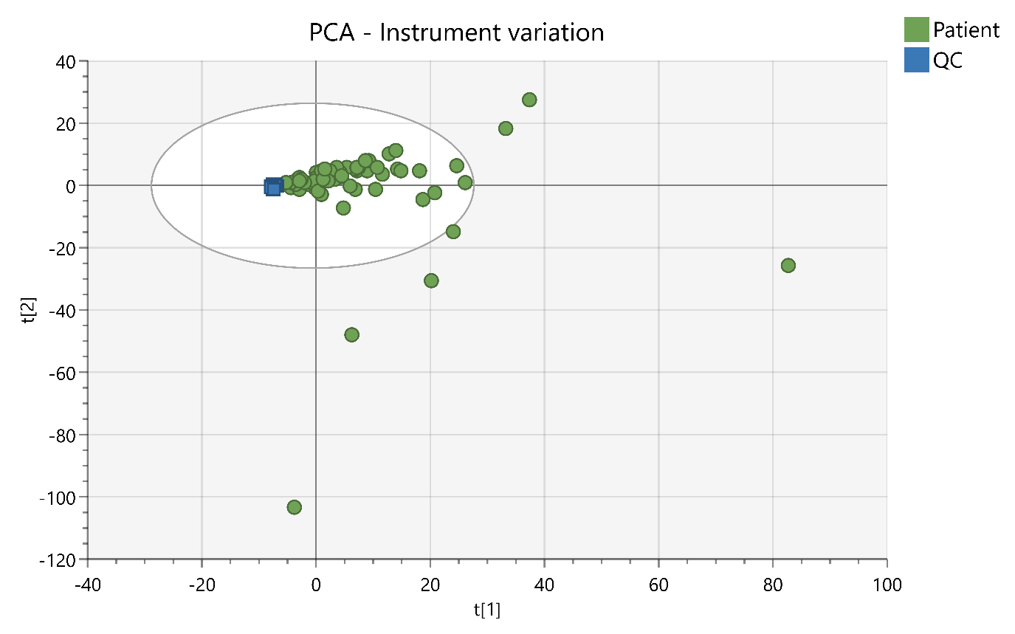
S2 Fig: Principal Component Analysis of each patient sample and run QC, showing low levels of QC variation according to position in the run sequence

