S9A Fig
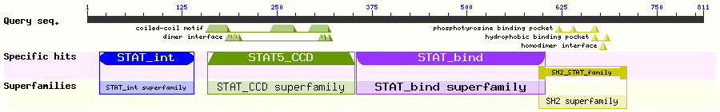

S9B Fig
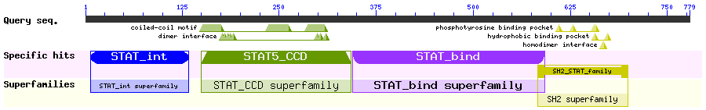

S9 Fig

