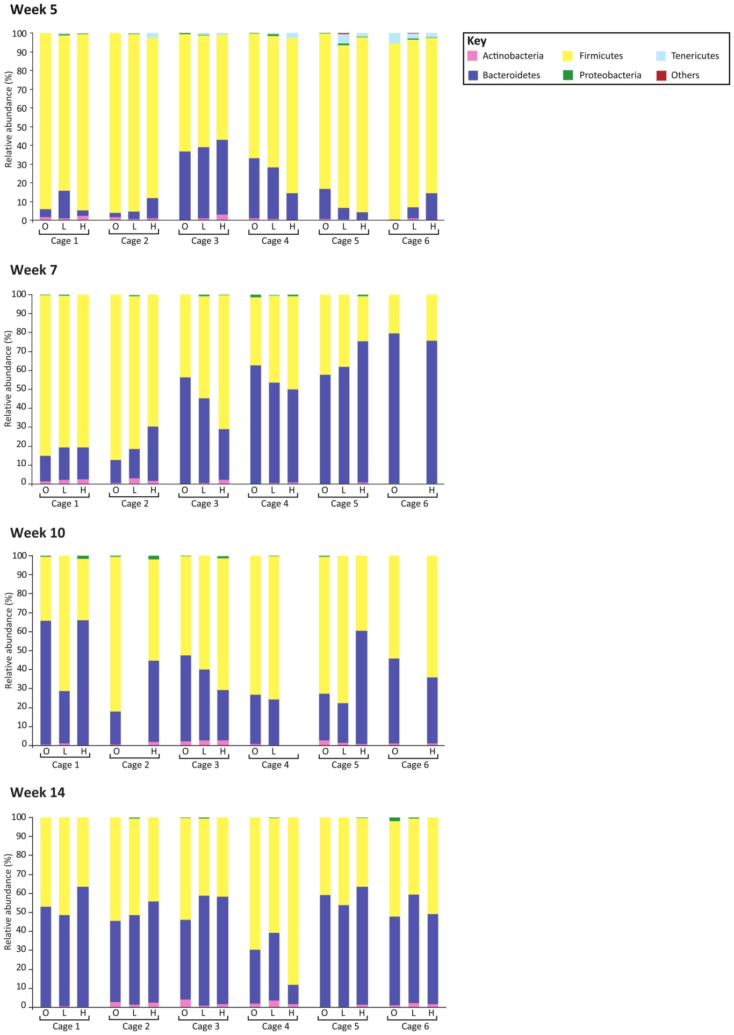
Figure S9: Relative abundances of bacteria at the phylum-level for all animals grouped according to cage, at each time point separately. Key: O = obese, L = homozygous lean, H = heterozygous lean. Phylum key: ‘Others’ composed of TM7 and Verrucomicrobia.

