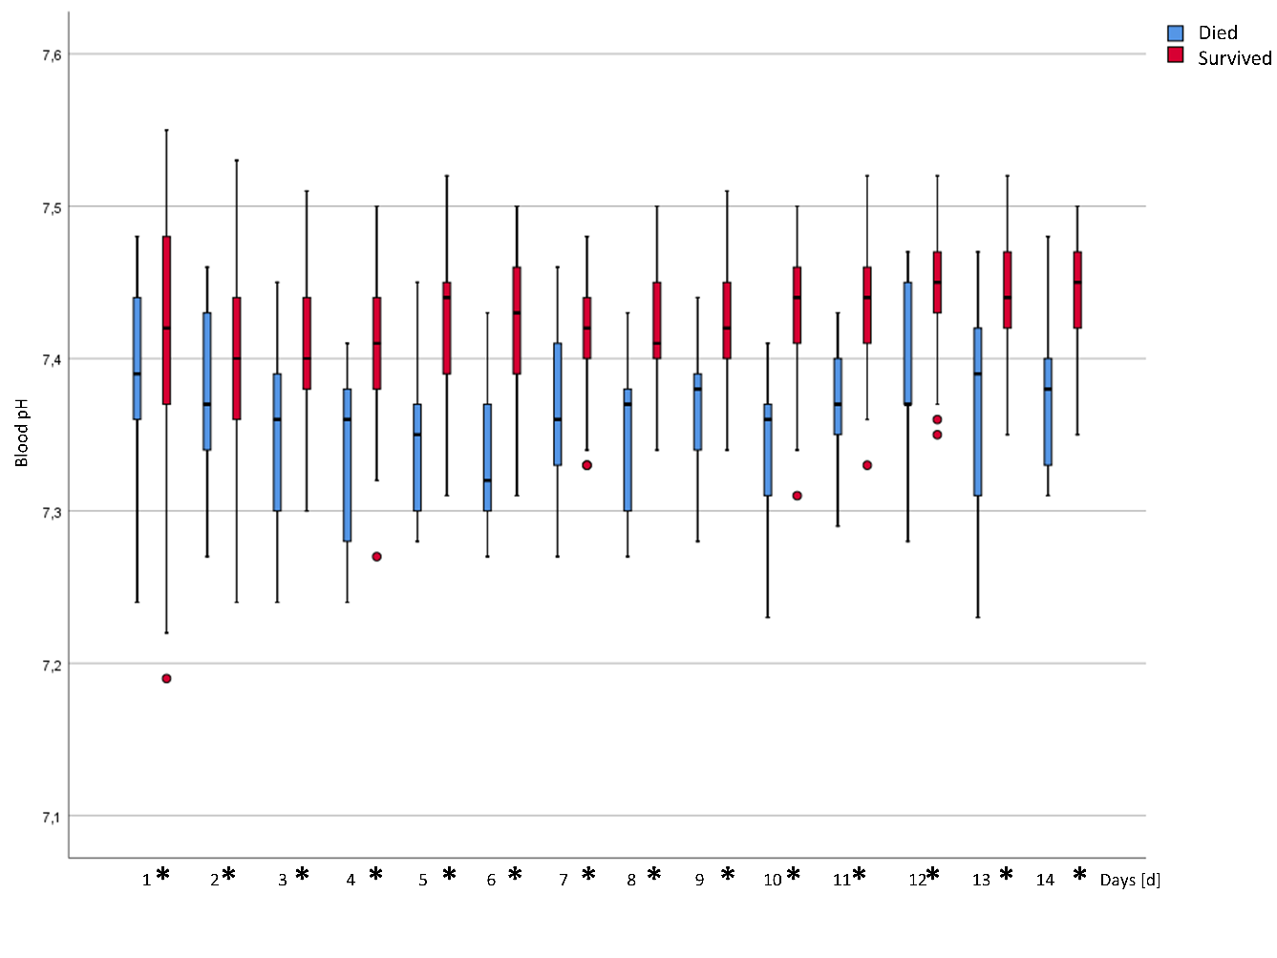
Daily mean blood pH values. Significant differences between the two groups are marked with an asterisk in the legend of the x-axis.
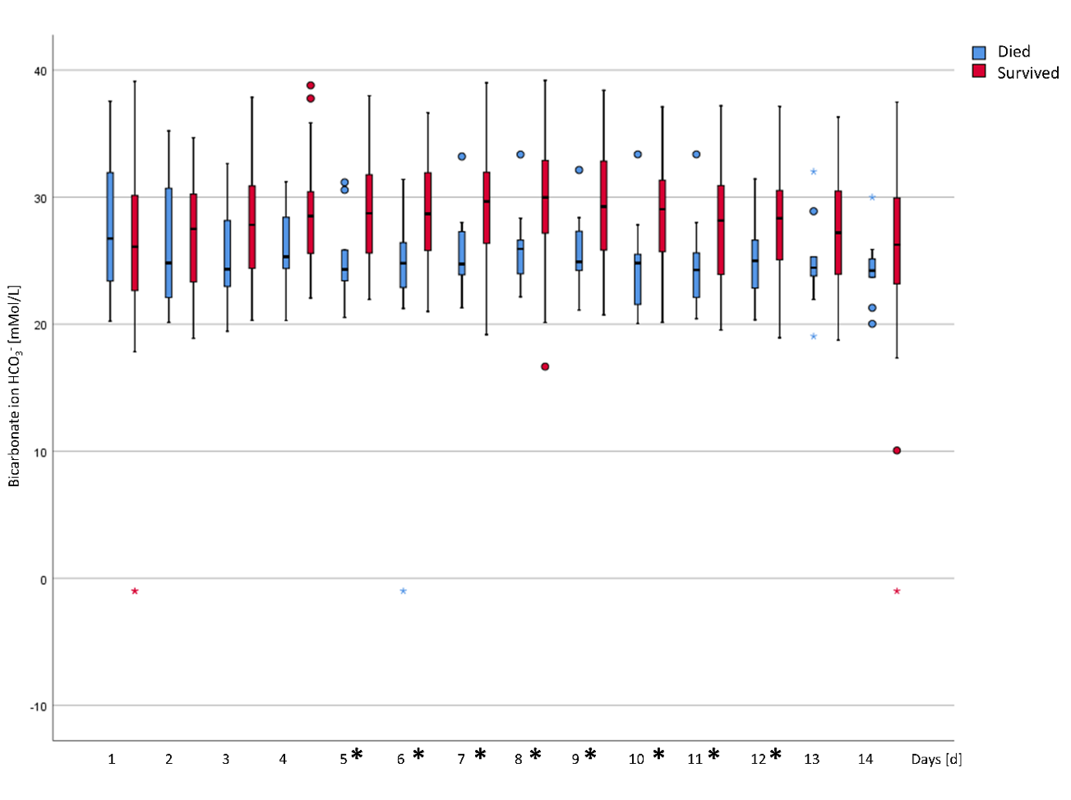
Daily mean standard bicarbonate values. Significant differences between the two groups are marked with an asterisk in the legend of the x-axis.
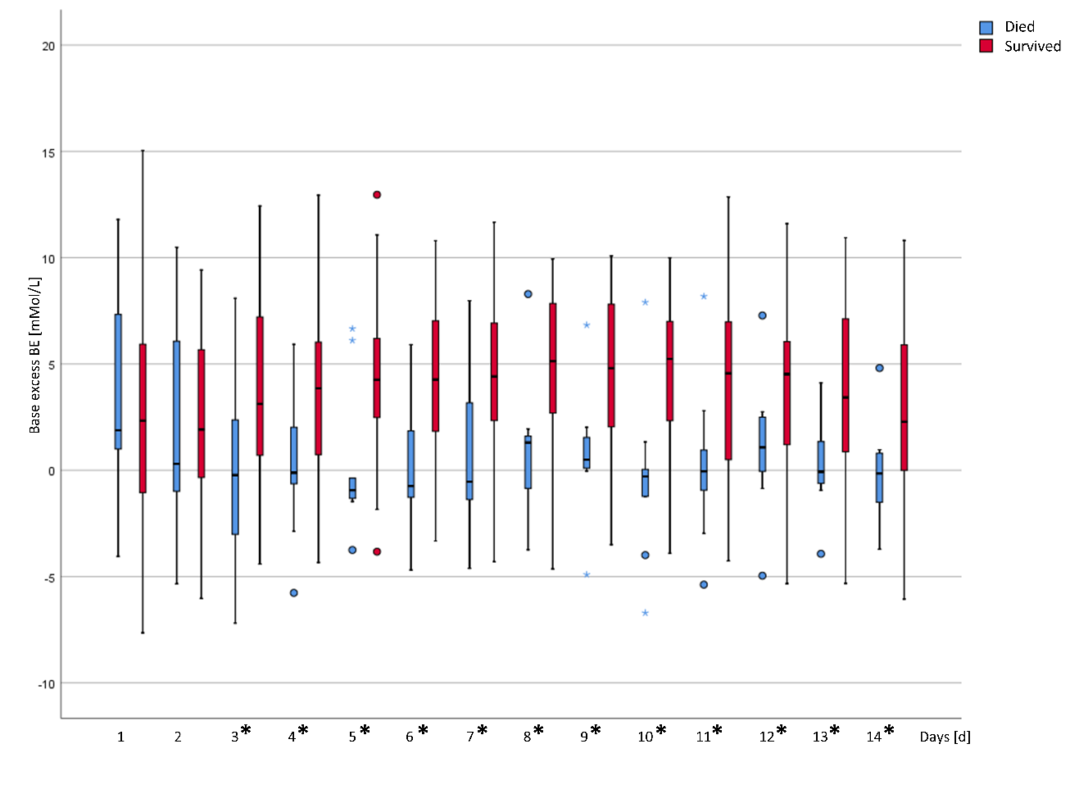
Daily mean base excess (BE) values. Significant differences between the two groups are marked with an asterisk in the legend of the x-axis
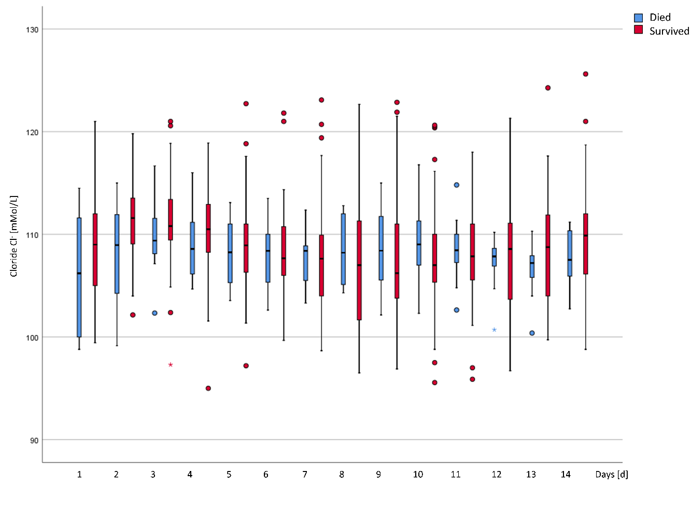
Daily mean blood chloride values. Significant differences between the two groups are marked with an asterisk in the legend of the x-axis.
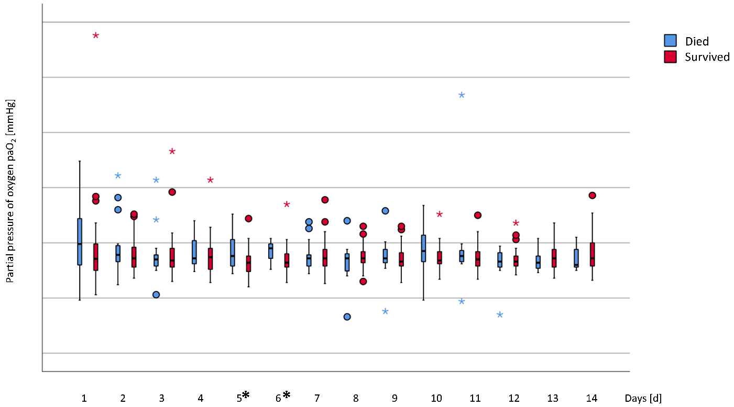
Daily mean values for arterial partial pressure of oxygen (paO₂). Significant differences between the two groups are marked with an asterisk in the legend of the x-axis.
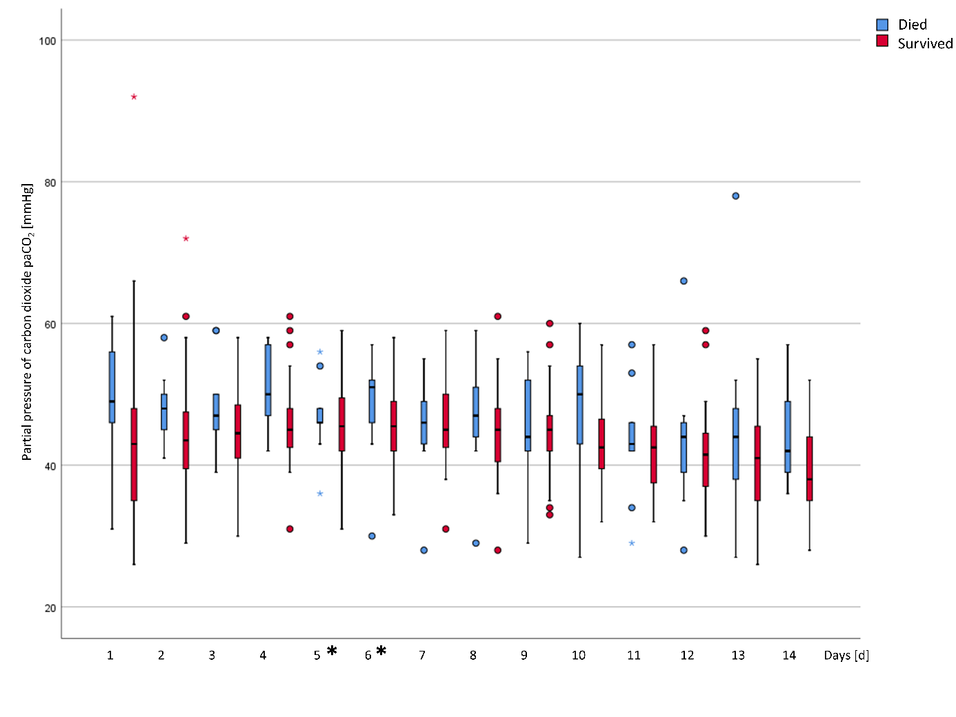
Daily mean values for arterial partial pressure of carbon dioxide (paCO₂). Significant differences between the two groups are marked with an asterisk in the legend of the x-axis.
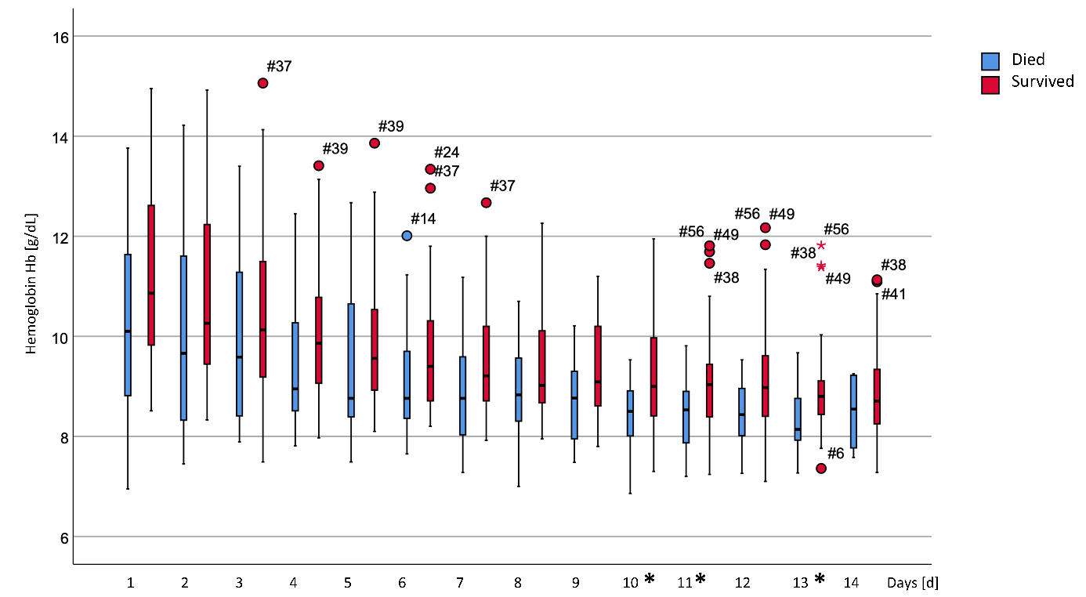
Daily mean values for hemoglobin (Hb). Significant differences between the two groups are marked with an asterisk in the legend of the x-axis.
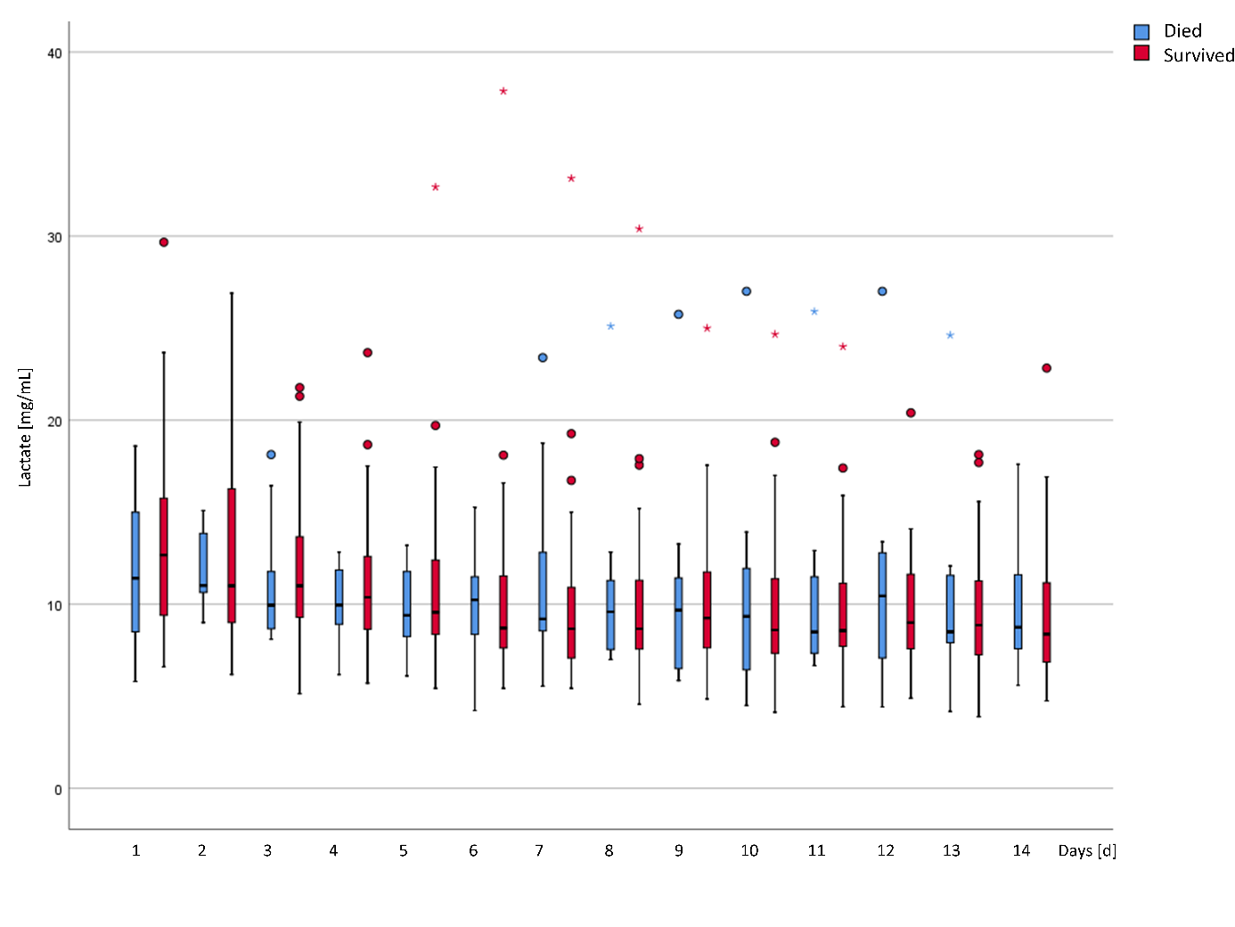
Daily mean values for blood lactate. Significant differences between the two groups are marked with an asterisk in the legend of the x-axis.
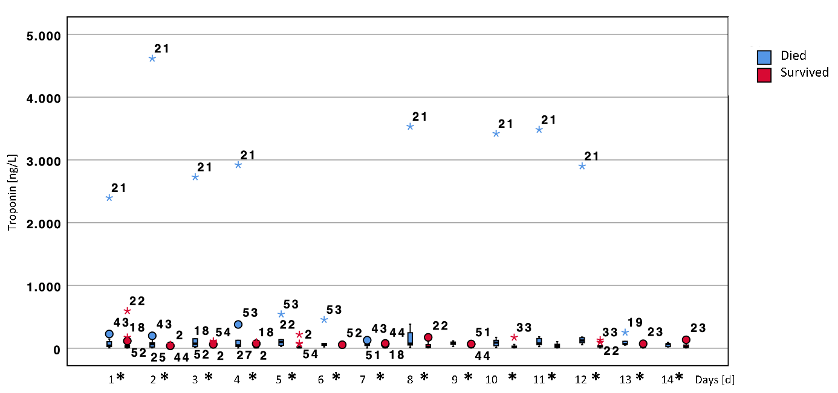
Daily values for troponin T. Significant differences between the two groups are marked with an asterisk in the legend of the x-axis.

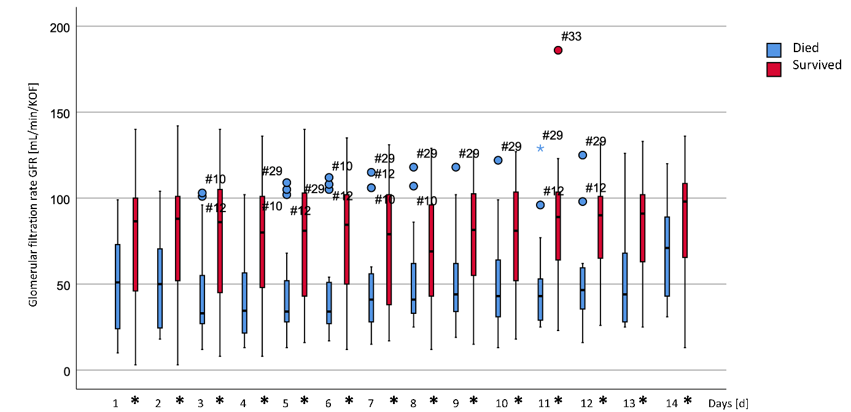
Daily values for the troponin estimated glomerular filtration rate (eGFR). Significant differences between the two groups are marked with an asterisk in the legend of the x-axis.
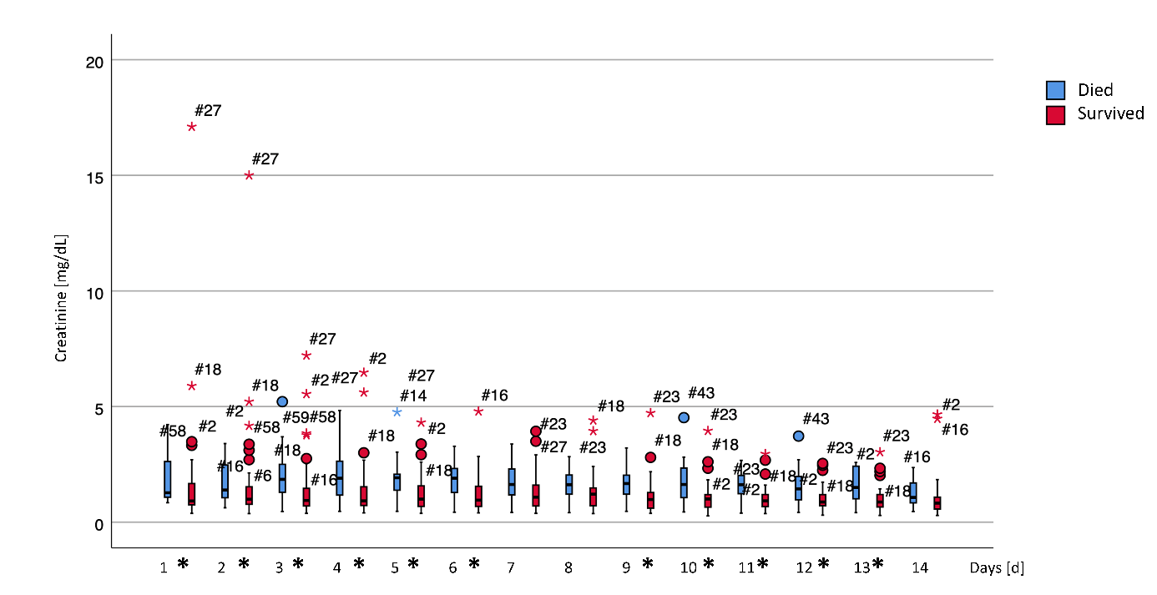
Daily values for blood creatinine (Crea). Significant differences between the two groups are marked with an asterisk in the legend of the x-axis.
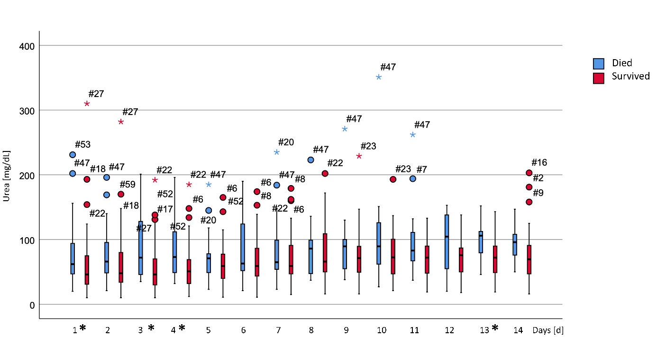
Daily values for urea. Significant differences between the two groups are marked with an asterisk in the legend of the x-axis.
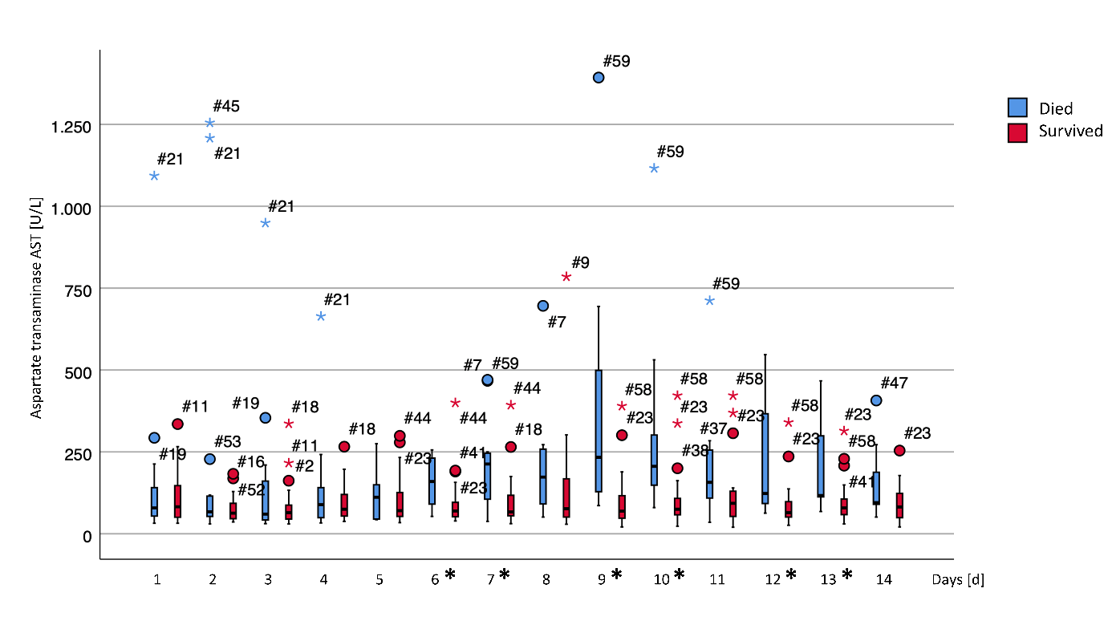
Daily values for aspartate transaminase (AST). Significant differences between the two groups are marked with an asterisk in the legend of the x-axis.
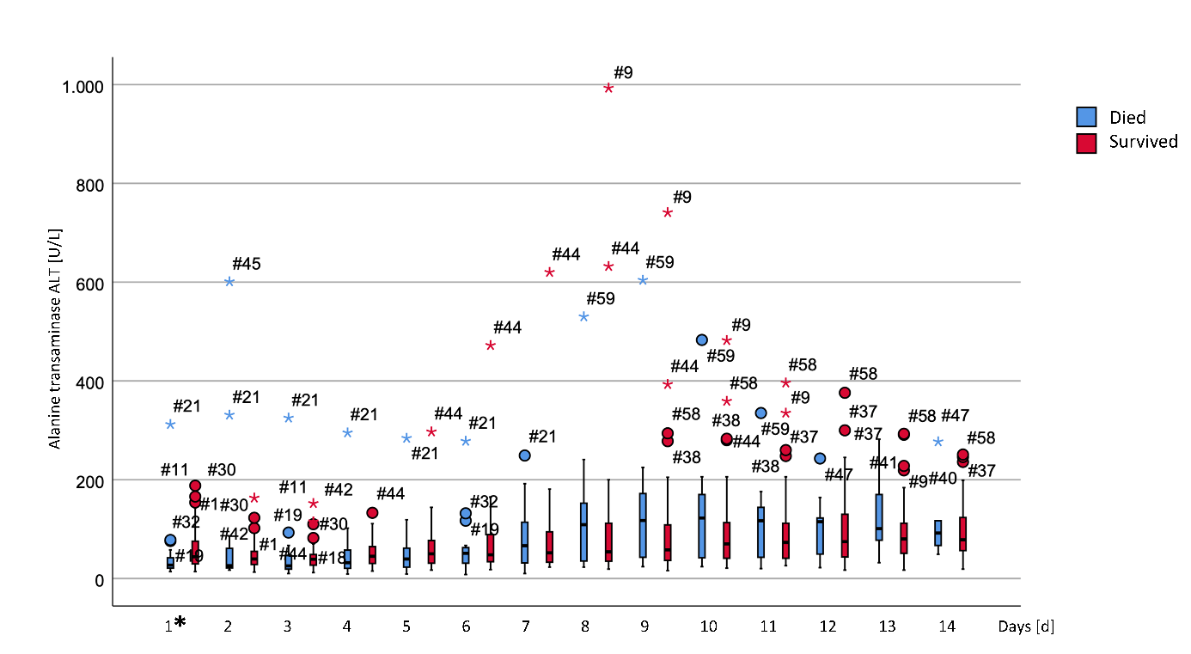
Daily values for alanine transaminase (ALT). Significant differences between the two groups are marked with an asterisk in the legend of the x-axis.
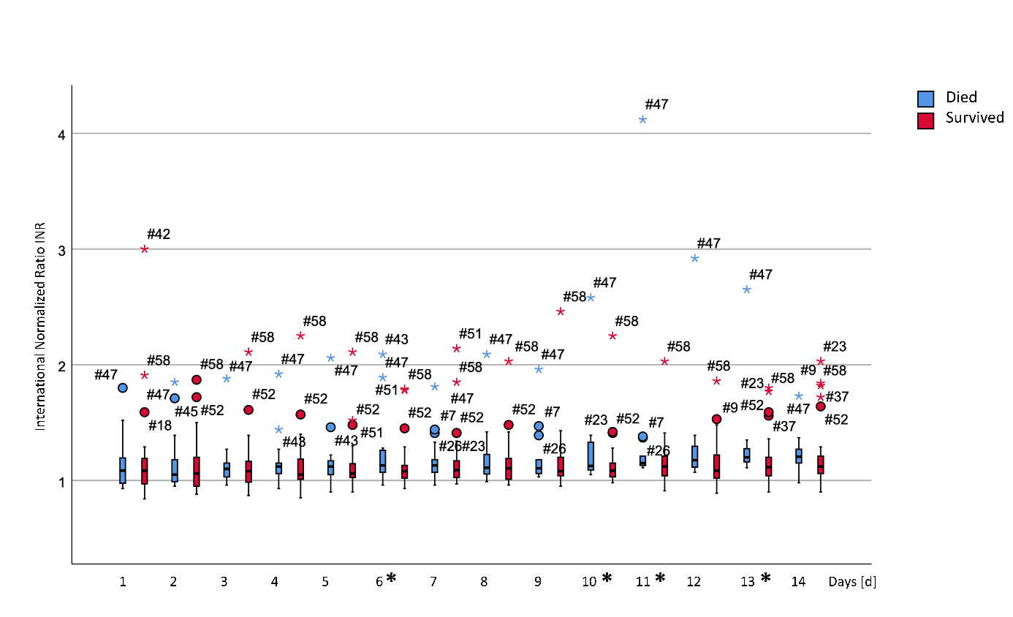
Daily values for the international normalized ratio (INR). Significant differences between the two groups are marked with an asterisk in the legend of the x-axis.
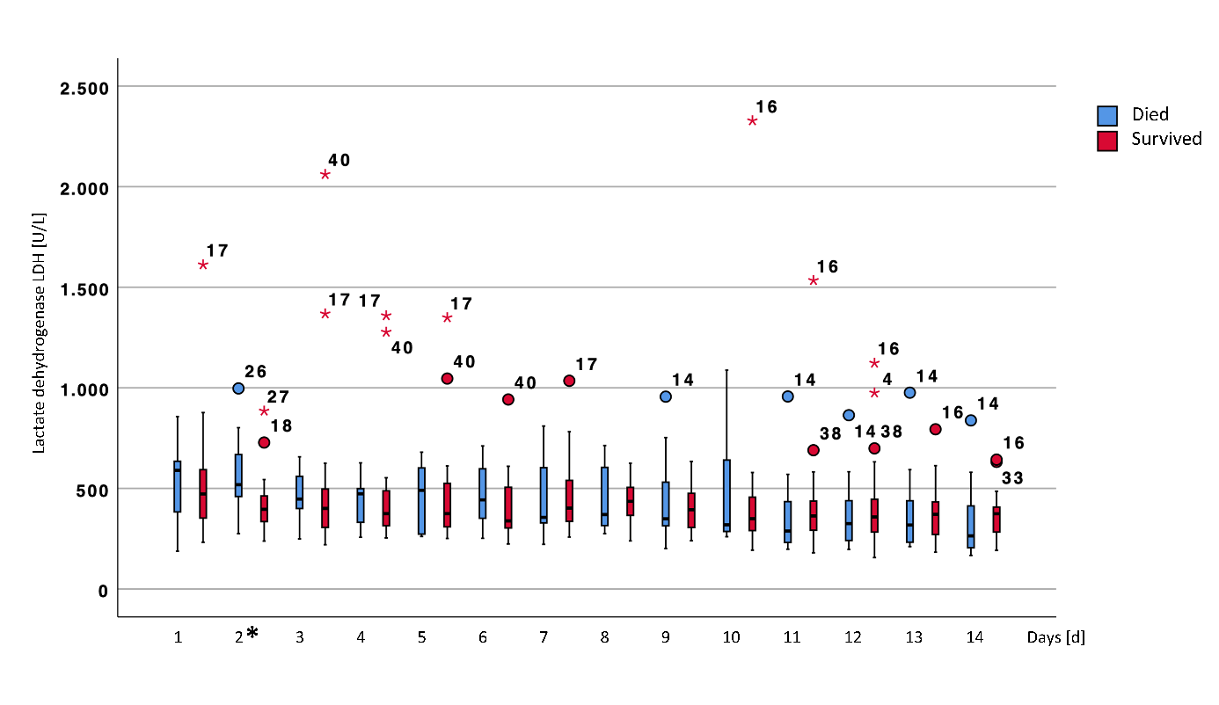
Daily values for lactate dehydrogenase (LDH). Significant differences between the two groups are marked with an asterisk in the legend of the x-axis.
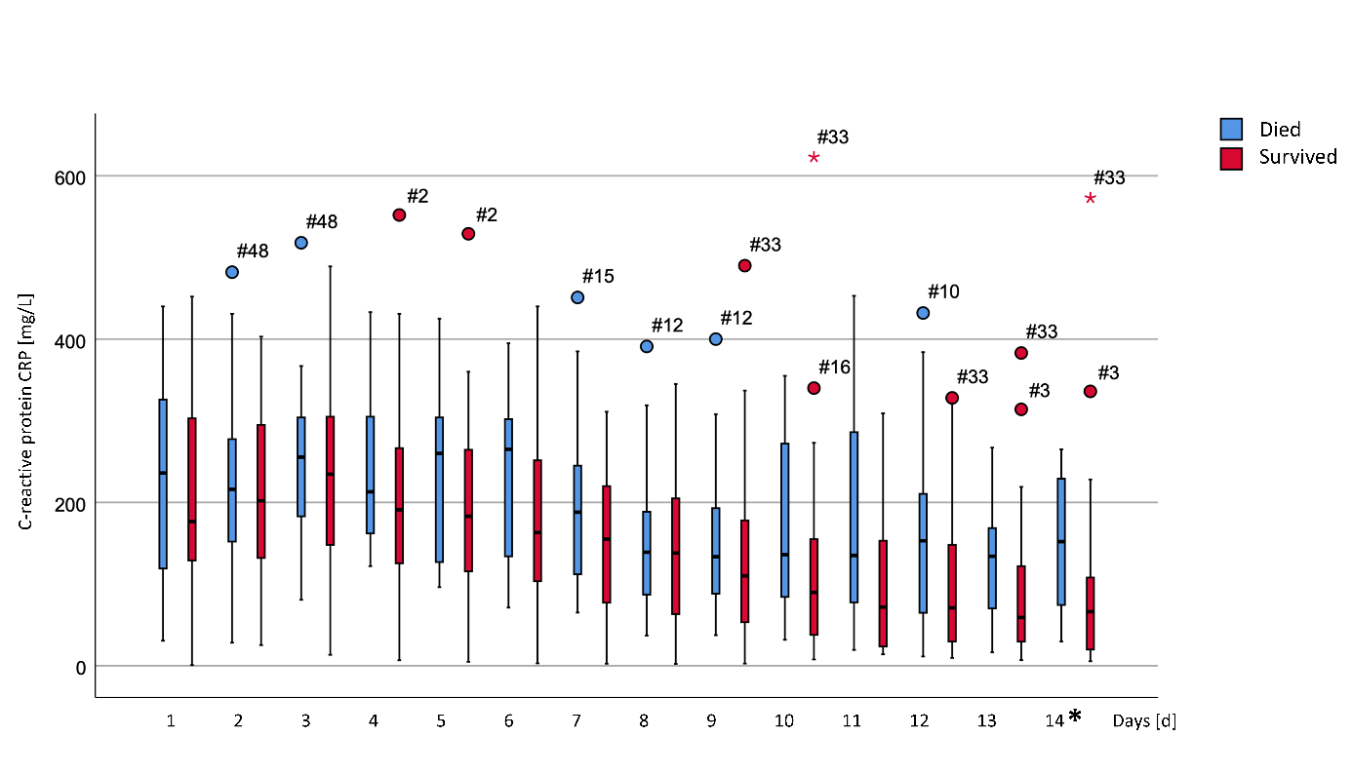
Daily values for C-reactive protein (CRP). Significant differences between the two groups are marked with an asterisk in the legend of the x-axis.
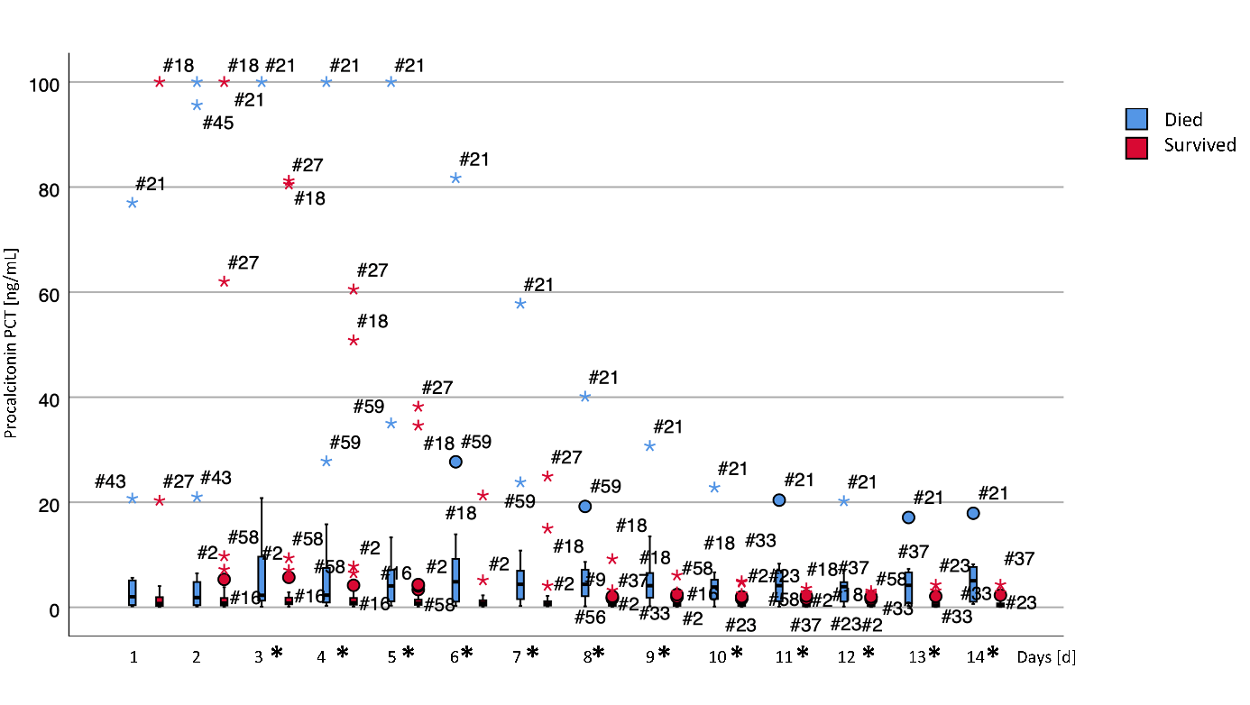
Daily values for procalcitonin (PCT). Significant differences between the two groups are marked with an asterisk in the legend of the x-axis.
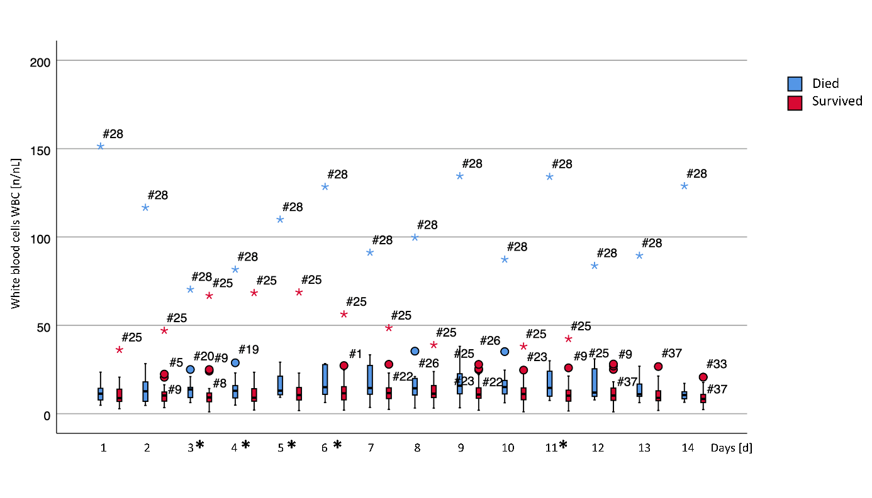
Daily values for the white blood cell count (WBC). Significant differences between the two groups are marked with an asterisk in the legend of the x-axis.
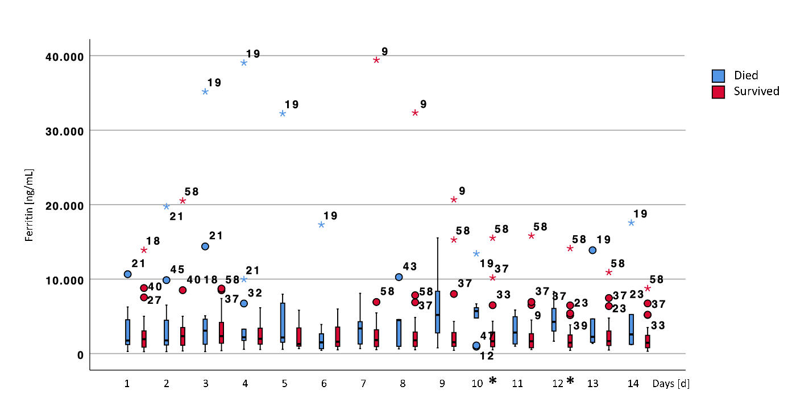
Daily values for ferritin. Significant differences between the two groups are marked with an asterisk in the legend of the x-axis.
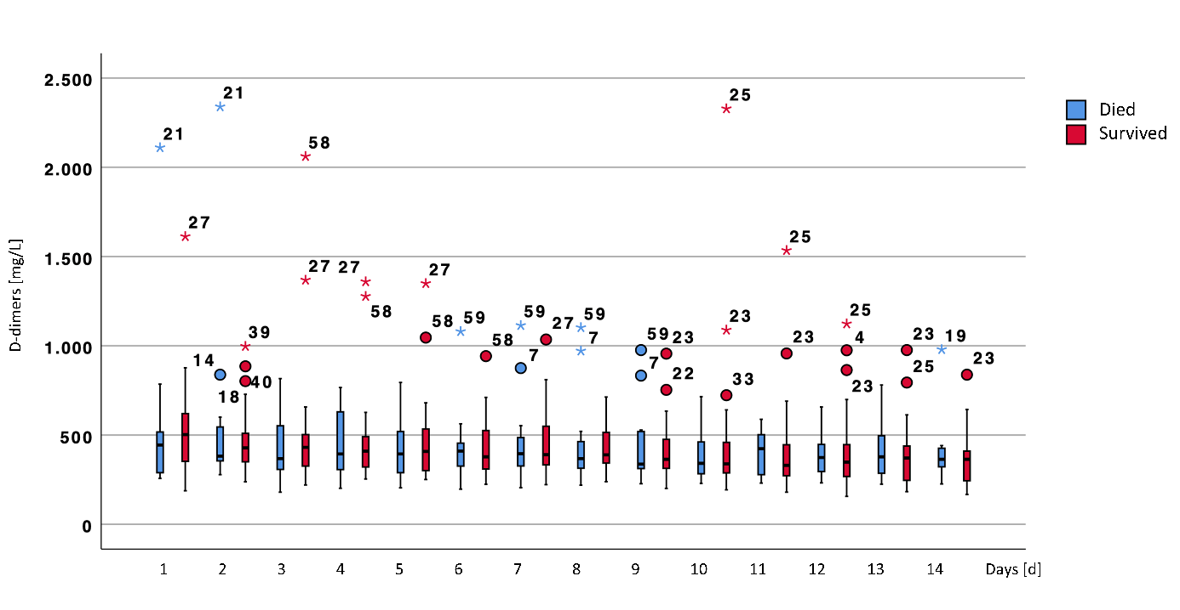
Daily values for D-dimers. Significant differences between the two groups are marked with an asterisk in the legend of the x-axis.
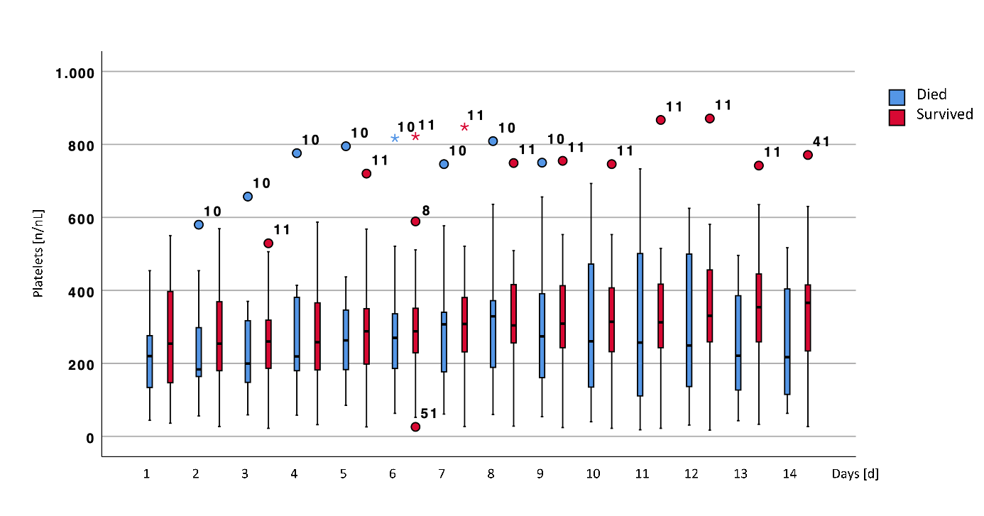
Daily values for the platelet count. Significant differences between the two groups are marked with an asterisk in the legend of the x-axis.
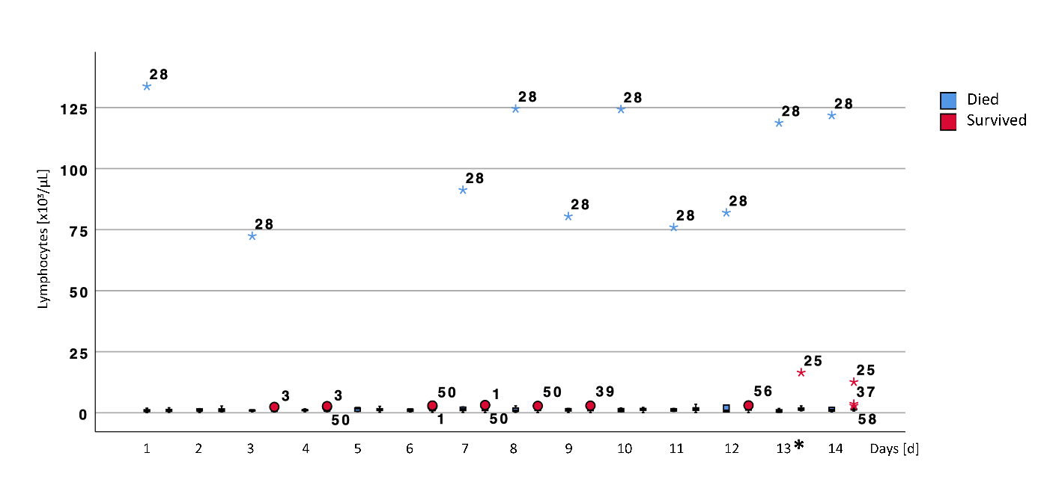
Daily values for the lymphocytes count. Significant differences between the two groups are marked with an asterisk in the legend of the x-axis.
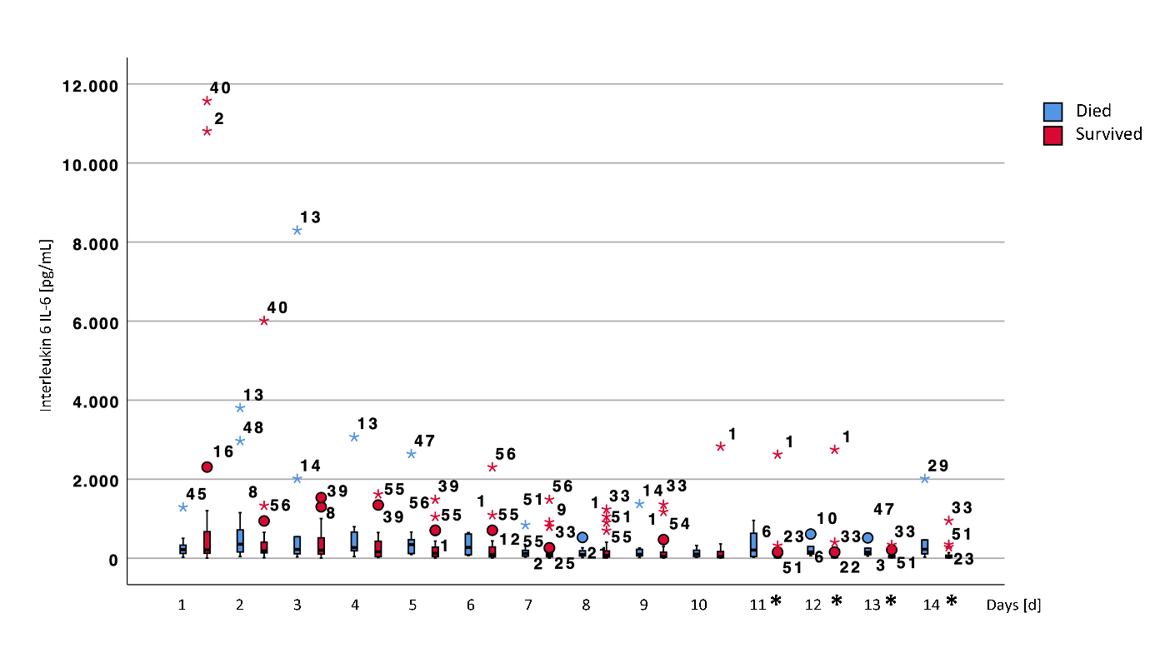
Daily values for interleukin 6 (IL-6). Significant differences between the two groups are marked with an asterisk in the legend of the x-axis.
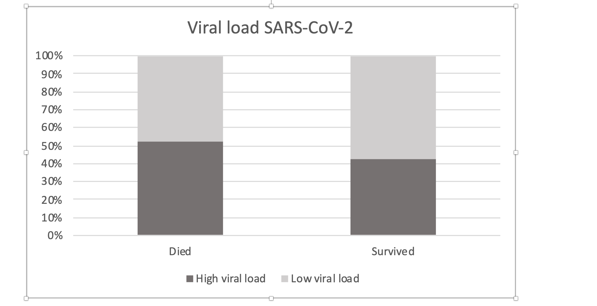
Frequencies of patients with high viral load (>1*10⁶ copies at least in one probe during the observation period). There was no significant difference between survivors and non-survivors (p=0.579).

Frequencies of bacterial, fungal, or additional viral infection.

