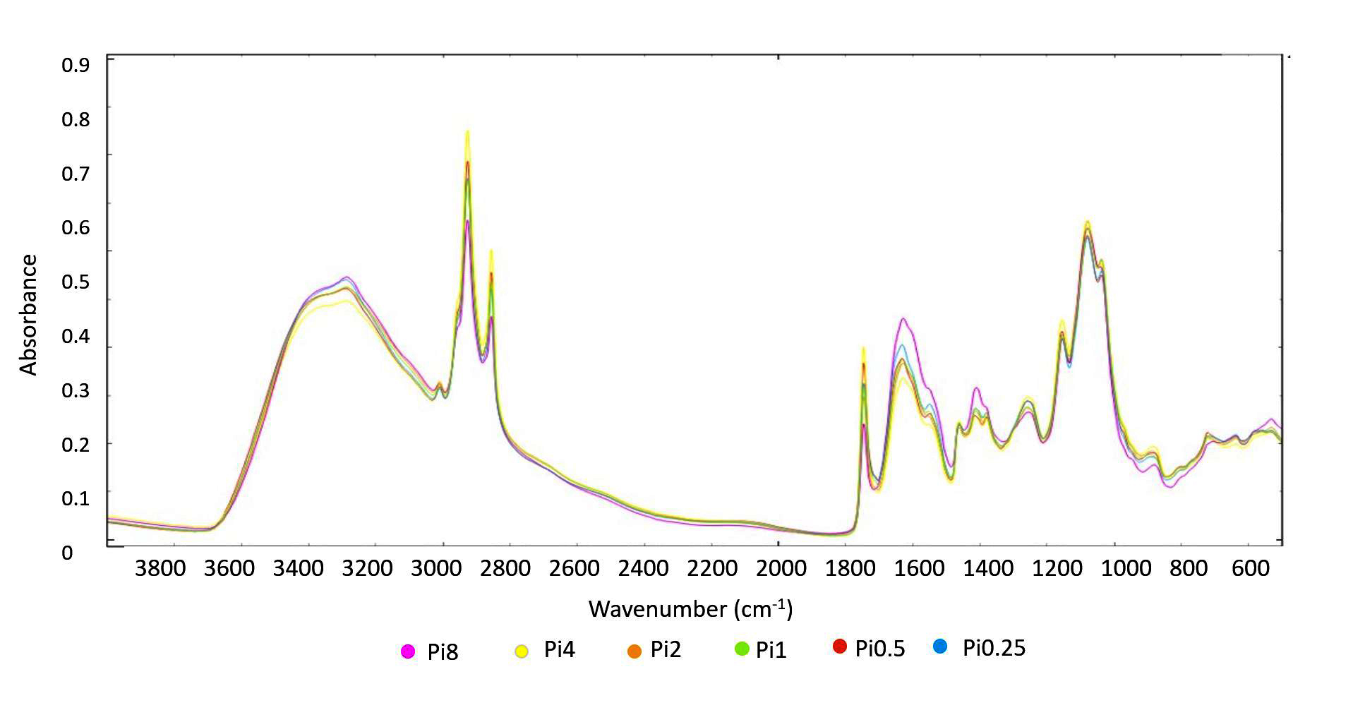
Supplementary Figure 6. FTIR-HTS spectra of Cunninghamella blakesleeana (EMSC corrected); yeast extract nitrogen source, different Pi-levels

