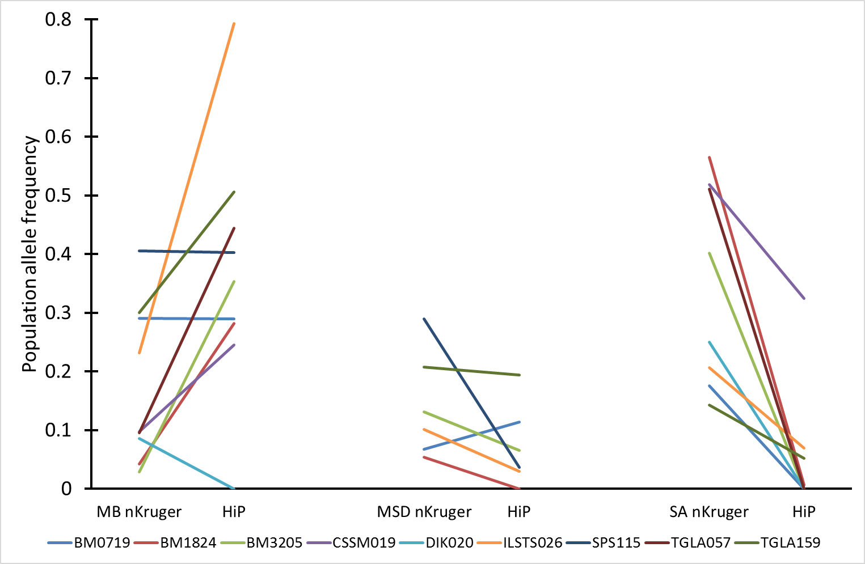
S6 Fig. Allele frequency differences between northern Kruger and HiP per SAE allele type.
Y-axis: total frequency per locus (i.e. pooled all alleles of a certain allele type), MB: male-beneficial linked microsatellite alleles (SAE_{indvN-A<1} alleles), MSD: male-specific-deleterious linked microsatellite alleles (SAE_{indvN-A>1}), SA: sexually-antagonistic linked microsatellite alleles (SAE_{indvO-A>1}).

