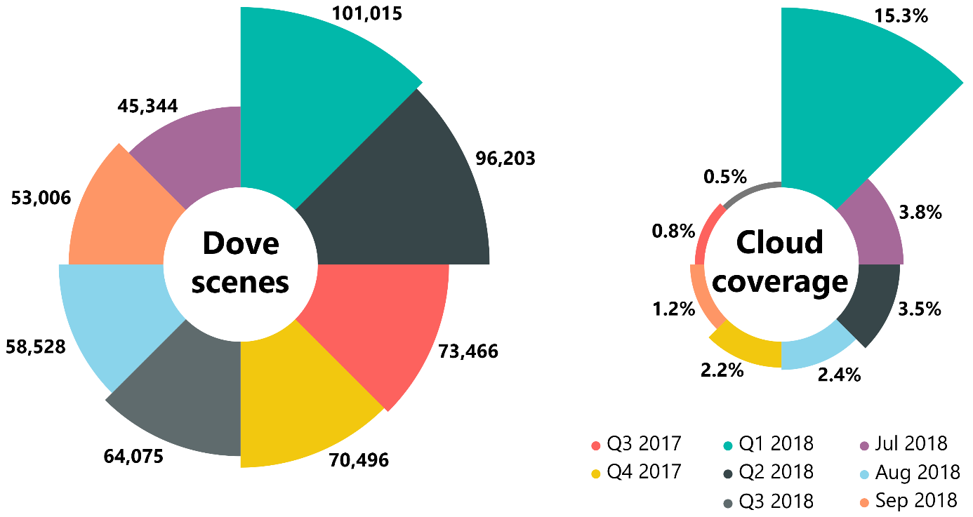
S1 Fig. Statistics of Planet Dove mosaics. The number of Planet Dove scenes comprising quarterly and monthly mosaics and the final cloud cover percentage of these mosaics.

