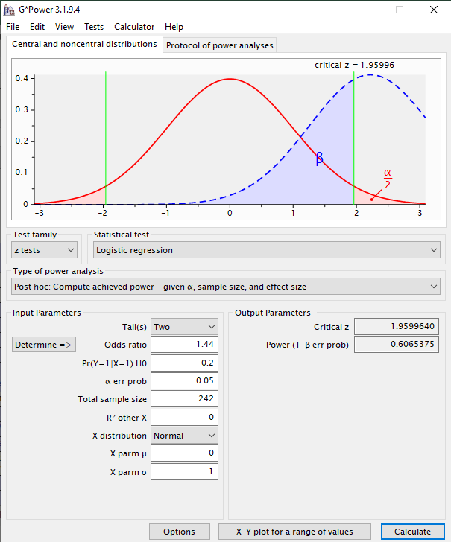
Figure 7. Achieved power for α = 0.05, a sample size of 242 participants and a small effect size.
Comment: For a small effect size, α = 0.05, a sample size of 242 participants, the achieved power was 60.6% for identifying predictors.

