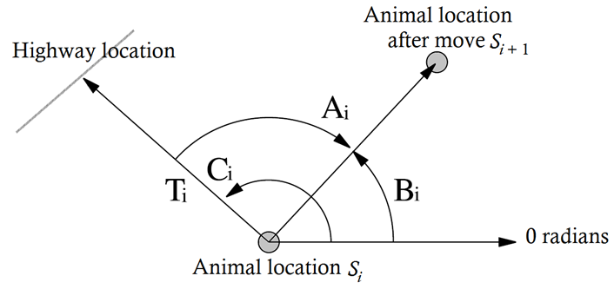

Figure S1 – Diagram illustrating the response angle in relation to the highway location (grey line). The animal moves from S_{i} to S_{i+1}. The animal-to-highway angle in radians is C_{i}. The move angle is B_{i} and the response angle is A_{i}. Adapted from Tracey et al. (2005).

