Appendix S4. Testing additional soil P measures for a subset of dataset
With dataset 1 (n=36), for which three extra soil P measures were available, we tested whether these extra measures have stronger contributions to among-site variations of plant traits than the soil P measures examined in the main analysis, irrespective of the correlations among the soil P measures. The additional soil P measures included: summer gross P mineralization rates, ‘summer P min’, (mgP kg soil⁻¹ 6weeks⁻¹), roughly estimated as increase in Olsen-extractable labile P (including both organic and inorganic part) in in-situ soil incubations; oxalate extractable P, ‘Pox’ (mgP kg soil⁻¹); and phosphorus saturation degree, ‘PSD’ (%), calculated as percentage of oxalate-extractable P over the half of oxalate-extractable Al and Fe [1].
Only PSD had a significant independent effect on WPC (Fig. S5B, p<0.05), Moreover, none of the independent effects of the extra P fertility measures was larger than those of the other P fertility measures (p>0.05 with bootstrapping) (Fig. S5A-F). This indicates that the limited selection of soil P measures used in our main analysis did not bias our findings.

Figure S5. Hierarchical partitioning of among-site variance of plant traits into independent (black bars) and joint (white bars) effects of various P-related soil fertility measures. Plant traits examined are A: log WNC (mg/g) (n=35), B: log WPC (mg/g) (n=35), C: IV_{nut} (n=36), D: component (n=36), E: S component (n=36), and F: R component (n=36). Soil fertility measures were log-transformed prior to the analysis except for PSD. Asterisks indicate that the independent effect was significant based on Z-scores computed with randomization (*: p <0.05, **: p <0.01, ***: p <0.001). 95% confidence intervals of independent effects, obtained by 1000-time bootstrapping, are shown.
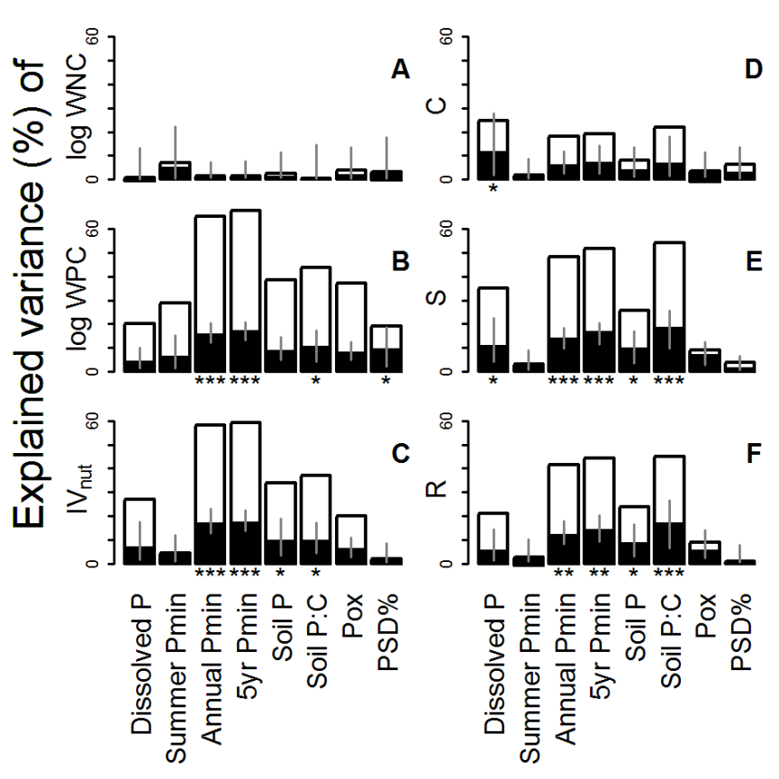
Reference

1. Lookman R, Vandeweert N, Merckx R, Vlassak K (1995) Geostatistical assessment of the regional distribution of phosphate sorption capacity parameters (FeOX and AlOX) in northern Belgium. Geoderma 66: 285-296.

