S1 File.
Counterbalancing orders
Table 1: Counterbalancing orders for Experiments 1, 2, and 3.
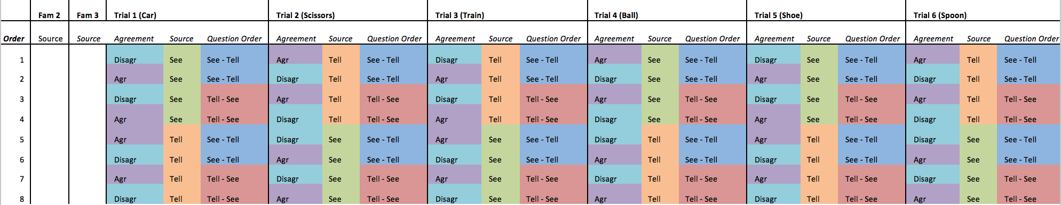
Counterbalancing assignments for each experiment
Table 2: Counterbalancing assignments for Experiments 1, 2, and 3.
 |  | Order
 |  | 1 | 2 | 3 | 4 | 5 | 6 | 7 | 8
Number of children | Experiment 1 – 4-year-olds | 4 | 4 | 4 | 4 | 4 | 4 | 4 | 4
 | Experiment 2 – 4-year-olds | 4 | 2 | 5 | 5 | 5 | 5 | 5 | 3
 | Experiment 3 – 3-year-olds | 3 | 5 | 5 | 5 | 5 | 3 | 4 | 4

