S1 Picture. Pictures of the smartphone and notebook in the study room (Studies 1 and 2).

- Smartphone versus notebook (Study 1)
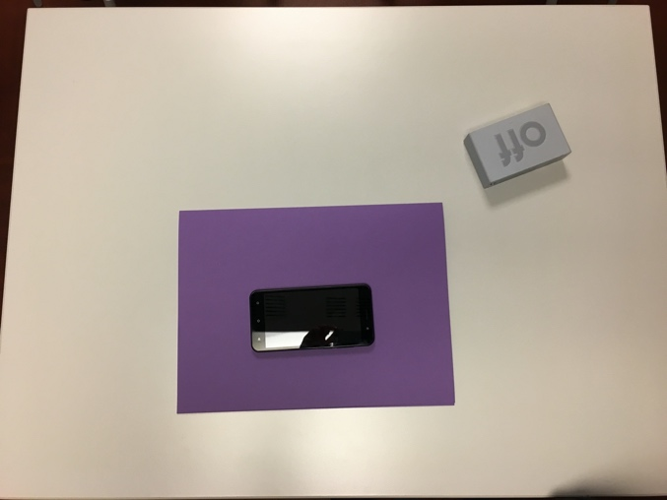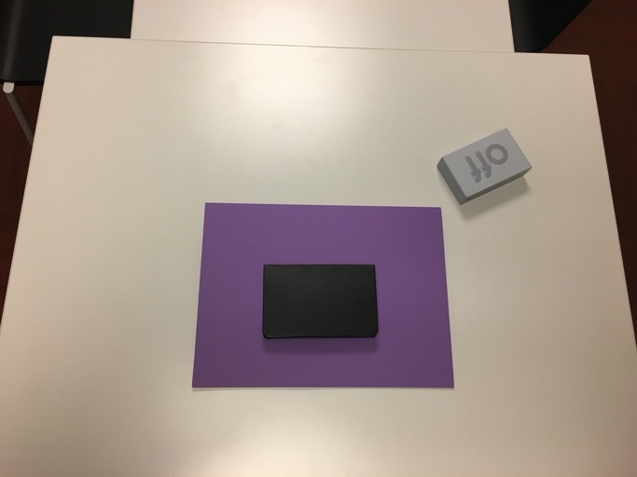

- Smartphone versus notebook (Study 2)
