Figure S4 - Inhibition models of compound 18 on the AR dependent reduction of different substrates.
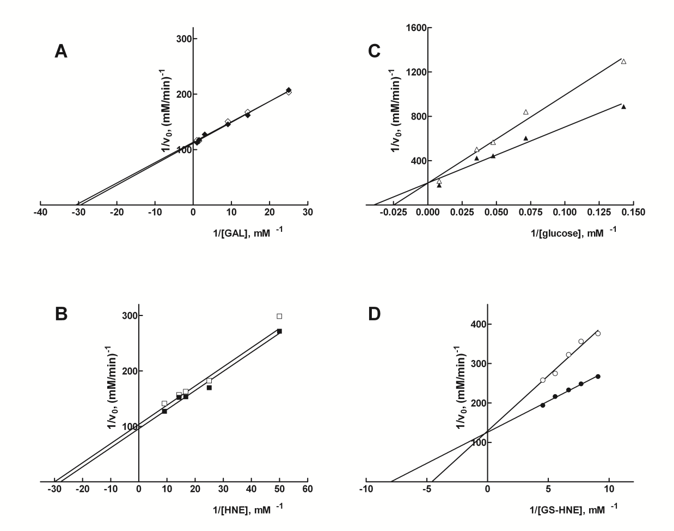

Double reciprocal plots of initial rate measurements of the AR catalyzed reduction of different substrates either in the absence (closed symbols) or in the presence (open symbols) of 47 µM of compound 18. The assay was performed in standard conditions using approximately 8 mU of purified AR.

