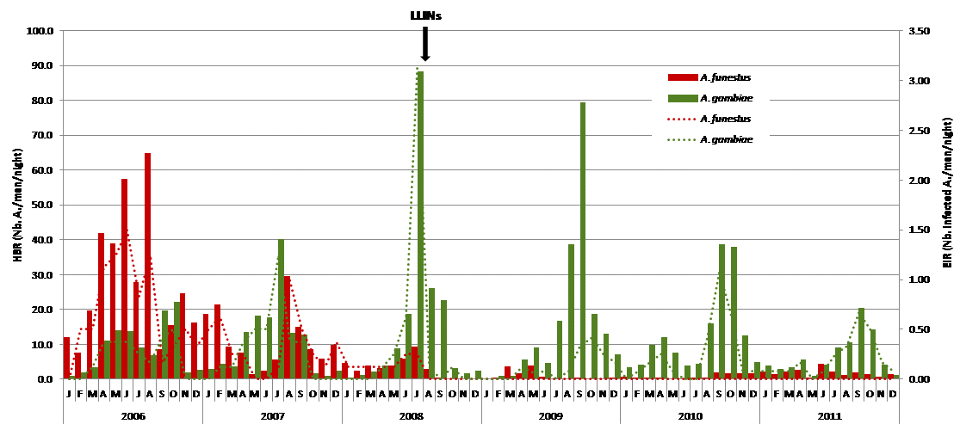
Figure A Human Biting Rate (HBR, number of Anopheles sampled per man and per night, bars) and Entomological Inoculation Rate (EIR, number of infected Anopheles sampled per man and per night, dotted lines) in A. funestus (red) and An. gambiae (green) sampled each month from Jan 2006 to Dec 2011, before and after the implementation of long lasting insecticide treated nets (LLINs).

Year | Man night | An. funestus | An. gambiae s.l. | An. nili | An. pharoensis | An. wellcomei | An. ziemanni
2006 | 116 | 3266 | 1112 | 1 | 9 |  | 5
2007 | 96 | 1085 | 1053 |  | 8 |  | 1
2008 | 104 | 300 | 1450 |  | 34 |  | 2
2009 | 140 | 155 | 2399 |  | 39 |  | 78
2010 | 144 | 122 | 1870 |  | 21 | 10 | 18
2011 | 144 | 262 | 971 |  | 10 | 5 | 6
Total | 744 | 5190 | 8855 | 1 | 121 | 15 | 110

SI Table 1. Number of specimens of each Anopheles species sampled during monthly human landing catches indoor and outdoor from 2006 to 2011.
Year | An. gambiae s.l. | Total genotyped | kdr genotype |  |  | R allelic frequency | Sub-species
 |  |  | RR | RS | SS |  | An. arabiensis | An. coluzzii | An. gambiae S | Hybrids*
2006 | 1112 | 206 |  | 9 (4.4%) | 197 (95.6%) | 2.18 | 21 (10.2%) | 31 (15.0 %) | 154 (74.8%)
2007 | 1053 | 150 |  | 8 (5.3%) | 142 (94.7%) | 2.67 | 21 (14.0%) | 27 (18.0%) | 99 (66.0%) | 3 (2.0%)
2008 | 1450 | 294 |  | 21 (7.1%) | 273 (92.9%) | 3.57 | 89 (30.5%) | 117 (40.1%) | 86 (29.5%)
2009 | 2399 | 288 | 5 (1.7%) | 46 (16.0%) | 237 (82.3%) | 9.72 | 105(36.5%) | 84 (29.2%) | 99 (34.4%)
2010 | 1870 | 313 | 23 (7.3%) | 99 (31.6%) | 191 (61.0%) | 23.16 | 82 (26.2%) | 72 (23.0%) | 159 (50.8%)
2011 | 971 | 243 | 27 (7.3%) | 96 (39.5%) | 120 (49.4%) | 30.86 | 49 (20.2%) | 50 (20.6%) | 144 (59.3%)
Total | 8855 | 1494 | 55 (11.1%) | 279 (18.7%) | 1160 (77.6%) | 13.02 | 367 (24.6%) | 381 (25.5%) | 741 (49.7%) | 3 (0.2%)

SI Table 2. Number of An. gambiae sampled and genotyped for (1) L1014F mutation (kdr) with heterozygote (RS), homozygote (RR), wild type (SS) and L1014F (R) allelic frequency (%), (2) An. arabiensis, An. coluzzii and An. gambiae S.

Year | An. arabiensis |  | An. Coluzzii |  | An. gambiae S |  | Kdr genotype
 |  |  |  |  |  |  | RR |  | RS |  | SS
 | Blood Origin |  | Blood Origin |  | Blood Origin |  | Blood Origin |  | Blood Origin |  | Blood Origin
 | Human | Animal | Human | Animal | Human | Animal | Human | Animal | Human | Animal | Human | Animal
2006 | 25 | 9 | 30 | 7 | 37 | 5 |  |  | 1 |  | 91 | 21
2007 | 23 | 9 | 35 | 9 | 41 | 7 |  |  | 3 |  | 96 | 25
2008 | 25 | 16 | 26 | 20 | 40 | 18 |  |  | 8 | 2 | 83 | 51
2009 | 10 | 23 | 22 | 31 | 35 | 26 | 3 |  | 17 | 6 | 47 | 73
2010 | 4 | 15 | 20 | 17 | 45 | 17 | 7 |  | 28 | 7 | 34 | 42
2011 | 6 | 17 | 16 | 10 | 34 | 6 | 8 |  | 26 | 8 | 22 | 25
HBI (%) | 51.10% |  | 61.32% |  | 74.6% |  | 100% |  | 78.3% |  | 64.5%

SI Table 3. Number of An. gambiae collected 2006 to 2011 by pyrethrum spray catch (PSC) and genotyped for (1) L1014F mutation (kdr) with heterozygote (RS), homozygote (RR), wild type (SS) and the mean of human blood index (%), (2) An. arabiensis, An. coluzzii and An. gambiae S.

Years | Number of gametocytes | Gametocyte prevalence rate | Proportion of P. falciparum infections with gametocytes
2006 | 6.29 ± 1.60 | 7.05 (66/936) | 22.6 (66/292)
2007 | 3.78 ± 1.11 | 5.49 (49/892) | 22.1 (49/222)
2008 | 7.19 ± 3.63 | 2.59 (32/1236) | 26.5 (32/121)
2009 | 5.56 ± 3.09 | 1.25 (16/1285) | 33.3 (16/48)
2010 | 6.00 ± 2.53 | 1.07 (13/1220) | 46.4 (13/28)
2011 | 43.25 ± 29.7 | 0.75 (8/1067) | 42.1 (8/19)

SI Table 4. Number of P. falciparum gametocytes per 200 oil immersion fields in gametocyte positive slides (mean ± standard error of the mean), gametocyte prevalence (% and number of villagers with gametocytes / total villagers examined), and proportion of P. falciparum infections with gametocytes (% and number of villagers with gametocytes / number of villagers with P. falciparum infection). Dielmo, quarterly transversal surveys, 2006-2011.

