Table S1. Inhibitory effects of individual phytochemicals reported in the literature for R. ulmifolius against biofilm formation and growth of UAMS-1.

 |  | Biofilm Formation |  | Growth
Chemical Name [CAS #] | Structure | IC₅₀ (μM) | IC₉₀ (μM) | MIC₅₀ (μM) | MIC₉₀ (μM)
Caffeic Acid [331-39-5] | 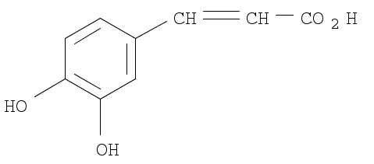 | >2000 | >2000 | >2000 | >2000
Ellagic Acid [476-66-4] | 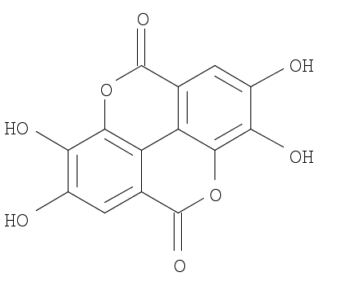 | 50 | 800 | >2000 | >2000
Ferulic Acid [1135-24-6] | 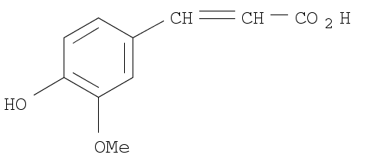 | >2000 | >2000 | >2000 | >2000
Gallic Acid [149-91-7] | 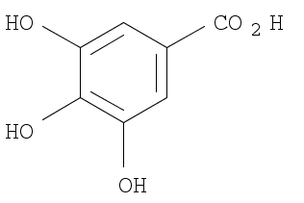 | 800 | >2000 | >2000 | >2000
Kaempferol [520-18-3] | 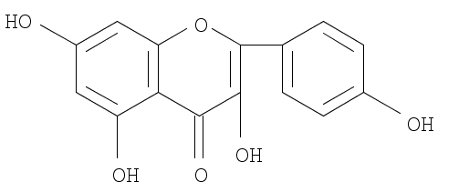 | 600 | 800 | 1700 | 1800
Oleanolic Acid [508-02-1] | 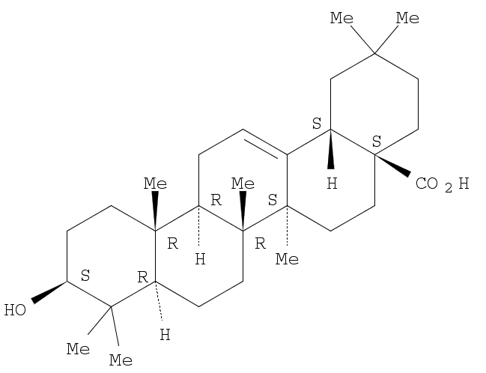 | 200 | 1000 | 1100 | 1600
Quercetin Dihydrate [6151-25-3] | 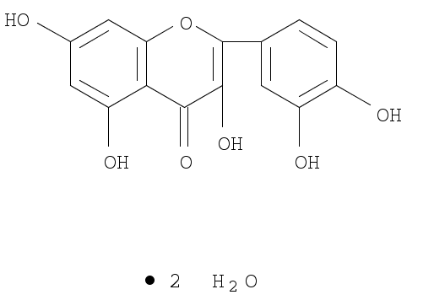 | 600 | 2000 | 1700 | 1900
Quercetin-3-O-glucuronide [22688-79-5] | 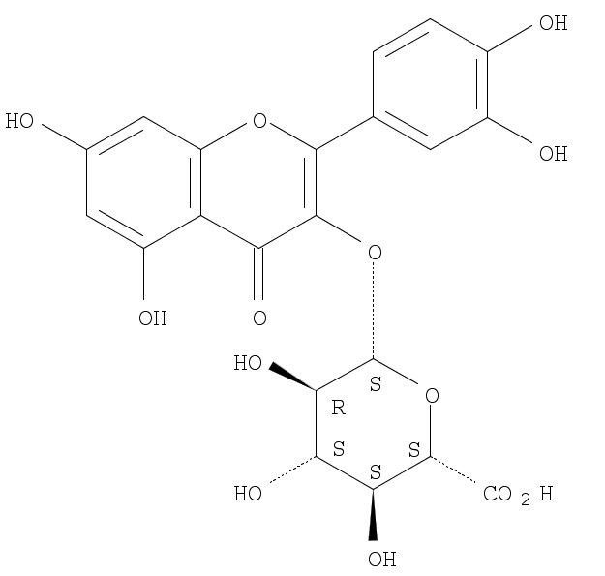 | >2000 | >2000 | >2000 | >2000
Tiliroside [20316-62-5] | 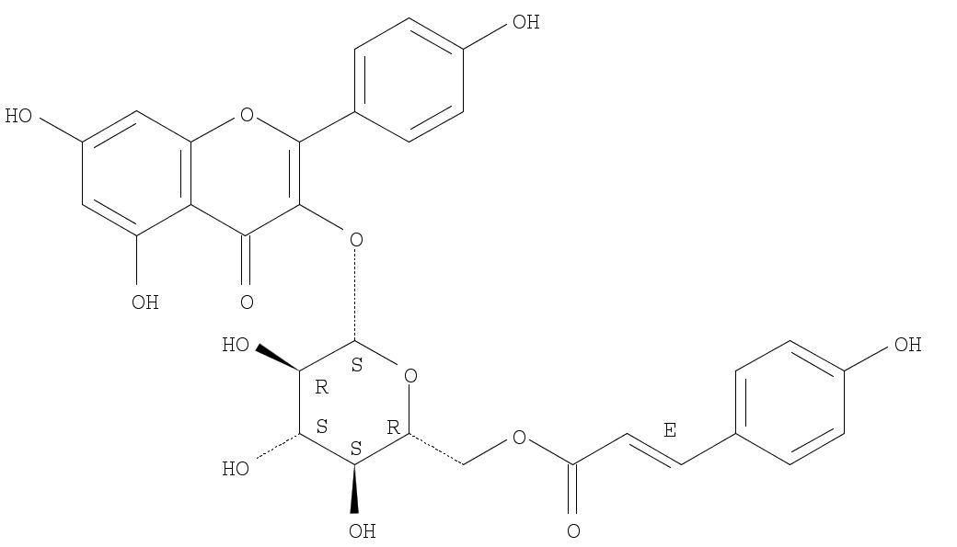 | >2000 | >2000 | >2000 | >2000
Ursolic Acid [77-52-1] | 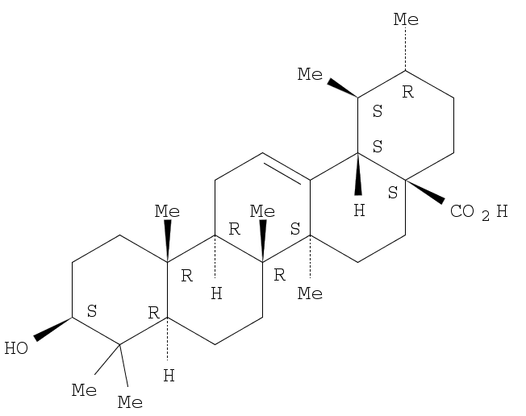 | 200 | 400 | 700 | 800

