S2 File

Supporting information
Hepatic DNA methylation and expression profiles under prenatal restricted diet in three generations of female rat fetuses

Joanna Nowacka-Woszuk,^{1*} Adrian Grzemski,¹ Magdalena Sliwinska,² Agata Chmurzynska²

¹Department of Genetics and Animal Breeding, Poznan University of Life Sciences, Wolynska 33, 60-637 Poznan, Poland
²Institute of Human Nutrition and Dietetics, Poznan University of Life Sciences, Wojska Polskiego 31, 60-624 Poznan, Poland

*Corresponding author’s e-mail address: joanna.nowacka-woszuk@up.poznan.pl

Table A. Location of the studied cytosines in the CpG islands, primers used in pyrosequencing, and amplicon lengths.
Cytosines genomic location (rn6/RGSC6.0) | Location in a gene context | Primers sequences | amplicon length (bp)
12:48316548 | 174 bp downstream of the Usp30 | F: 5’ GGGTGGGAAAGTTTTGTAGTAAG  R: 5’ TTCTAAACCCACTCCAACCCCCTCAATCTA  seq: 5’ GGAGGTTATTTTGGTTATT | 178
14:92117731 | 192 bp downstream of the Grb10 | F: 5’ AGTATAGGTGTTGGGAAGTTT  R: 5’ AAACTACAAACCCTATTCCTATTCTTACCC  seq: 5’ GGGAATTGATTGGGTAT | 327
2:113652068 | 280 bp upstream of the Pld1 | F: 5’ AGGGATTTGTAAGAAGGTTATAGT  R: 5’ ACCTTCCTCCATACCTCAATTCTAA  seq: 5’ AGTTGGTTTTTTGTTGT | 293
2:258052775 | 60 bp downstream of the St6galnac5 | F: 5’ TTTTTGGATGTTGGAATGTG  R: 5’ CCCCTACCTTACAACCCTTAAA  seq: 5’ GTGGGGGTTTTGTTGA | 206
5:140802879 | 759 bp upstream of the Oxct2b | F: 5’ AGTTTGTTTGGGGTTGGATTA  R: 5’ ATCACCAAAAACTACCAATACTAAAC  seq: 5’ GTTTTAGAGGAAAGTTAATAGTT | 200
6:26821801 | 842 bp upstream of the Khk | F: 5’ GTGGTAGGATGAGGTTGAAGATTTTTAGA  R: 5’ AACCACCCTCTCCCTTCCTAACTATCAT  seq: 5’ AGTTTTTAGAGTTTATG | 256
X:113660107 | 163 bp upstream of the Acsl4 | F: 5’ GGGGGAGTATAGTGGTGTG  R: 5’ ACCCCCCAAAAAACTTTCATCCTAAAT  seq: 5’ GTTAAGGAAGTTATTATTAAAGAGG | 330

Table B. Sequences of primers used for real-time PCR studies.
Gene | Primers | Amplicon length
Usp30 | F: 5’ TGGGGTCCCATTACAGAGAG  R: 5’ TCAGCAGTGTCAAGGACAGG | 208
Grb10 | F: 5’ GATGGGACAAGCAAAGTGGT  R: 5’ ACGATCTCATGGTCCTCCAG | 164
Pld1 | F: 5’ ATCTACCTCTCTGGCTGTCCTG  R: 5’ GTATGTCTTTTGGTGGGAATGG | 220
St6galnac5 | F: 5’ CAACACTTGGCTGAGCACTG  R: 5’ TTGTACATTCATCGGGTCCA | 164
Oxct2b | F: 5’ GAGCACTGCACCAAGACAAA  R: 5’ CCTTAACCTCGTCCAACGAC | 175
Khk | F: 5’ TTCGGCTATGGAGAGGTGGT  R: 5’ TGAGCGTAGCCCCTTTCTTC | 118
Acsl4 | F: 5’ AGCCGCACTGAAGAATTGTC  R: 5’ TCTACCCCCTTCTGTTGTGC | 233

Table C. Clustering analysis into functional pathways of the 374 genes with significantly differed cytosines (accorging to KEGG database).
Pathway | No of genes | P value | P value (after Bonferroni correction) | Gene’s ID
rno01100: Metabolic pathways | 144 | 1.32306E-44 | 3.09595137598173E-42 | ENSRNOG00000000466, ENSRNOG00000005512, ENSRNOG00000002781, ENSRNOG00000010626, ENSRNOG00000024629, ENSRNOG00000019180, ENSRNOG00000001344, ENSRNOG00000019372, ENSRNOG00000048320, ENSRNOG00000011949, ENSRNOG00000014365, ENSRNOG00000001992, ENSRNOG00000014856, ENSRNOG00000001796, ENSRNOG00000009345, ENSRNOG00000049912, ENSRNOG00000017087, ENSRNOG00000032908, ENSRNOG00000017571, ENSRNOG00000008099, ENSRNOG00000012055, ENSRNOG00000046345, ENSRNOG00000021177, ENSRNOG00000010633, ENSRNOG00000013816, ENSRNOG00000005668, ENSRNOG00000008209, ENSRNOG00000009157, ENSRNOG00000003223, ENSRNOG00000009889, ENSRNOG00000019804, ENSRNOG00000016776, ENSRNOG00000003070, ENSRNOG00000006388, ENSRNOG00000001701, ENSRNOG00000007967, ENSRNOG00000012210, ENSRNOG00000010993, ENSRNOG00000014508, ENSRNOG00000012616, ENSRNOG00000017291, ENSRNOG00000028292, ENSRNOG00000020479, ENSRNOG00000028156, ENSRNOG00000021265, ENSRNOG00000059453, ENSRNOG00000018077, ENSRNOG00000005993, ENSRNOG00000014511, ENSRNOG00000011366, ENSRNOG00000017817, ENSRNOG00000032134, ENSRNOG00000012698, ENSRNOG00000012559, ENSRNOG00000010881, ENSRNOG00000011419, ENSRNOG00000003114, ENSRNOG00000007951, ENSRNOG00000029280, ENSRNOG00000016214, ENSRNOG00000038951, ENSRNOG00000046864, ENSRNOG00000004027, ENSRNOG00000024112, ENSRNOG00000026646, ENSRNOG00000018281, ENSRNOG00000042359, ENSRNOG00000000257, ENSRNOG00000029528, ENSRNOG00000005358, ENSRNOG00000018816, ENSRNOG00000003554, ENSRNOG00000006369, ENSRNOG00000008945, ENSRNOG00000008047, ENSRNOG00000000168, ENSRNOG00000026705, ENSRNOG00000015859, ENSRNOG00000006947, ENSRNOG00000008944, ENSRNOG00000000437, ENSRNOG00000016791, ENSRNOG00000016989, ENSRNOG00000006116, ENSRNOG00000013331, ENSRNOG00000002636, ENSRNOG00000018764, ENSRNOG00000059622, ENSRNOG00000018507, ENSRNOG00000007446, ENSRNOG00000032297, ENSRNOG00000060045, ENSRNOG00000046515, ENSRNOG00000004234, ENSRNOG00000003653, ENSRNOG00000005424, ENSRNOG00000000177, ENSRNOG00000002755, ENSRNOG00000019843, ENSRNOG00000028368, ENSRNOG00000009630, ENSRNOG00000037229, ENSRNOG00000020902, ENSRNOG00000018367, ENSRNOG00000037225, ENSRNOG00000052704, ENSRNOG00000016470, ENSRNOG00000009980, ENSRNOG00000016643, ENSRNOG00000018516, ENSRNOG00000011922, ENSRNOG00000007735, ENSRNOG00000008163, ENSRNOG00000000800, ENSRNOG00000052070, ENSRNOG00000008569, ENSRNOG00000011528, ENSRNOG00000017777, ENSRNOG00000047708, ENSRNOG00000043377, ENSRNOG00000028717, ENSRNOG00000011329, ENSRNOG00000018319, ENSRNOG00000042503, ENSRNOG00000009994, ENSRNOG00000028711, ENSRNOG00000007775, ENSRNOG00000019979, ENSRNOG00000018129, ENSRNOG00000001440, ENSRNOG00000021886, ENSRNOG00000017593, ENSRNOG00000039859, ENSRNOG00000028047, ENSRNOG00000001736, ENSRNOG00000011053, ENSRNOG00000016122, ENSRNOG00000056954, ENSRNOG00000038085, ENSRNOG00000008475, ENSRNOG00000002642, ENSRNOG00000049110, ENSRNOG00000007583, ENSRNOG00000021150
rno04910: Insulin signaling pathway | 28 | 1.98241E-13 | 4.63989E-11 | ENSRNOG00000021147, ENSRNOG00000006388, ENSRNOG00000052343, ENSRNOG00000021689, ENSRNOG00000011377, ENSRNOG00000015480, ENSRNOG00000010957, ENSRNOG00000018494, ENSRNOG00000014366, ENSRNOG00000050578, ENSRNOG00000014904, ENSRNOG00000006116, ENSRNOG00000002833, ENSRNOG00000029986, ENSRNOG00000009079, ENSRNOG00000053869, ENSRNOG00000004060, ENSRNOG00000019228, ENSRNOG00000003463, ENSRNOG00000002946, ENSRNOG00000018903, ENSRNOG00000020902, ENSRNOG00000001868, ENSRNOG00000004978, ENSRNOG00000020657, ENSRNOG00000003919, ENSRNOG00000007583, ENSRNOG00000023428
rno04932: Non-alcoholic fatty liver disease (NAFLD) | 27 | 4.56661E-11 | 1.06859E-08 | ENSRNOG00000005512, ENSRNOG00000018816, ENSRNOG00000001068, ENSRNOG00000007967, ENSRNOG00000008569, ENSRNOG00000020417, ENSRNOG00000048320, ENSRNOG00000011949, ENSRNOG00000028717, ENSRNOG00000013331, ENSRNOG00000002833, ENSRNOG00000042503, ENSRNOG00000029986, ENSRNOG00000018129, ENSRNOG00000017571, ENSRNOG00000019228, ENSRNOG00000003463, ENSRNOG00000021177, ENSRNOG00000017817, ENSRNOG00000032134, ENSRNOG00000002946, ENSRNOG00000018903, ENSRNOG00000005668, ENSRNOG00000026646, ENSRNOG00000016470, ENSRNOG00000018281, ENSRNOG00000023428
rno00190: Oxidative phosphorylation | 24 | 7.0201E-10 | 1.6427E-07 | ENSRNOG00000005512, ENSRNOG00000017571, ENSRNOG00000008163, ENSRNOG00000018816, ENSRNOG00000008569, ENSRNOG00000007967, ENSRNOG00000021177, ENSRNOG00000017817, ENSRNOG00000000557, ENSRNOG00000032134, ENSRNOG00000048320, ENSRNOG00000011949, ENSRNOG00000005668, ENSRNOG00000028717, ENSRNOG00000038951, ENSRNOG00000001992, ENSRNOG00000052704, ENSRNOG00000013331, ENSRNOG00000016470, ENSRNOG00000026646, ENSRNOG00000042503, ENSRNOG00000018281, ENSRNOG00000049912, ENSRNOG00000018129
rno04931: Insulin resistance | 20 | 5.92681E-09 | 1.38687E-06 | ENSRNOG00000053869, ENSRNOG00000042411, ENSRNOG00000006388, ENSRNOG00000019228, ENSRNOG00000021689, ENSRNOG00000003463, ENSRNOG00000015480, ENSRNOG00000018494, ENSRNOG00000002946, ENSRNOG00000018903, ENSRNOG00000020902, ENSRNOG00000014904, ENSRNOG00000019742, ENSRNOG00000002833, ENSRNOG00000003919, ENSRNOG00000029986, ENSRNOG00000018507, ENSRNOG00000007583, ENSRNOG00000023428, ENSRNOG00000019057
rno00510: N-Glycan biosynthesis | 14 | 9.36456E-09 | 2.19131E-06 | ENSRNOG00000017087, ENSRNOG00000004234, ENSRNOG00000046515, ENSRNOG00000000800, ENSRNOG00000014511, ENSRNOG00000006369, ENSRNOG00000012055, ENSRNOG00000011528, ENSRNOG00000046345, ENSRNOG00000010993, ENSRNOG00000012559, ENSRNOG00000016989, ENSRNOG00000049110, ENSRNOG00000011922
rno00310: Lysine degradation | 14 | 1.57418E-08 | 3.68358E-06 | ENSRNOG00000016680, ENSRNOG00000001417, ENSRNOG00000024629, ENSRNOG00000001344, ENSRNOG00000061499, ENSRNOG00000015621, ENSRNOG00000028207, ENSRNOG00000016790, ENSRNOG00000004027, ENSRNOG00000013045, ENSRNOG00000020386, ENSRNOG00000017508, ENSRNOG00000021614, ENSRNOG00000023317
rno04150: mTOR signaling pathway | 15 | 1.80238E-08 | 4.21756E-06 | ENSRNOG00000042411, ENSRNOG00000052343, ENSRNOG00000019228, ENSRNOG00000021689, ENSRNOG00000037505, ENSRNOG00000002763, ENSRNOG00000010957, ENSRNOG00000050578, ENSRNOG00000018903, ENSRNOG00000012061, ENSRNOG00000057078, ENSRNOG00000017426, ENSRNOG00000017297, ENSRNOG00000003919, ENSRNOG00000023428
rno00564: Glycerophospholipid metabolism | 17 | 1.40689E-07 | 3.29207E-05 | ENSRNOG00000018077, ENSRNOG00000008320, ENSRNOG00000000177, ENSRNOG00000025012, ENSRNOG00000026705, ENSRNOG00000000437, ENSRNOG00000028368, ENSRNOG00000016791, ENSRNOG00000009980, ENSRNOG00000014856, ENSRNOG00000024112, ENSRNOG00000028156, ENSRNOG00000018319, ENSRNOG00000016643, ENSRNOG00000012269, ENSRNOG00000021265, ENSRNOG00000001796
rno05012: Parkinson's disease | 21 | 2.65611E-07 | 6.2151E-05 | ENSRNOG00000005512, ENSRNOG00000017571, ENSRNOG00000018816, ENSRNOG00000008569, ENSRNOG00000007967, ENSRNOG00000021177, ENSRNOG00000017817, ENSRNOG00000019465, ENSRNOG00000032134, ENSRNOG00000048320, ENSRNOG00000011949, ENSRNOG00000005668, ENSRNOG00000028717, ENSRNOG00000004978, ENSRNOG00000013331, ENSRNOG00000016470, ENSRNOG00000026646, ENSRNOG00000042503, ENSRNOG00000018281, ENSRNOG00000049912, ENSRNOG00000018129
rno05010: Alzheimer's disease | 23 | 3.0069E-07 | 7.03589E-05 | ENSRNOG00000005512, ENSRNOG00000021147, ENSRNOG00000017571, ENSRNOG00000004060, ENSRNOG00000018816, ENSRNOG00000008569, ENSRNOG00000007967, ENSRNOG00000021177, ENSRNOG00000017817, ENSRNOG00000032134, ENSRNOG00000048320, ENSRNOG00000011949, ENSRNOG00000005668, ENSRNOG00000028717, ENSRNOG00000013331, ENSRNOG00000002833, ENSRNOG00000026646, ENSRNOG00000016470, ENSRNOG00000042503, ENSRNOG00000018281, ENSRNOG00000049912, ENSRNOG00000018129, ENSRNOG00000021150
rno05231: Choline metabolism in cancer | 16 | 1.85099E-06 | 0.000433038 | ENSRNOG00000008320, ENSRNOG00000019228, ENSRNOG00000001068, ENSRNOG00000021689, ENSRNOG00000000177, ENSRNOG00000050578, ENSRNOG00000026705, ENSRNOG00000018903, ENSRNOG00000016791, ENSRNOG00000012061, ENSRNOG00000009980, ENSRNOG00000024112, ENSRNOG00000028156, ENSRNOG00000003919, ENSRNOG00000001796, ENSRNOG00000023428
rno00600: Sphingolipid metabolism | 11 | 5.51419E-06 | 0.001289491 | ENSRNOG00000002781, ENSRNOG00000009980, ENSRNOG00000032942, ENSRNOG00000000177, ENSRNOG00000012210, ENSRNOG00000003223, ENSRNOG00000010626, ENSRNOG00000036866, ENSRNOG00000012953, ENSRNOG00000009345, ENSRNOG00000000257
rno00514: Other types of O-glycan biosynthesis | 8 | 6.277E-06 | 0.001467745 | ENSRNOG00000019843, ENSRNOG00000046515, ENSRNOG00000050298, ENSRNOG00000012146, ENSRNOG00000028207, ENSRNOG00000010104, ENSRNOG00000001417, ENSRNOG00000023317
rno05016: Huntington's disease | 22 | 7.18234E-06 | 0.001679261 | ENSRNOG00000005512, ENSRNOG00000017571, ENSRNOG00000018816, ENSRNOG00000008569, ENSRNOG00000000604, ENSRNOG00000007967, ENSRNOG00000019298, ENSRNOG00000021177, ENSRNOG00000017817, ENSRNOG00000032134, ENSRNOG00000048320, ENSRNOG00000011949, ENSRNOG00000005668, ENSRNOG00000028717, ENSRNOG00000013331, ENSRNOG00000016470, ENSRNOG00000026646, ENSRNOG00000042503, ENSRNOG00000018281, ENSRNOG00000049912, ENSRNOG00000018129, ENSRNOG00000021150
rno04012: ErbB signaling pathway | 14 | 1.40695E-05 | 0.003286883 | ENSRNOG00000021147, ENSRNOG00000019228, ENSRNOG00000021689, ENSRNOG00000010957, ENSRNOG00000006450, ENSRNOG00000014366, ENSRNOG00000018903, ENSRNOG00000017879, ENSRNOG00000012061, ENSRNOG00000001868, ENSRNOG00000002833, ENSRNOG00000020657, ENSRNOG00000003919, ENSRNOG00000023428
rno00534: Glycosaminoglycan biosynthesis - heparan sulfate / heparin | 8 | 1.61706E-05 | 0.003776809 | ENSRNOG00000016776, ENSRNOG00000017659, ENSRNOG00000024591, ENSRNOG00000010598, ENSRNOG00000021886, ENSRNOG00000019979, ENSRNOG00000019804, ENSRNOG00000008944
rno04070: Phosphatidylinositol signaling system | 14 | 2.53482E-05 | 0.005913996 | ENSRNOG00000056954, ENSRNOG00000012061, ENSRNOG00000004060, ENSRNOG00000019228, ENSRNOG00000020479, ENSRNOG00000024112, ENSRNOG00000021265, ENSRNOG00000001796, ENSRNOG00000018516, ENSRNOG00000023428, ENSRNOG00000026705, ENSRNOG00000060045, ENSRNOG00000021150, ENSRNOG00000018903
rno00563: Glycosylphosphatidylinositol(GPI)-anchor biosynthesis | 8 | 2.81363E-05 | 0.006562353 | ENSRNOG00000029280, ENSRNOG00000003070, ENSRNOG00000003554, ENSRNOG00000011366, ENSRNOG00000059622, ENSRNOG00000049110, ENSRNOG00000042359, ENSRNOG00000007735
rno00561: Glycerolipid metabolism | 11 | 3.0989E-05 | 0.007225319 | ENSRNOG00000000437, ENSRNOG00000018077, ENSRNOG00000004027, ENSRNOG00000009980, ENSRNOG00000000177, ENSRNOG00000024112, ENSRNOG00000001796, ENSRNOG00000001344, ENSRNOG00000028711, ENSRNOG00000014508, ENSRNOG00000026705
rno01130: Biosynthesis of antibiotics | 21 | 7.29922E-05 | 0.016935737 | ENSRNOG00000003653, ENSRNOG00000032908, ENSRNOG00000001440, ENSRNOG00000005424, ENSRNOG00000007967, ENSRNOG00000024629, ENSRNOG00000001344, ENSRNOG00000043377, ENSRNOG00000011329, ENSRNOG00000016122, ENSRNOG00000018367, ENSRNOG00000038085, ENSRNOG00000006116, ENSRNOG00000013331, ENSRNOG00000028292, ENSRNOG00000004027, ENSRNOG00000009994, ENSRNOG00000018507, ENSRNOG00000032297, ENSRNOG00000009889, ENSRNOG00000029528
rno04152: AMPK signaling pathway | 15 | 0.000137029 | 0.031558398 | ENSRNOG00000019228, ENSRNOG00000021689, ENSRNOG00000003463, ENSRNOG00000010728, ENSRNOG00000050578, ENSRNOG00000018911, ENSRNOG00000018903, ENSRNOG00000016122, ENSRNOG00000013552, ENSRNOG00000020902, ENSRNOG00000005389, ENSRNOG00000017297, ENSRNOG00000003919, ENSRNOG00000029986, ENSRNOG00000023428
rno04666: Fc gamma R-mediated phagocytosis | 12 | 0.00016187 | 0.037172188 | ENSRNOG00000012061, ENSRNOG00000001868, ENSRNOG00000019228, ENSRNOG00000001068, ENSRNOG00000021689, ENSRNOG00000009980, ENSRNOG00000028156, ENSRNOG00000000177, ENSRNOG00000003919, ENSRNOG00000010626, ENSRNOG00000023428, ENSRNOG00000018903

Table D. Genes involved in oxidative phosphorylation with altered cytosine methylation in R group when comparing to C group.
Mitochondrial membrane complex | Genes with altered cytosine methylation | Chromosome and cytosine position (rn6/RGSC6.0) | % of difference in methylation in R group comparing to C group
I - NADH-coenzyme Q oxidoreductase | Ndufa10 | 9:99651701 | 2.6415
 | Ndufa11 | 9:10338253 | 1.7341
 | Ndufa2 | 18:29587615 | -1.7483
 | Ndufa2 | 18:29587928 | 1.4493
 | Ndufa4 | 4:38241166 | -1.9520
 | Ndufa6 | 7:123586929 | 1.7263
 | Ndufa6 | 7:123586974 | -1.9820
 | Ndufa8 | 3:15379153 | -3.3846
 | Ndufab1 | 1:192057610 | 1.9727
 | Ndufb5 | 2:119139606 | -1.3447
 | Ndufb7 | 19:24701019 | 2.1622
 | Ndufs5 | 5:141405271 | 2.4540
 | Ndufv2 | 9:113900145 | -2.1638
 | Ndufv2 | 9:113900307 | -2.4433
II - Succinate-Q oxidoreductase | Sdha | 1:31545326 | 1.2642
 | Sdhb | 5:159484430 | 1.6000
III - Q-cytochrome c oxidoreductase | Uqcrc1 | 8:117679138 | 1.7568
 | Uqcrfs1 | 17:35678011 | 2.4272
IV - Cytochrome c oxidase | Cox17 | 11:64968378 | -3.2258
 | Cox4i1 | 19:54245885 | 2.1033
 | Cox5a | 8:62298290 | -2.2312
 | Cox5a | 8:62298415 | -2.7837
 | Cox8a | 1:222468938 | 1.4742
V - ATP synthase | Ppa1 | 20:31265624 | 2.2409
 | Atp6v1a | 11:61530667 | 3.0641
 | Atp6v1g1 | 5:79367706 | -2.6634
+ or – means that the methylation in R group was higher or lower than in C group, respectively

Table E. Mean coverage after tNGS (± SD) for the analysed cytosines in the seven selected genes

Gene | C-group |  | R-group
 | Mean | ± SD | Mean | ± SD
Usp30 | 54.67 | 7.69 | 46.50 | 18.36
Grb10 | 40.83 | 4.75 | 40.00 | 9.94
Pld1 | 35.50 | 13.44 | 33.50 | 12.29
St6galnac5 | 54.00 | 8.07 | 51.17 | 14.86
Oxct2b | 67.33 | 20.87 | 72.33 | 30.19
Khk | 41.67 | 5.01 | 39.00 | 11.40
Acsl4 | 41.67 | 14.36 | 37.33 | 13.03

Table F. The assignment of the selected seven genes to particular KEGG pathways.
Gene | Pathways (rat database)
Grb10 (growth factor receptor bound protein 10) | rno04150: mTOR signalling pathway
Oxct2b (3-oxoacid CoA transferase 2B) | no pathway for rat
Usp30 (ubiquitin specific peptidase 30) | rno04137: Mitophagy - animal
Pld1 (phospholipase D1) | rno00564: Glycerophospholipid metabolism  rno00565: Ether lipid metabolism  rno01100: Metabolic pathways  rno04014: Ras signalling pathway  rno04024: cAMP signalling pathway  rno04071: Sphingolipid signalling pathway  rno04072: Phospholipase D signalling pathway  rno04144: Endocytosis  rno04666: Fc gamma R-mediated phagocytosis  rno04724: Glutamatergic synapse  rno04912: GnRH signalling pathway  rno04928: Parathyroid hormone synthesis, secretion and action  rno05212: Pancreatic cancer  rno05231: Choline metabolism in cancer
Khk (ketohexokinase) | rno00051: Fructose and mannose metabolism  rno01100: Metabolic pathways
St6galnac5 (ST6 N-acetylgalactosaminide alpha-2,6-sialyltransferase 5) | rno00604: Glycosphingolipid biosynthesis - ganglio series  rno01100: Metabolic pathways
Acsl4 (acyl-CoA synthetase long-chain family member 4) | rno00061: Fatty acid biosynthesis  rno00071: Fatty acid degradation  rno01100: Metabolic pathways  rno01212: Fatty acid metabolism  rno03320: PPAR signalling pathway  rno04146: Peroxisome  rno04216: Ferroptosis  rno04714: Thermogenesis  rno04920: Adipocytokine signalling pathway

Table G. Methylation level analysis of particular cytosines across generations.
Gene | CpG | Group | P value | P value (after Bonferroni correction) | Tukey Honest Significant Test  (mean difference and S: significant or NS: not significant)
 |  |  |  |  | F1 versus F2 | F1 versus F3 | F2 versus F3
Grb10 | CpG1 | C | 0.2339 | 1.0000 | NA | NA | NA
 | CpG1 | R | 0.2888 | 1.0000 | NA | NA | NA
 | CpG2 | C | 0.3149 | 1.0000 | NA | NA | NA
 | CpG2 | R | 0.5150 | 1.0000 | NA | NA | NA
 | CpG3** | C | 0.0000 | 0.0005 | 13.833 (S) | 12.666 (S) | -1.166 (NS)
 | CpG3* | R | 0.0001 | 0.0036 | 12.500 (S) | 10.833 (S) | -1.666 (NS)
 | CpG4* | C | 0.0000 | 0.0019 | 14.500 (S) | 15.000 (S) | 0.500 (NS)
 | CpG4** | R | 0.0000 | 0.0000 | 16.333 (S) | 16.500 (S) | 0.166 (NS)
 | CpG5** | C | 0.0000 | 0.0003 | 15.333 (S) | 15.000 (S) | -0.333 (NS)
 | CpG5** | R | 0.0000 | 0.0000 | 16.333 (S) | 16.166 (S) | -0.166 (NS)
Oxct2b | CpG1 | C | 0.7613 | 1.0000 | NA | NA | NA
 | CpG1 | R | 0.4800 | 1.0000 | NA | NA | NA
 | CpG2 | C | 0.8426 | 1.0000 | NA | NA | NA
 | CpG2 | R | 0.0889 | 1.0000 | NA | NA | NA
 | CpG3 | C | 0.7217 | 1.0000 | NA | NA | NA
 | CpG3 | R | 0.3066 | 1.0000 | NA | NA | NA
 | CpG4 | C | 0.3398 | 1.0000 | NA | NA | NA
 | CpG4 | R | 0.0779 | 1.0000 | NA | NA | NA
Usp30 | CpG1 | C | 0.8263 | 1.0000 | NA | NA | NA
 | CpG1 | R | 0.3512 | 1.0000 | NA | NA | NA
 | CpG2 | C | 0.7512 | 1.0000 | NA | NA | NA
 | CpG2 | R | 0.4797 | 1.0000 | NA | NA | NA
 | CpG3 | C | 0.7257 | 1.0000 | NA | NA | NA
 | CpG3 | R | 0.5072 | 1.0000 | NA | NA | NA
 | CpG4 | C | 0.0462 | 1.0000 | NA | NA | NA
 | CpG4 | R | 0.3911 | 1.0000 | NA | NA | NA
Pld1 | CpG1 | C | 0.8036 | 1.0000 | NA | NA | NA
 | CpG1 | R | 0.0917 | 1.0000 | NA | NA | NA
 | CpG2 | C | 0.6844 | 1.0000 | NA | NA | NA
 | CpG2 | R | 0.9256 | 1.0000 | NA | NA | NA
 | CpG3 | C | 0.1609 | 1.0000 | NA | NA | NA
 | CpG3 | R | 0.2423 | 1.0000 | NA | NA | NA
 | CpG4 | C | 0.5425 | 1.0000 | NA | NA | NA
 | CpG4 | R | 0.0600 | 1.0000 | NA | NA | NA
St6galnac5 | CpG1 | C | 0.1230 | 1.0000 | NA | NA | NA
 | CpG1 | R | 0.0041 | 0.2453 | NA | NA | NA
 | CpG2 | C | 0.6291 | 1.0000 | NA | NA | NA
 | CpG2 | R | 0.4814 | 1.0000 | NA | NA | NA
 | CpG3 | C | 0.0041 | 0.2478 | NA | NA | NA
 | CpG3* | R | 0.0001 | 0.0046 | 8.166 (S) | 7.000 (S) | -1.166 (NS)
Khk | CpG1 | C | 0.0575 | 1.0000 | NA | NA | NA
 | CpG1 | R | 0.2216 | 1.0000 | NA | NA | NA
 | CpG2 | C | 0.1402 | 1.0000 | NA | NA | NA
 | CpG2 | R | 0.0269 | 1.0000 | NA | NA | NA
 | CpG3 | C | 0.3828 | 1.0000 | NA | NA | NA
 | CpG3 | R | 0.1012 | 1.0000 | NA | NA | NA
 | CpG4 | C | 0.0431 | 1.0000 | NA | NA | NA
 | CpG4 | R | 0.1130 | 1.0000 | NA | NA | NA
 | CpG5 | C | 0.1042 | 1.0000 | NA | NA | NA
 | CpG5 | R | 0.5638 | 1.0000 | NA | NA | NA
Acsl4 | CpG1 | C | 0.2444 | 1.0000 | NA | NA | NA
 | CpG1 | R | 0.0009 | 0.0540 | NA | NA | NA
 | CpG2 | C | 0.0143 | 0.8568 | NA | NA | NA
 | CpG2 | R | 0.0187 | 1.0000 | NA | NA | NA
 | CpG3 | C | 0.1625 | 1.0000 | NA | NA | NA
 | CpG3 | R | 0.0066 | 0.3974 | NA | NA | NA
 | CpG4 | C | 0.0785 | 1.0000 | NA | NA | NA
 | CpG4 | R | 0.7792 | 1.0000 | NA | NA | NA
 | CpG5 | C | 0.0518 | 1.0000 | NA | NA | NA
 | CpG5 | R | 0.0380 | 1.0000 | NA | NA | NA
* p value < 0.05; ** p value < 0.001 after Bonferroni correction; NA-not analysed

Figure A. The histogram of absolute differences in methylation levels of cytosines, between studied groups from F1 fetuses. Y-axis indicates frequency of cytosines with detected absolute difference in methylation level on X-axis. Methylation levels differences are expressed as percentages. Only cytosines with absolute difference higher than 10% were selected for further analyses.

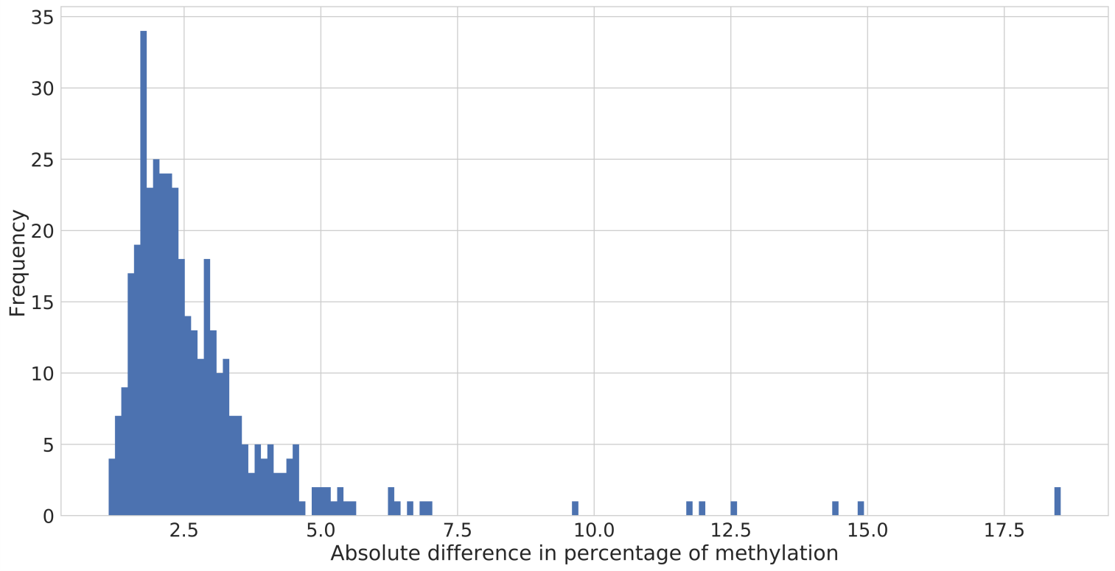

Figure B. Transgenerational study of cytosine (CpG) methylation levels by pyrosequencing. Values are means ± SDs. A: Khk; B: Grb10; C: Pld1; D: Acsl4. The underlined cytosines are those selected from NGS.
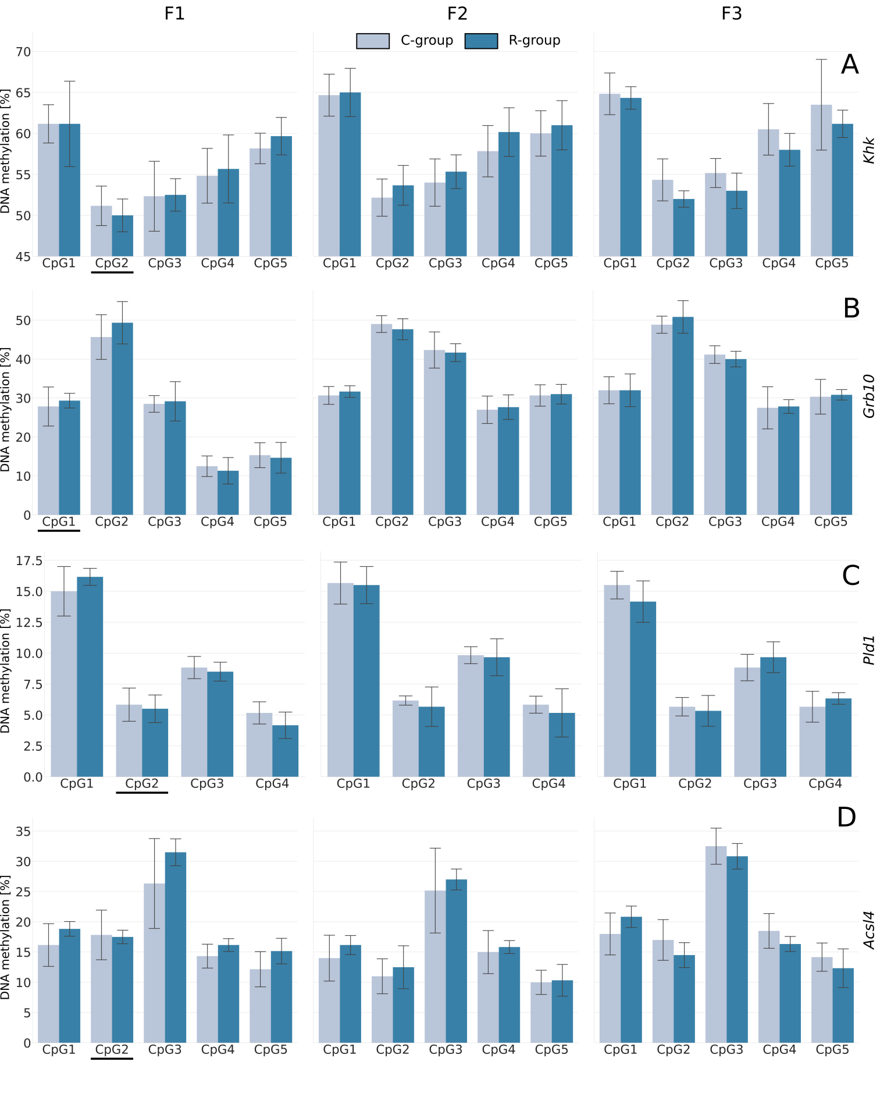

Figure C. The transgenerational analysis of methylation level across generation. The boxes indicate the lower and upper quartiles, with the median marked by the horizontal line. Whiskers indicate 1.5 of the interquartile range. Outlying observations are marked with diamonds. Ona-way ANOVA was applied to compare group means. A star and double star, indicate a significant difference of p < 0.05 and p < 0.001, respectively.
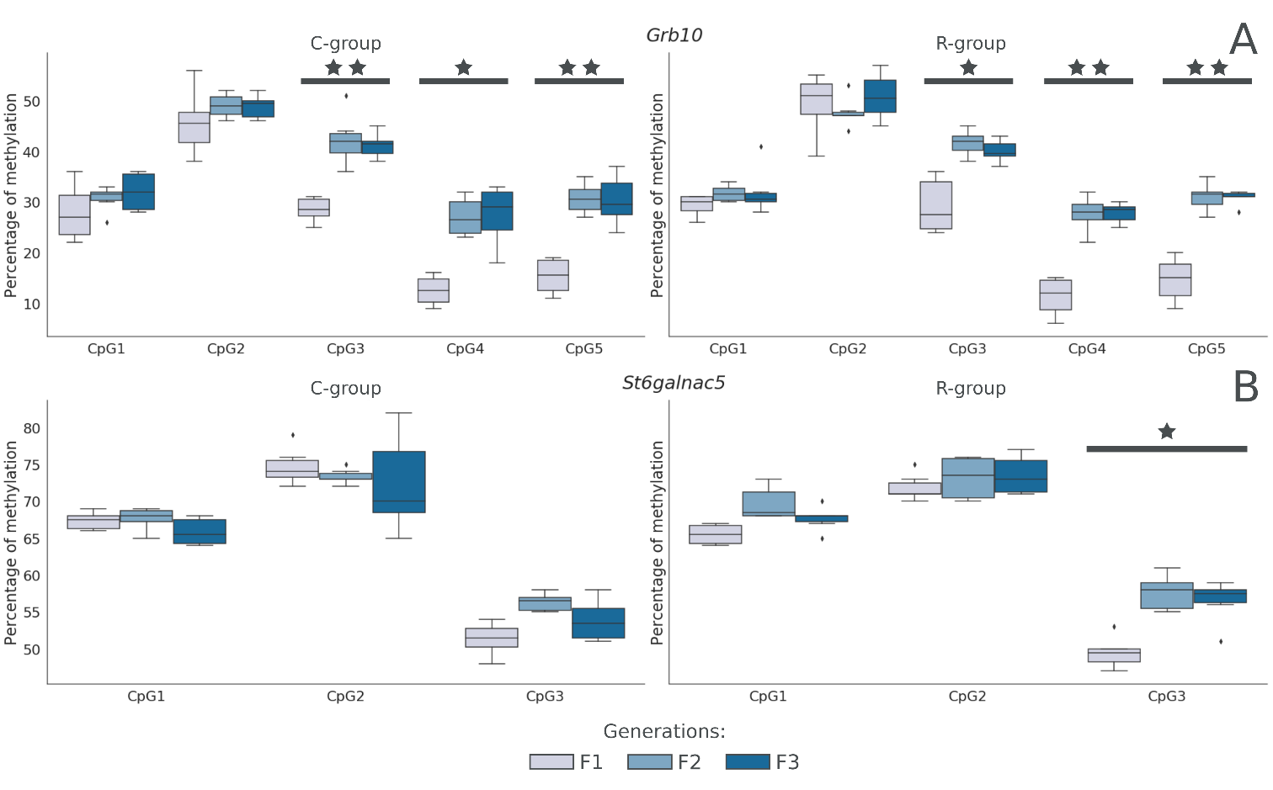

Figure D. The hepatic relative transcript level in three generations of rats. The results show the deltaCt value. The boxes indicate the lower and upper quartiles, with the median marked by the horizontal line. Whiskers indicate 1.5 of the interquartile range. Outlying observations are marked with diamonds. Ona-way ANOVA was applied to compare group means. A star indicates a significant difference (p = 0.0295 for Pld1 and p = 0.0253 for Oxct2b, respectively).
