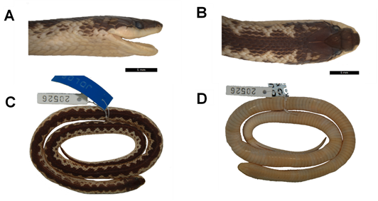
S2 Fig. Lateral (A) and dorsal (B) views of the head and dorsal (C) and ventral (D) views of the body of Xenopholis undulatus (MPEG 20526) from Santo Amaro Farm, Urbano Santos, state of Maranhão, Brazil.

