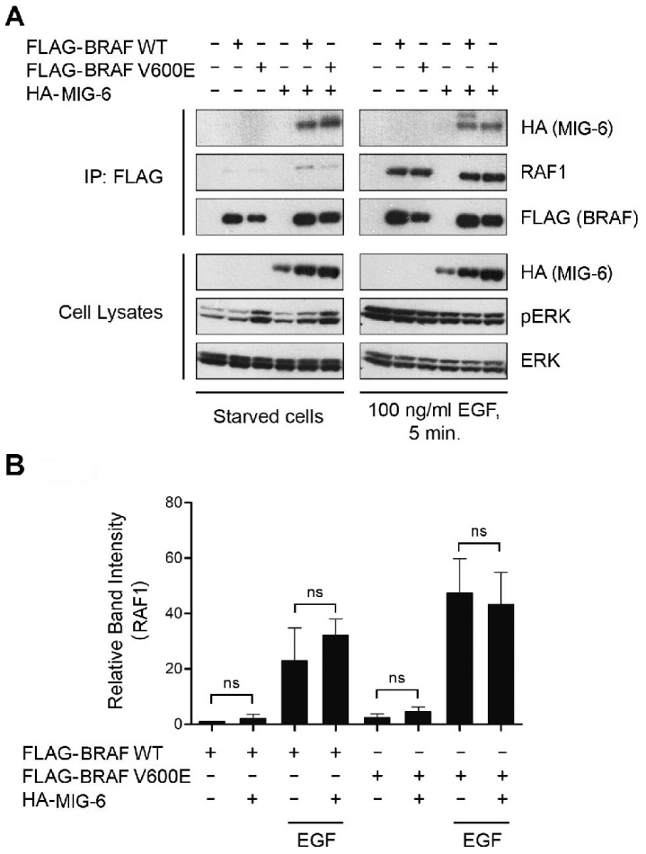

S4 File. MIG-6 does not Affect BRAF/RAF1 Heterodimerization. A. Cos-1 cells were transiently transfected with FLAG-tagged BRAF WT and V600E, respectively, either alone or in combination with plasmid DNA encoding HA-MIG-6. Serum starved cells were stimulated with 100ng/ml EGF for 5 minutes. Total cell extracts were subjected to anti-FLAG specific IP and analyzed by Western blotting. B. Densitometric quantification of immunoprecipitated RAF1 proteins normalized to the RAF1/FLAG-BRAF WT co-immunoprecipitation in starved cells. Graphs represent the mean of three independent experiments ± SD. Statistical significance was calculated using paired Student`s t-test. (ns, non-significant).

