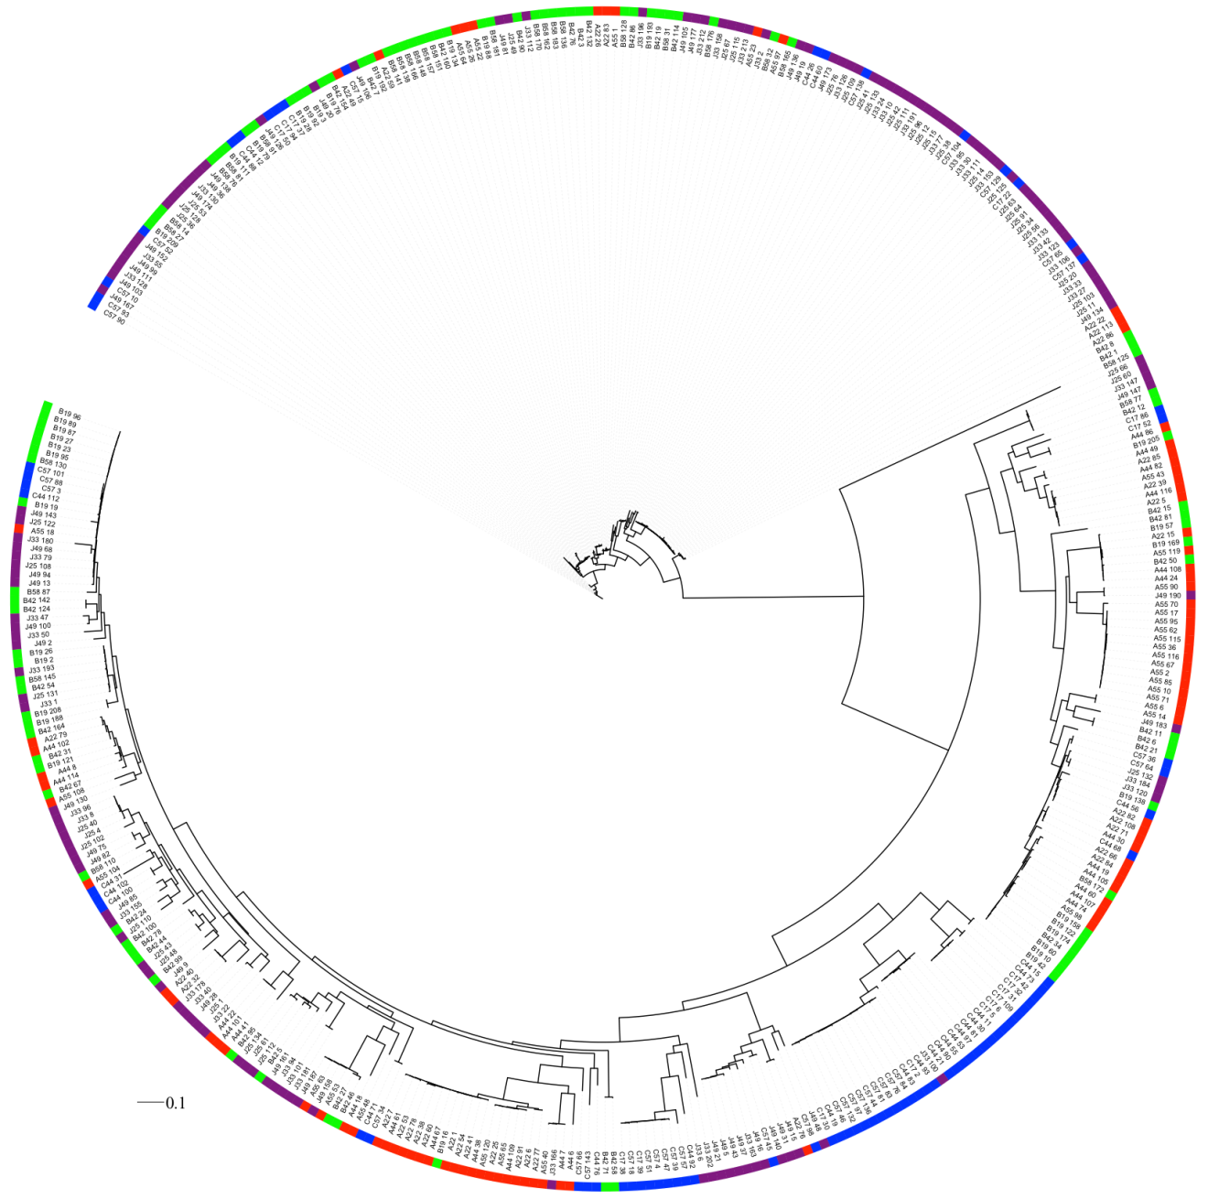

Figure S3 Maximum likelihood phylogenetic analysis of 400 nosZ gene sequences (708 bp) from soil communities colored by community and soil treatment: red, community A, fallow; green, community B, unfertilized; blue, community C, nitrate fertilized; and purple, community J, cattle manure fertilized.. The tree was displayed and colored by treatment using the iTOL web-based tool.

