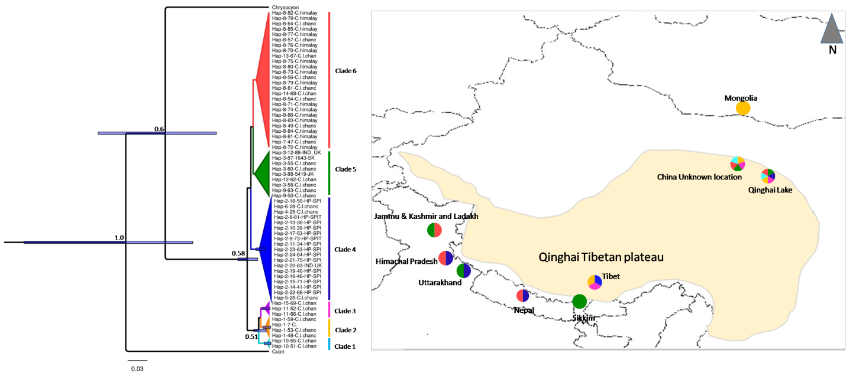

Figure S2. Phylogenetic analysis based on Bayesian inferences (BI) tree constructed of Canis lupus chanco using mitochondrial control region of Cuon alpines and Chrysocyon brachyurus as the out group. Map showing the clade wise distribution of samples in their distribution range. Values above the nodes are posterior probabilities

