S2 Fig. Climatic conditions October 2015 - October 2016.
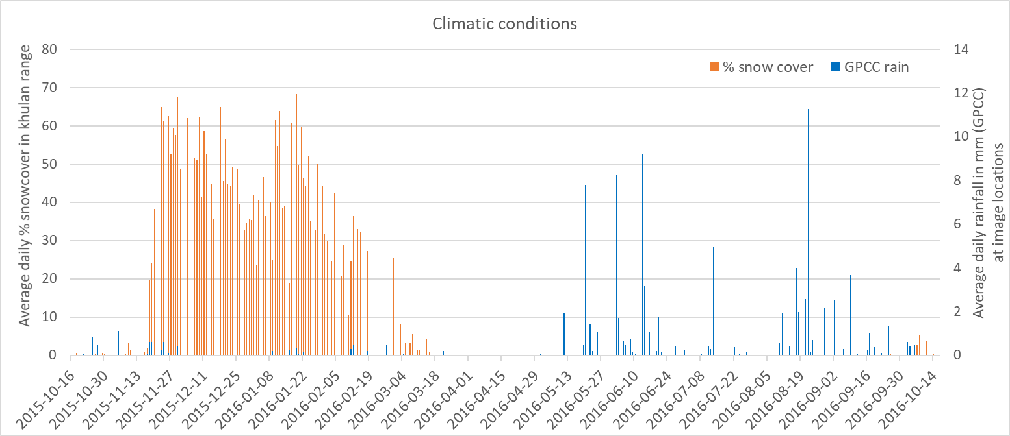
Gap in
snow data
S2 Figure. Daily snow cover based on the MODIS/Terra Snow Cover daily product (note gap in data from 19-28 Feb 2016) and precipitation (mm) based on the GPCC First Guess daily product for the monitoring period 16 Oct 2015 – 16 Oct 2016.

