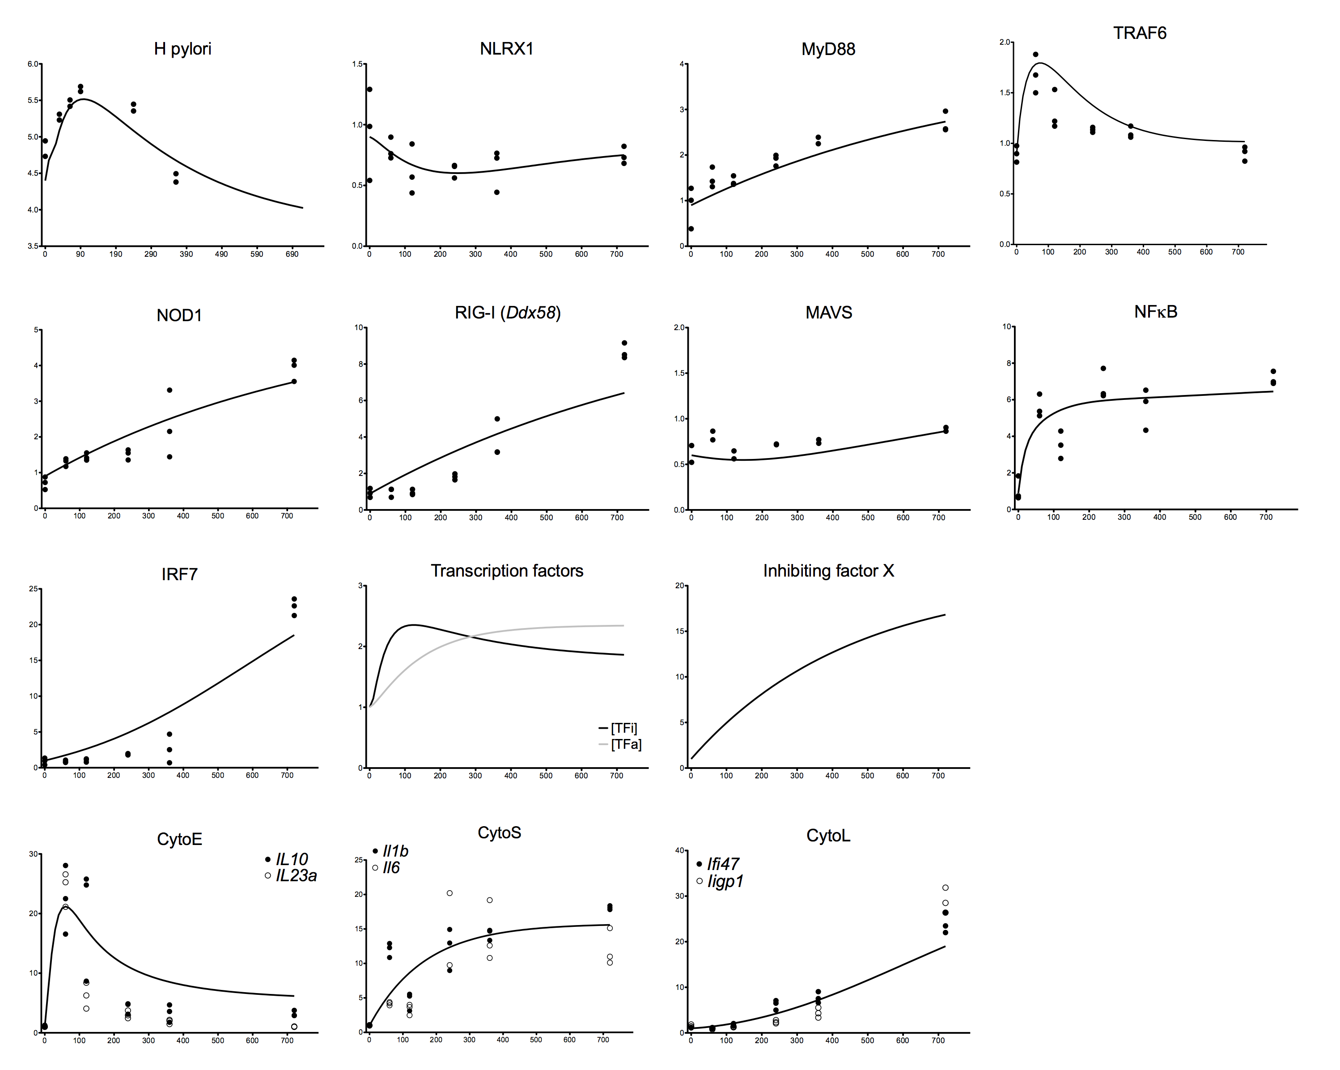
S2 Fig. Model fitting to experimental training dataset. Simulations for each model species (solid black line) compared to respective training data (dots). All training data, except for Helicoabcter pylori, was extracted from our time course RNAseq dataset for wild type bone marrow derived macrophages co-cultured with H. pylori. Training data for H. pylori represent two separate projects and each dot represents the average of three replicates. A Genetic Algorithm in COPASI was used to fit data and calculate parameter values.

