S2 Fig Cost-effectiveness acceptability curve showing the probability that COTiD-UK vs TAU is cost-effective at different values of the maximum willingness to pay for a QALY.
QALY=quality adjusted life year. The probability TUA is cost-effective is one minus the probability COTiD-UK is cost-effective at each value of the maximum willingness to pay for a QALY.
- NHS costs person with dementia only, EQ-5D-5L
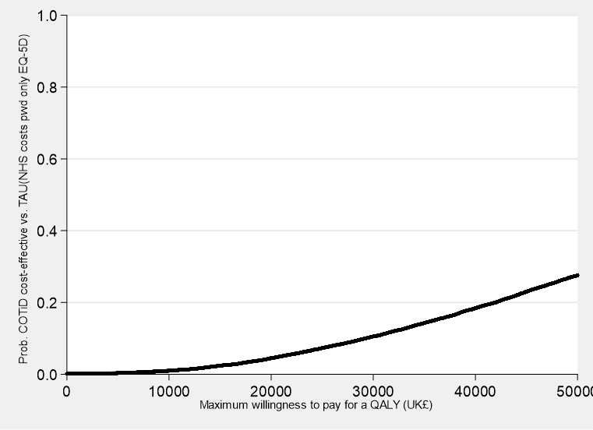
- NHS costs person with dementia only, DEMQOL- Proxy

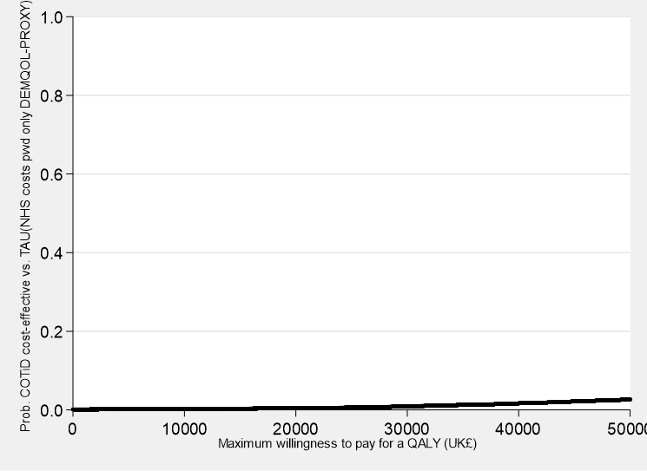
c) Societal costs person with dementia only, EQ-5D-5L
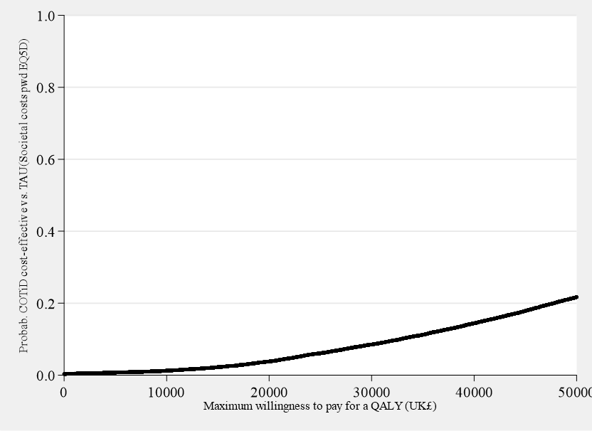
d) Societal costs person with dementia only, DEMQOL

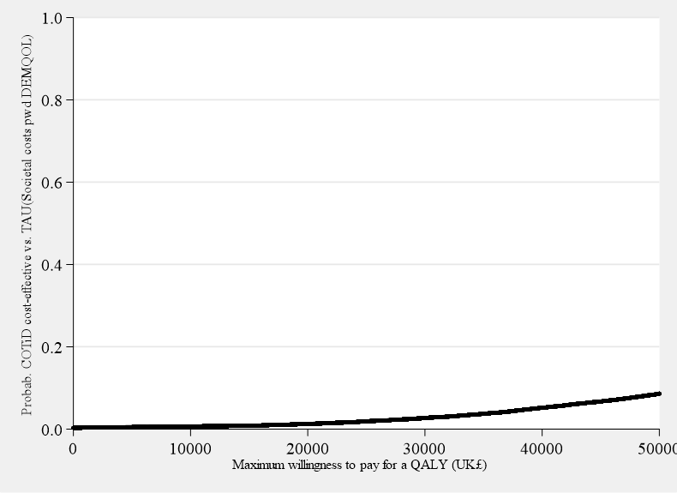
e) Societal costs person with dementia only, DEMQOL-Proxy
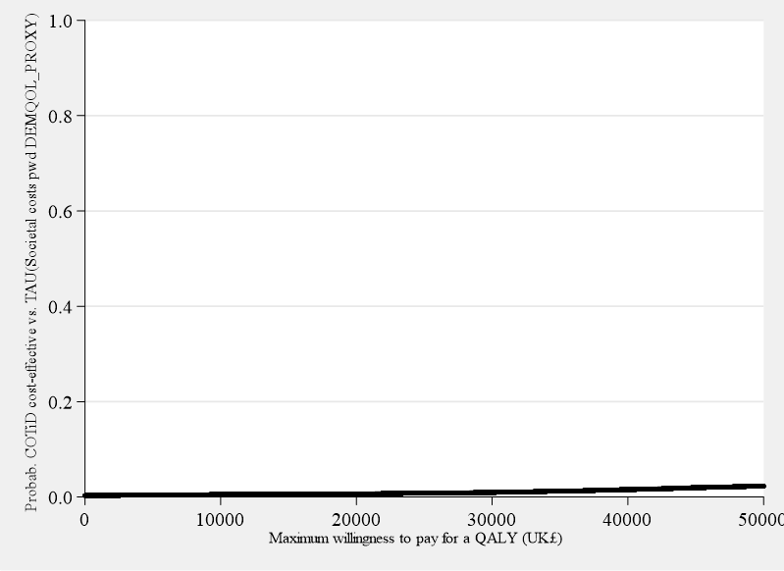

f) NHS costs both, EQ-5D-5L

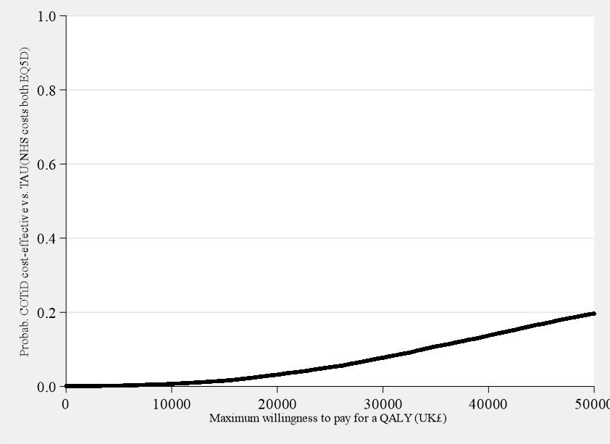
g) NHS costs both, DEMQOL
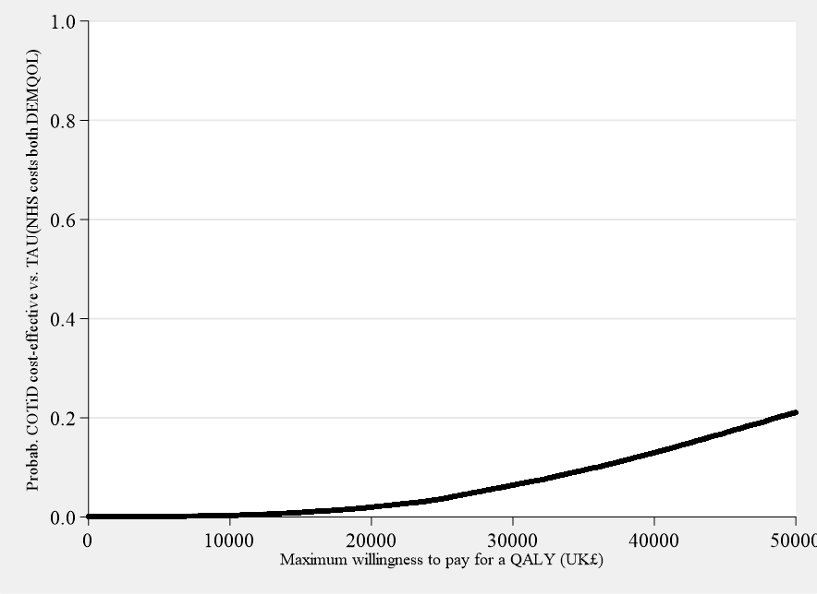
h) NHS costs both, DEMQOL-Proxy
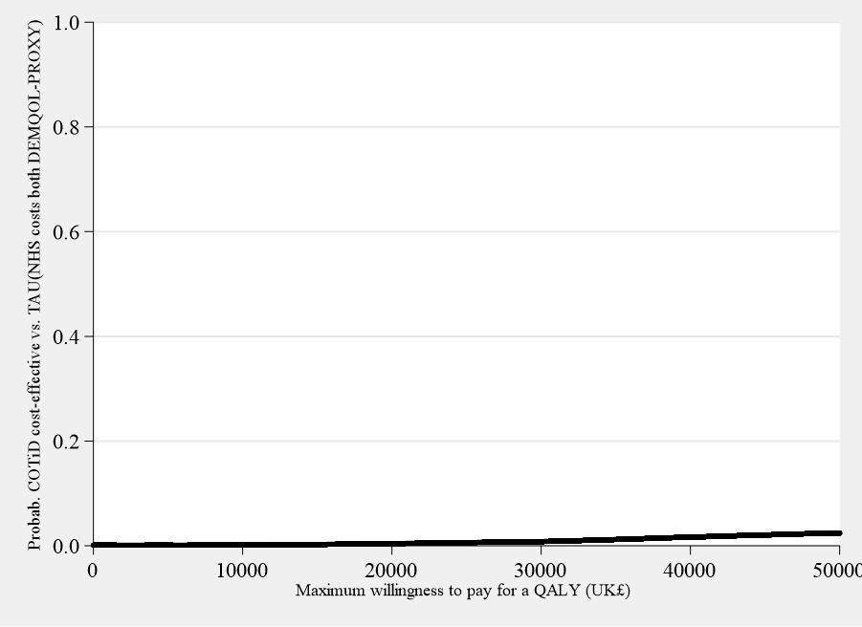

i) Societal costs both, EQ-5D-5L
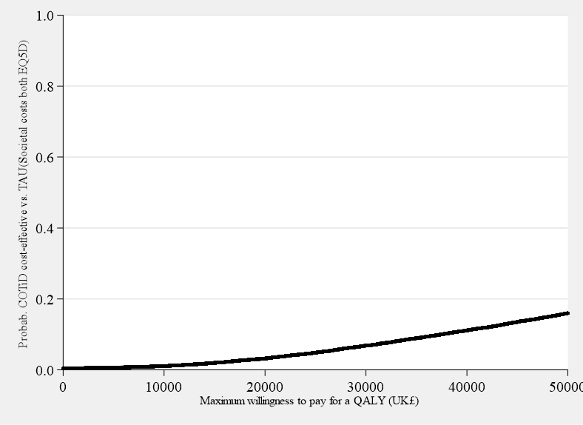

j) Societal costs both, DEMQOL
