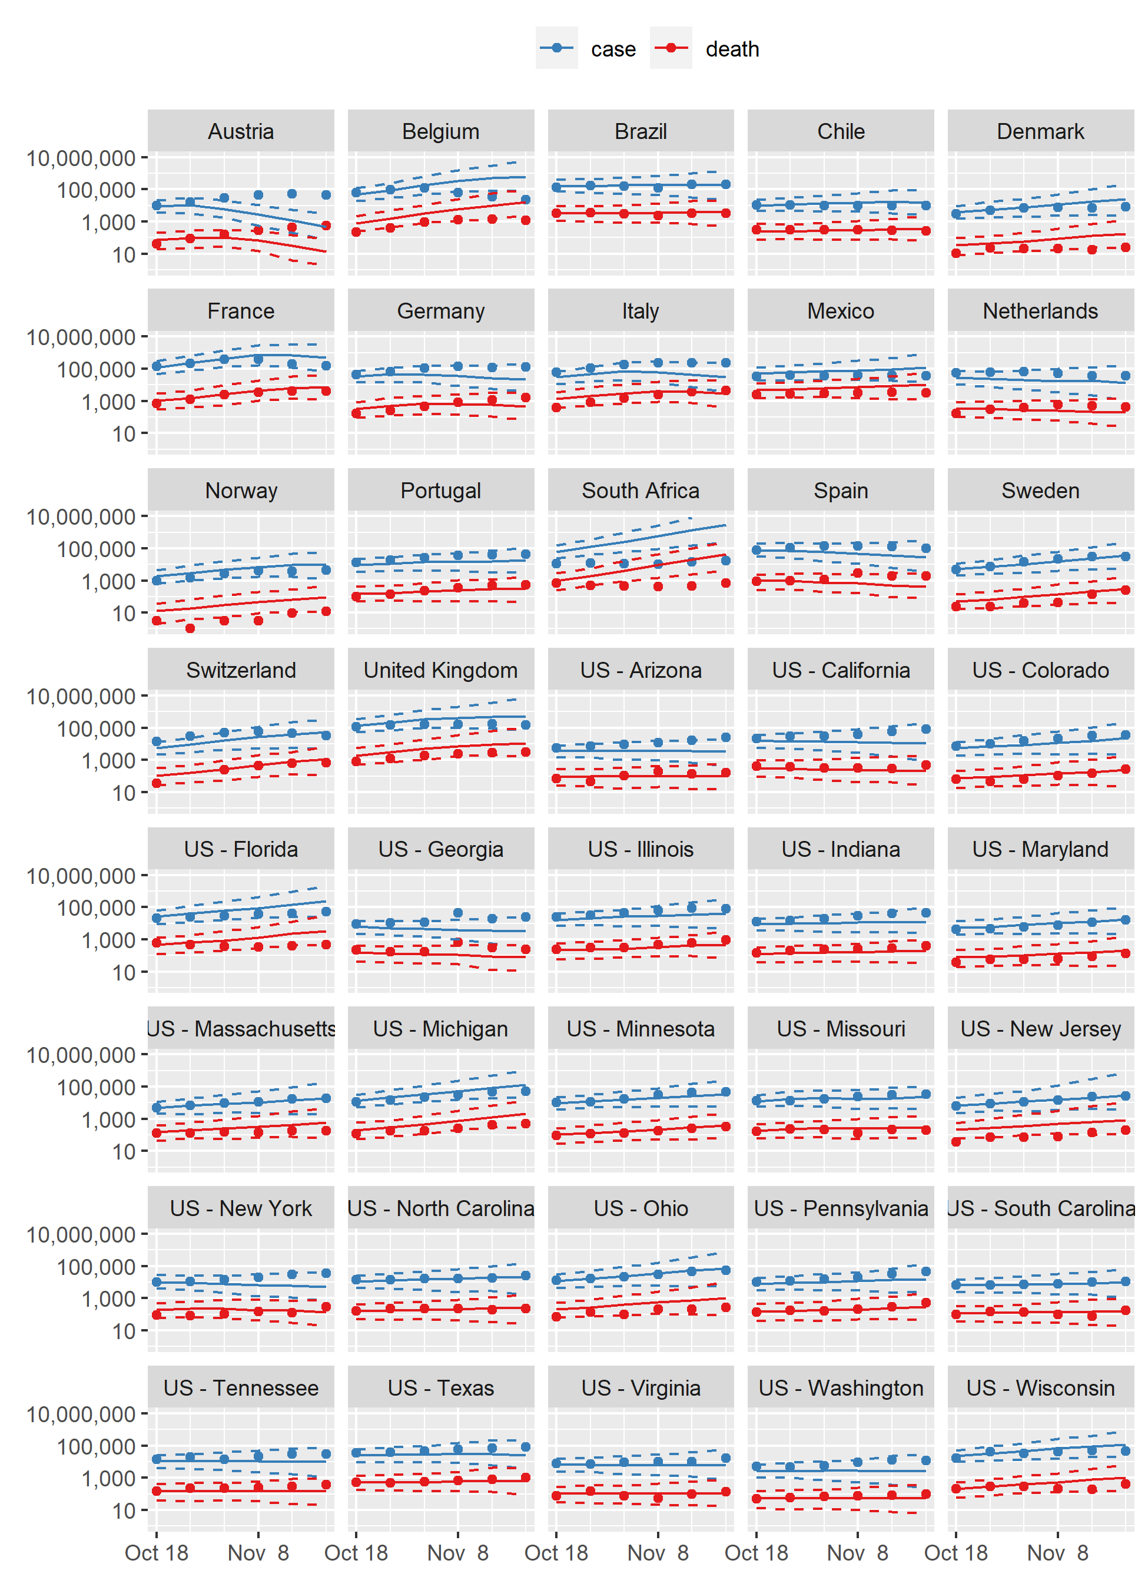
Figure S4. Out of sample estimates of newly identified COVID cases and deaths (log scale), with reported numbers. Dots = reported; Solid lines = model prediction; Dashed lines = 95% intervals

