Dissecting out the complex Ca²⁺-mediated phenylephrine-induced contractions of mouse aortic segments
Paul Fransen¹, Cor E. Van Hove², Arthur J.A. Leloup¹, Wim Martinet¹, Guido R.Y. De Meyer¹, Katrien Lemmens², Hidde Bult², Dorien M. Schrijvers¹
¹ Department of Pharmaceutical Sciences, University of Antwerp, Antwerp, Belgium
² Department of Medicine and Health Sciences, University of Antwerp, Antwerp, Belgium

Running head:

Corresponding author: Paul Fransen, paul.fransen@uantwerpen.be, Laboratory of Physiopharmacology, Department Pharmaceutical Sciences, Campus Drie Eiken, Universiteitsplein 1, 2610 Antwerp

Supplementary information
Effects of 2-APB on phasic and tonic contractions by PE in mouse aortic segments.
The putative non-selective cation channel blocker, 2-APB, was used in the present study at concentrations of 50 or 100 µM in order to block non-selective cation channels (NSCC, store-operated calcium influx). 2-APB, however, also inhibited the PE-induced phasic contraction by blocking the IP₃ receptor (figure S1 A) and subsequent Ca²⁺ influx (figure S1 B). This occurred with similar IC50-values indicating both processes are linked (figure S1 C, D). Therefore, and to study its effect on NSCC, 2-APB was always applied after eliciting the IP₃-mediated contraction by PE or after inhibition of L-type Ca²⁺ channels with diltiazem or verapamil to avoid non-specific effects on L-type Ca²⁺ channels.
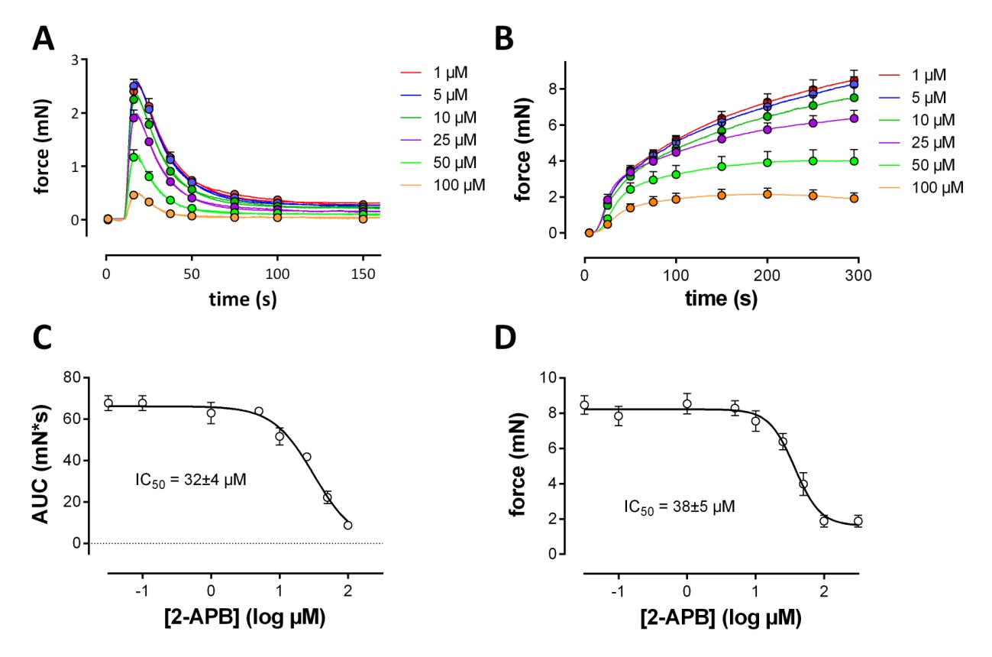
S1. Fig 1. Inhibition of PE(1 µM)-mediated phasic (A) and tonic (B) contractions by 2-APB. A. Phasic contractions by 1 µM PE were measured 3 minutes after applying 0Ca. The concentration-response (area under the curve, AUC) curve in C revealed an IC₅₀ of 34±4 µM 2-APB. B. Tonic contractions by 1 µM PE upon re-addition of 3.5 µm Ca²⁺ to the 0Ca solution containing 1 µM PE. The concentration-response (isometric force) curve in D revealed an IC₅₀ of 38±5 µM and was not significantly different from the IC₅₀ for inhibition of the tonic contraction. (n=5)
Figure Legends
S1 Fig 1. Inhibition of PE(1 µM)-mediated phasic (A) and tonic (B) contractions by 2-APB. A. Phasic contractions by 1 µM PE were measured 3 minutes after applying 0Ca. The concentration-response (area under the curve, AUC) curve in C revealed an IC₅₀ of 34±4 µM 2-APB. B. Tonic contractions by 1 µM PE upon re-addition of 3.5 µm Ca²⁺ to the 0Ca solution containing 1 µM PE. The concentration-response (isometric force) curve in D revealed an IC₅₀ of 38±5 µM and was not significantly different from the IC₅₀ for inhibition of the tonic contraction. (n=5)

