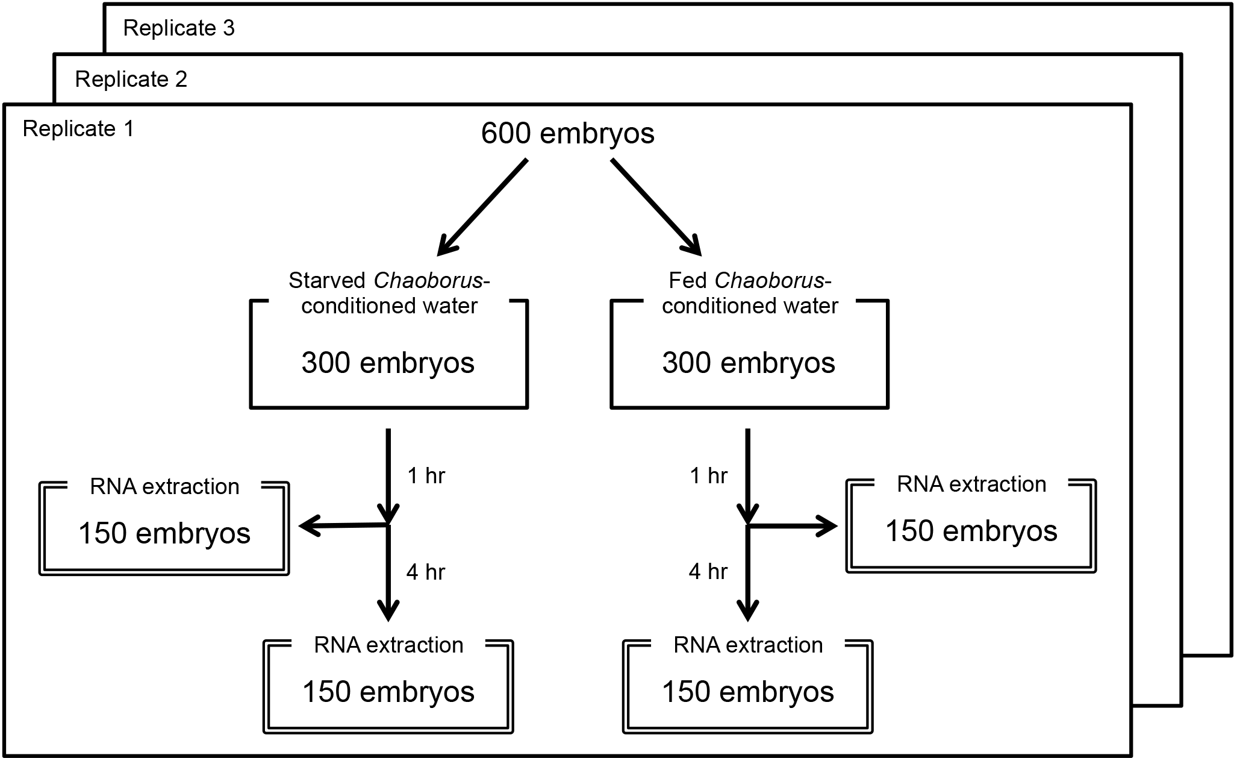

S1_Fig. Schematic view of how Daphnia RNA was prepared for microarray analysis.

