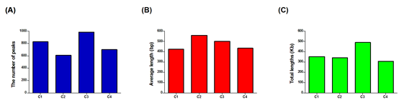
Figure S4. H3K27me3 Peaks information.
(A) to (C) Peaks Numbers, average lengths, and total lengths of epigenetically modified regions detected by MACS1.4.0 software, respectively.

