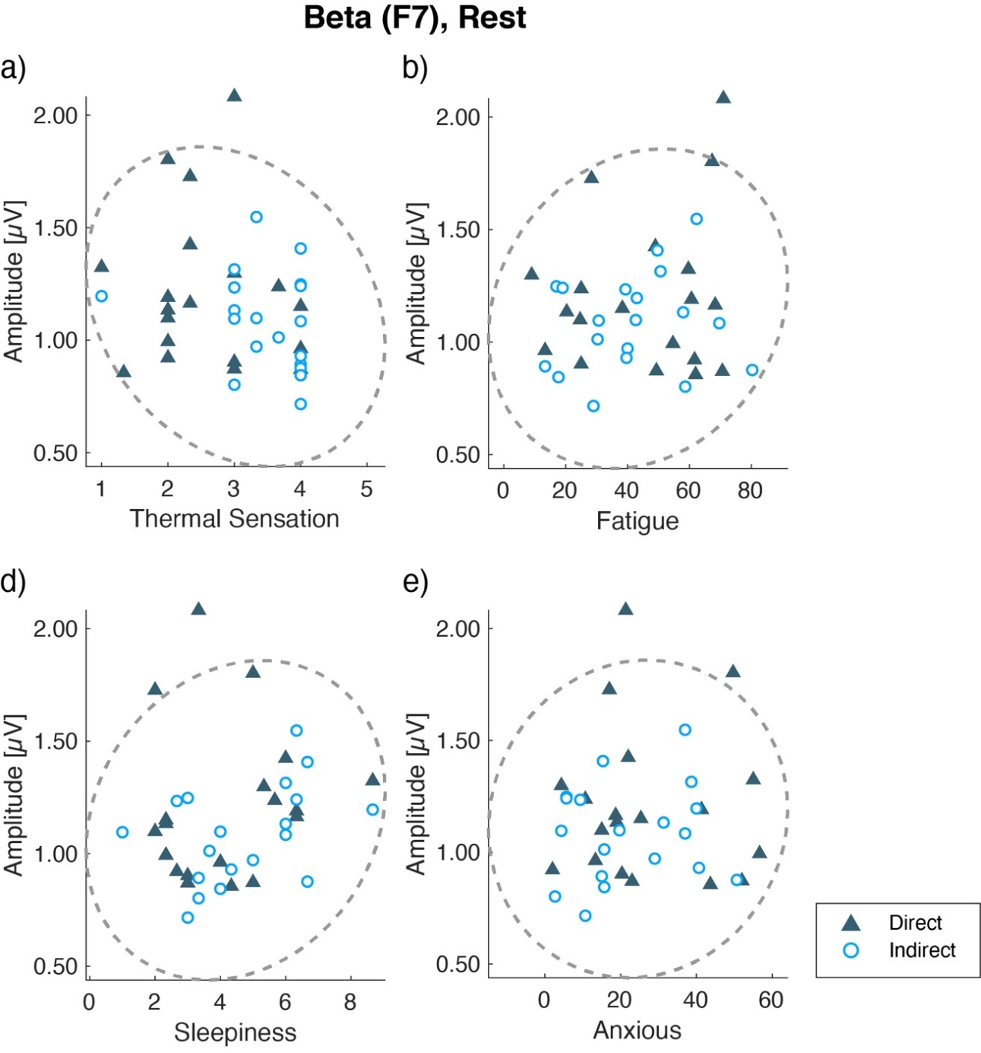
Supplementary Figure 5. Scatter plots of each subjective assessment and beta amplitudes at F7 during Rest. Gray lines show the 95% density eclipse. Each point indicates individual mean data across three repetitions. There was no significant correlation (P > 0.05).

