Table S4 – Discriminant Functions: Eigenvalues and Wilk’s Lambda statistics.
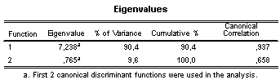
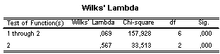
NOTE: Eigenvalues show that the biggest proportion (90.4%) of variances (in terms of differences between groups) can be explained by first discriminant function (in this case CCH-induced I_{sc} (following IBMX/Fsk application). Wilks’ Lambda (Λ) test of functions shows that both discriminant functions are significant in determining these differences between groups.

