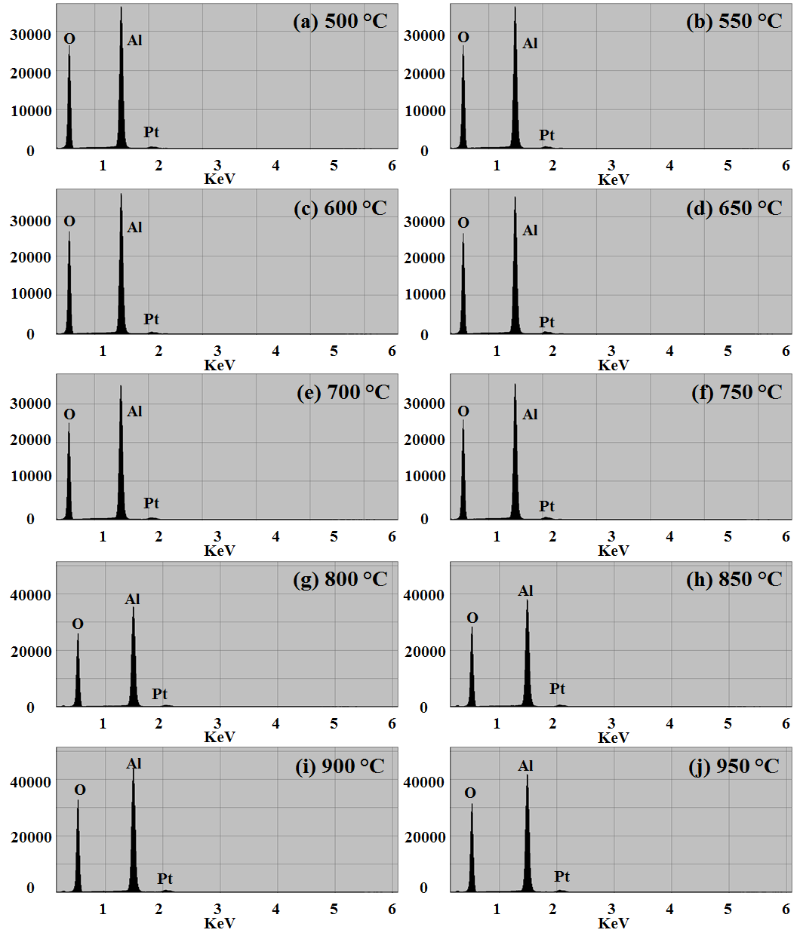
S4 Fig. (a) - (j) Energy-dispersive x-ray spectroscopy (EDS) spectra of samples fabricated at various annealing temperatures between 500 and 950 °C with the 10 nm Pt thickness (surface morphologies shown in Fig. S3). The peaks appeared at 2.051 keV are Pt Mα1.

