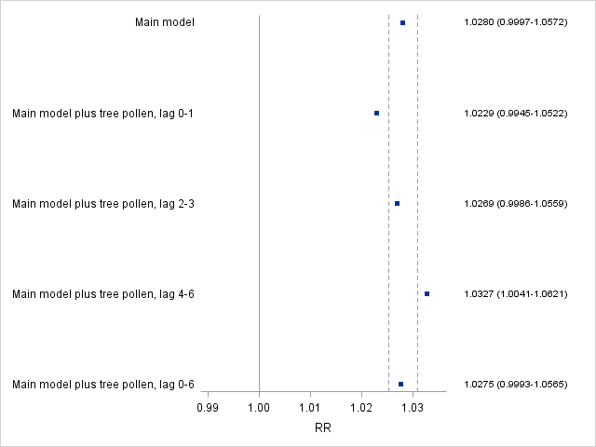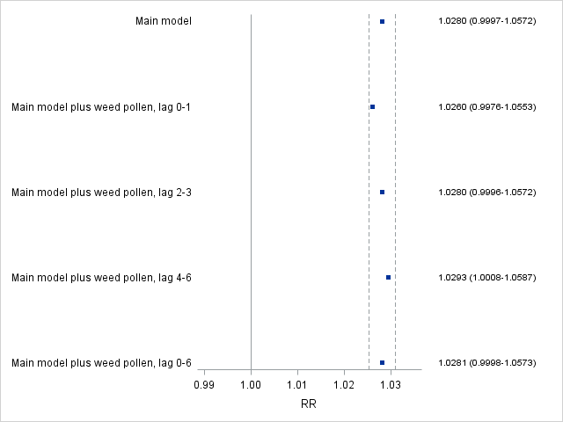
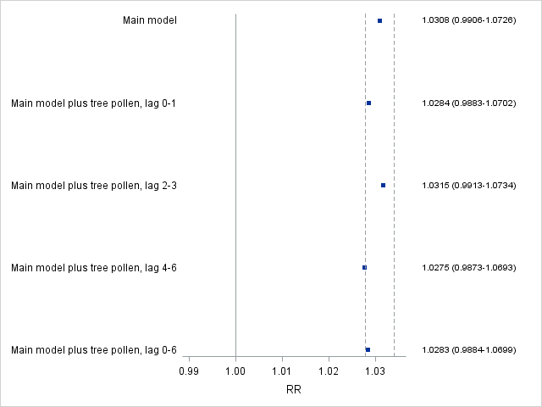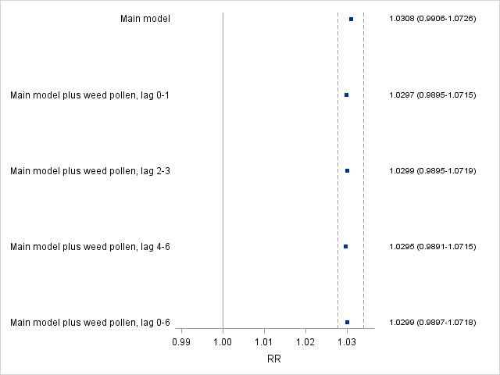
S4 Fig. Confounding Effects of Outdoor Tree Pollen (left) and Weed Pollen (right) on the Associations Between Asthma Hospital Admissions in School-age Children and Ozone (top) and PM_{2.5} (bottom). Squares are point estimates for relative risks of asthma hospital admissions associated with increases in air pollutants. The dashed lines represent ±10% changes in the point estimates from the main model.

