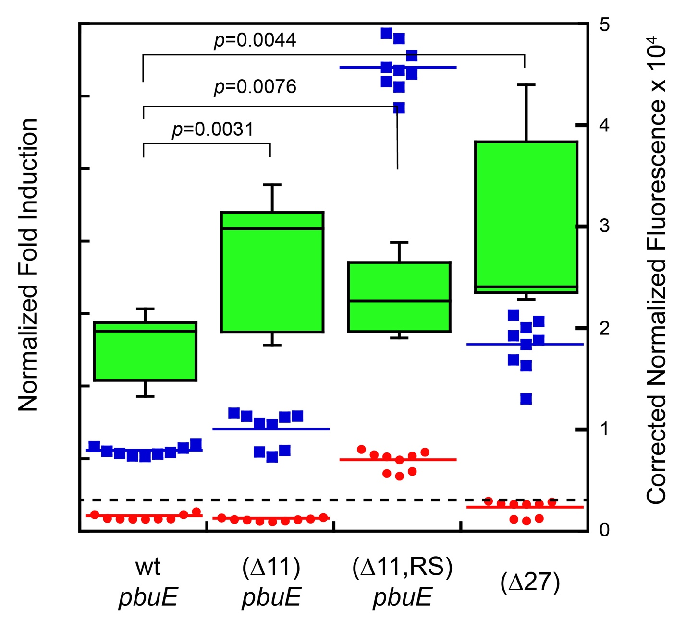

S2 Figure. Engineering of the pre-aptamer sequence of pbuE. Direct comparison of wild type (wt) pbuE, pbuE with first 11 nucleotides removed from the pre- aptamer sequence (∆11), and pbuE with 11 nucleotides removed and additional AatII and SpeI restriction sites added (∆11,RS) and pbuE with the first 27 nucleotides removed (∆27). Each control was assayed in the absence (red) and presence (blue) of 2AP with the fold induction reported in a standard boxplot format in green. Red and blue bars represent the median value and the dashed line represents a fold induction value of 1 (no induction of reporter expression in the presence of 2AP).

