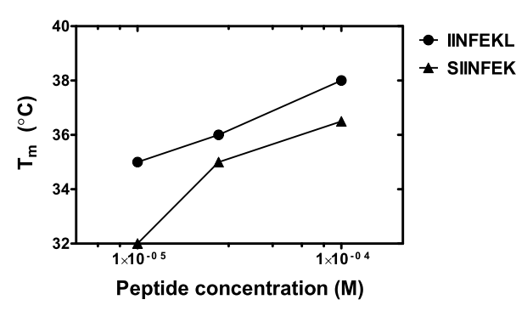
S4 Fig. Thermal denaturation of low-affinity peptide complexes is dependent of the concentration of free peptide. TDTF experiments were performed with the H-2K^{b}-hβ2m-peptide complex in the presence of different peptide concentration. The T_{m} values of low-affinity peptide complexes increase with the free peptide concentration, but the relative difference in the T_{m} values between the C-terminal and N-terminal truncation remains.

