GUINEA BISSAU

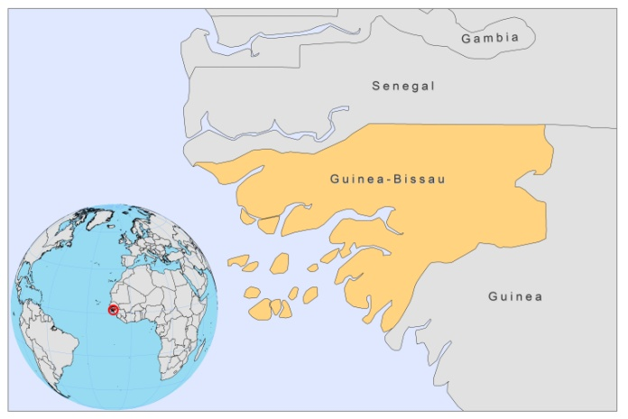

BASIC COUNTRY DATA

Total Population: 1,515,224
Population 0-14 years: 41%
Rural population: 70%
Population living under USD 1.25 a day: no data
Population living under the national poverty line: no data
Income status: Low income economy
Ranking: Low human development (ranking 176)
Per capita total expenditure on health at average exchange rate (US dollar): 18
Life expectancy at birth (years): 47
Healthy life expectancy at birth (years): 41

BACKGROUND INFORMATION

Up to date, no cases of leishmaniasis have been reported in Guinea Bissau. In 1990, a case of atypical visceral leishmaniasis, associated with an HIV infection, was reported in a 10 year old girl [1]. As leishmaniasis species had not been previously described in the country, it was ascribed to infection with a reptilian trypanosomatid.

CL has not been documented, but as Guinea Bissau is part of a proposed CL endemicity belt, running across West Africa, cases may occur regularly and remain unreported [2] .

PARASITOLOGICAL INFORMATION

Leishmania  species | Clinical form | Vector species | Reservoirs
L. major | CL | P. duboscqi | Unknown

MAPS AND TRENDS, CONTROL, DIAGNOSIS, TREATMENT, ACCESS TO CARE, ACCESS TO DRUGS

No data available.
No antimonials are registered.

SOURCES OF INFORMATION

1. Sabbatani S, Isuierdo Calzado A, Ferro A, Lopez Goudiaby AM, Borghi V et al (1991). Atypical leishmaniasis in an HIV-2-seropositive patient from Guinea-Bissau. AIDS 5(7):899-901.
2. Boakye DA, Wilson MD, Kweku M (2005). A review of leishmaniasis in West Africa. Ghana Medical J 39 (3):94-7.

