S2 Fig. Mean change of EQ-5D from baseline: TF TAVI versus SAVR (operable at a high risk)
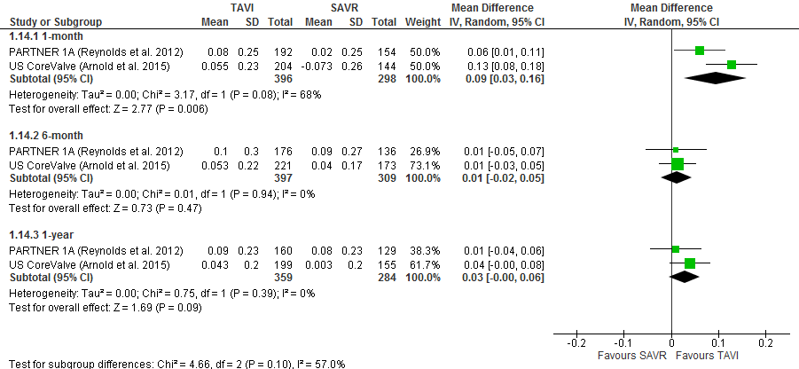
Legend: Standard deviations were calculated for the meta-analysis by the authors of the current review. EQ-5D, EuroQol five dimensions questionnaire. TF, transfemoral.

