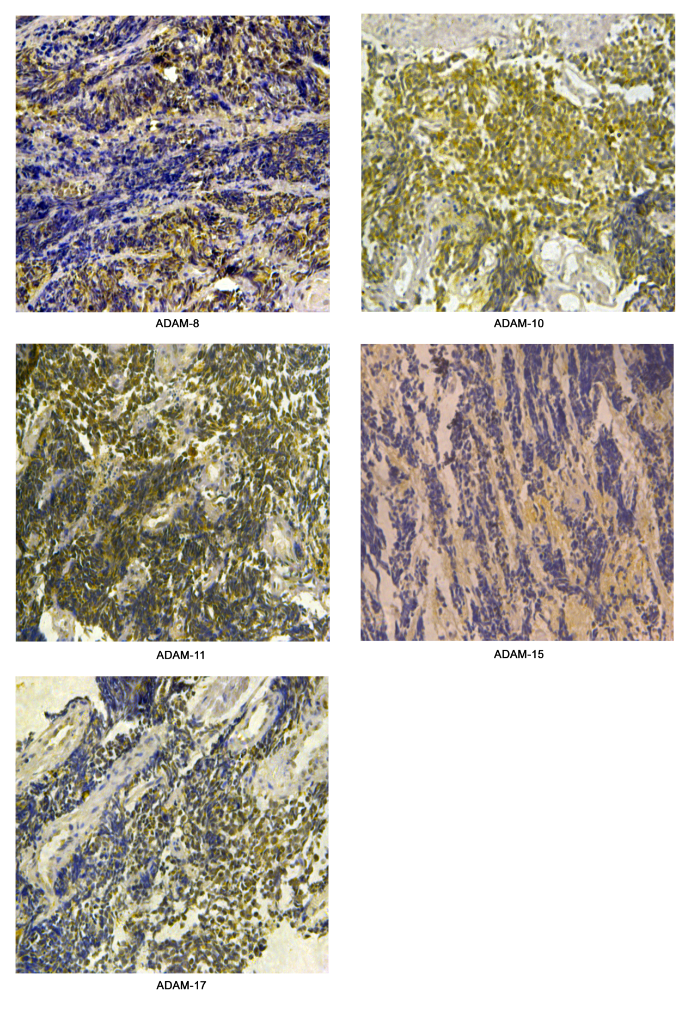 Figure S1. The expression of other ADAMs in SCLC by IHC.

