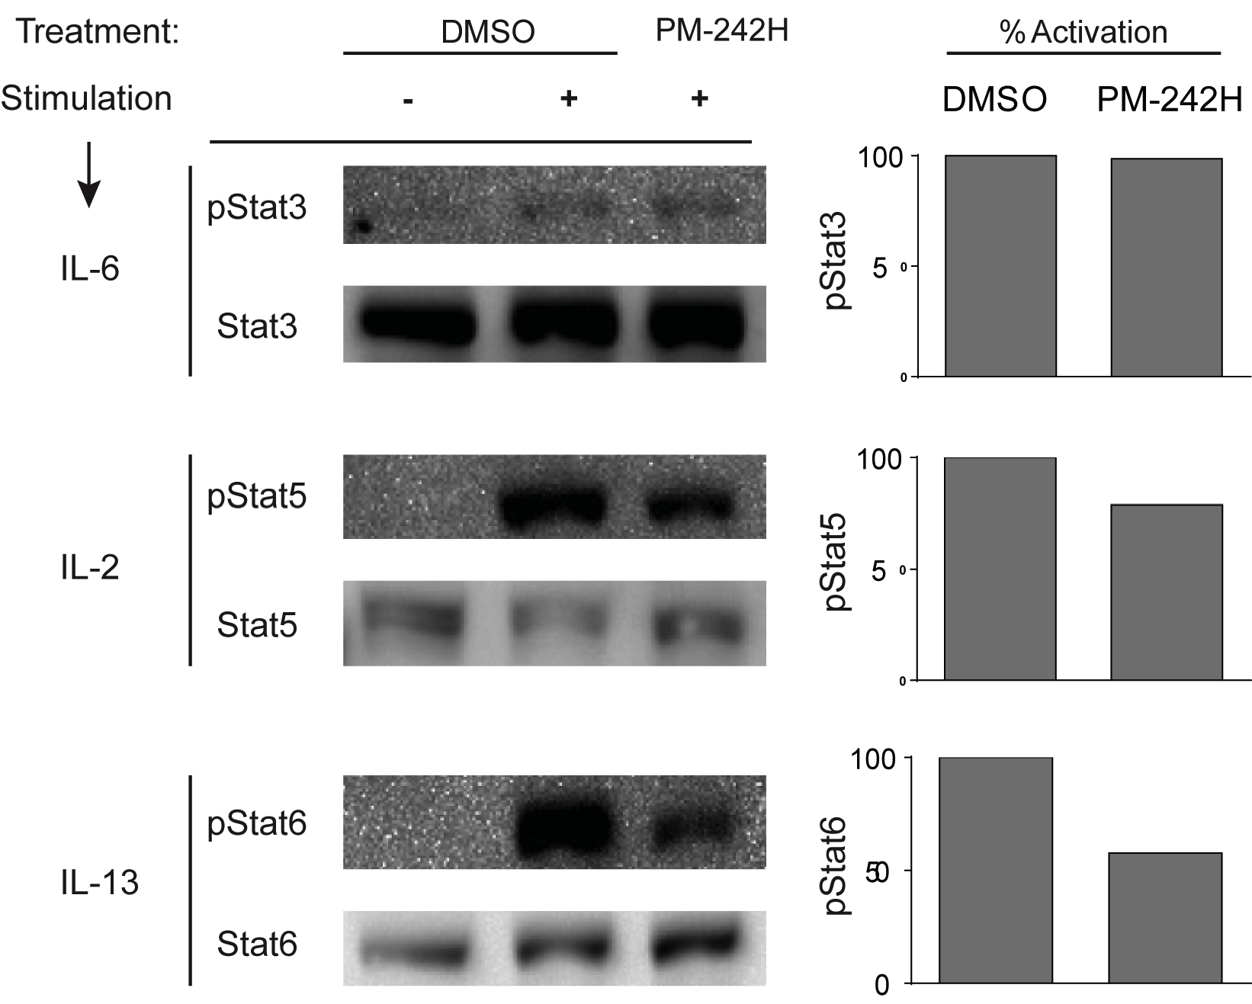
Figure S8. PM-242H cross-reactivity with STAT transcription factor family members. Murine splenocytes were incubated with vehicle (DMSO) or 242H for 2 hours and stimulated with IL-6, IL-2, or IL-13 for 30 min after which phosphorylation of STAT3, STAT5 and STAT6 was assessed. Data are from one of 3 independent and comparable biological experiments.

