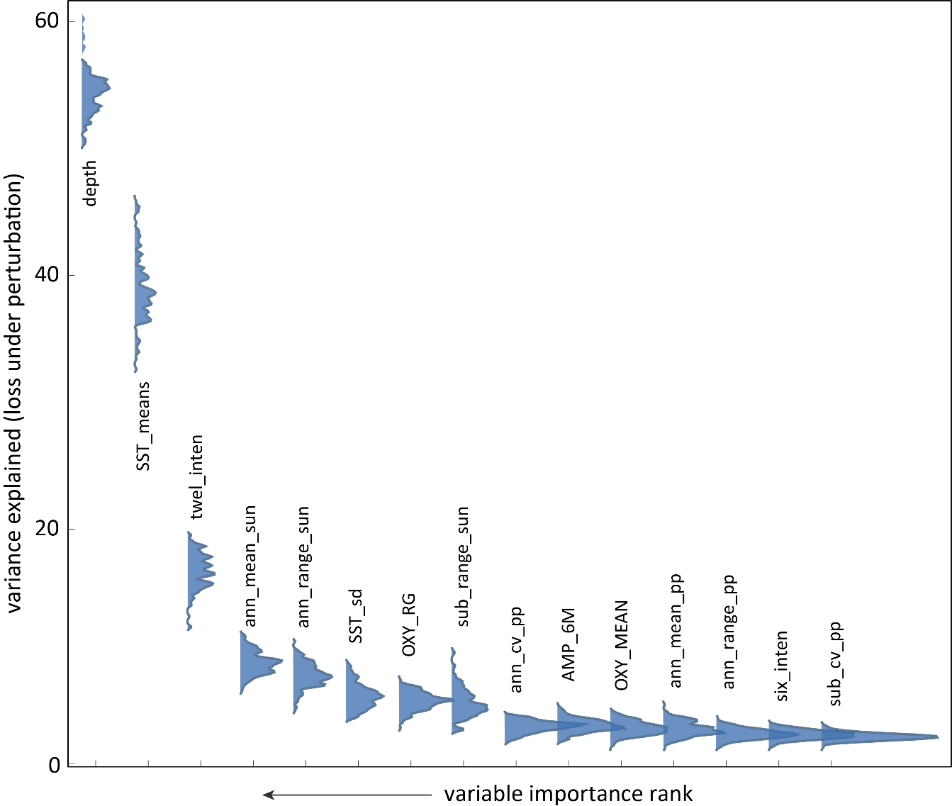

Figure S15. Variable importance in marine domain without invertebrate taxa. The top four most important variables remain the same as the model of the species richness data containing invertebrate taxa.

