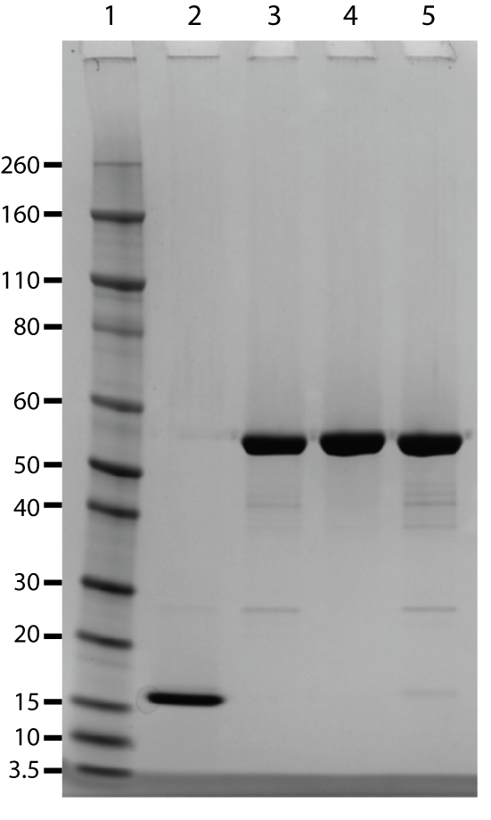

Figure S2: SDS-PAGE of MCL1 constructs used in crystallographic studies. Samples were reduced and loaded at 6µg; lane 2: MCL1 173-321, lane 3: MBP-MCL1 lane 4: MBP-MCL1-GSGGGG, lane 5: MBP-MCL1-WT.

