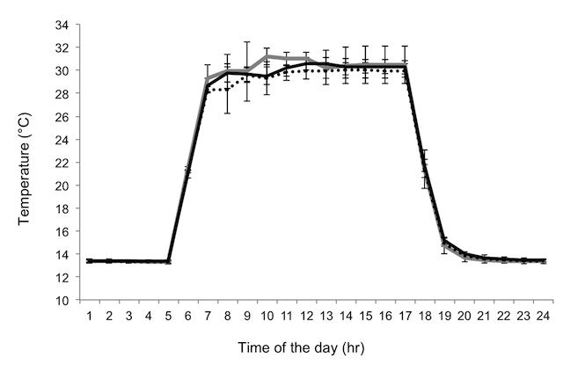
Figure S2. Temperature profile within the experimental units. Mean temperature profile recorded inside the experimental unit over 24 hrs. The presence (i.e. F open, black dotted line; F masked, black solid line) or absence of an adult plant within the box (i.e. Control masked; grey solid line) had no effect on the temperature profiles seeds would experience within the box (Repeated-measure ANOVA, F_{46, 115} = 1.10, P = 0.33). Error bars indicate 95% CI (n = 5 per treatment). Temperature data were collected using an U12-011 - HOBO® Temperature/RH Data Logger.

