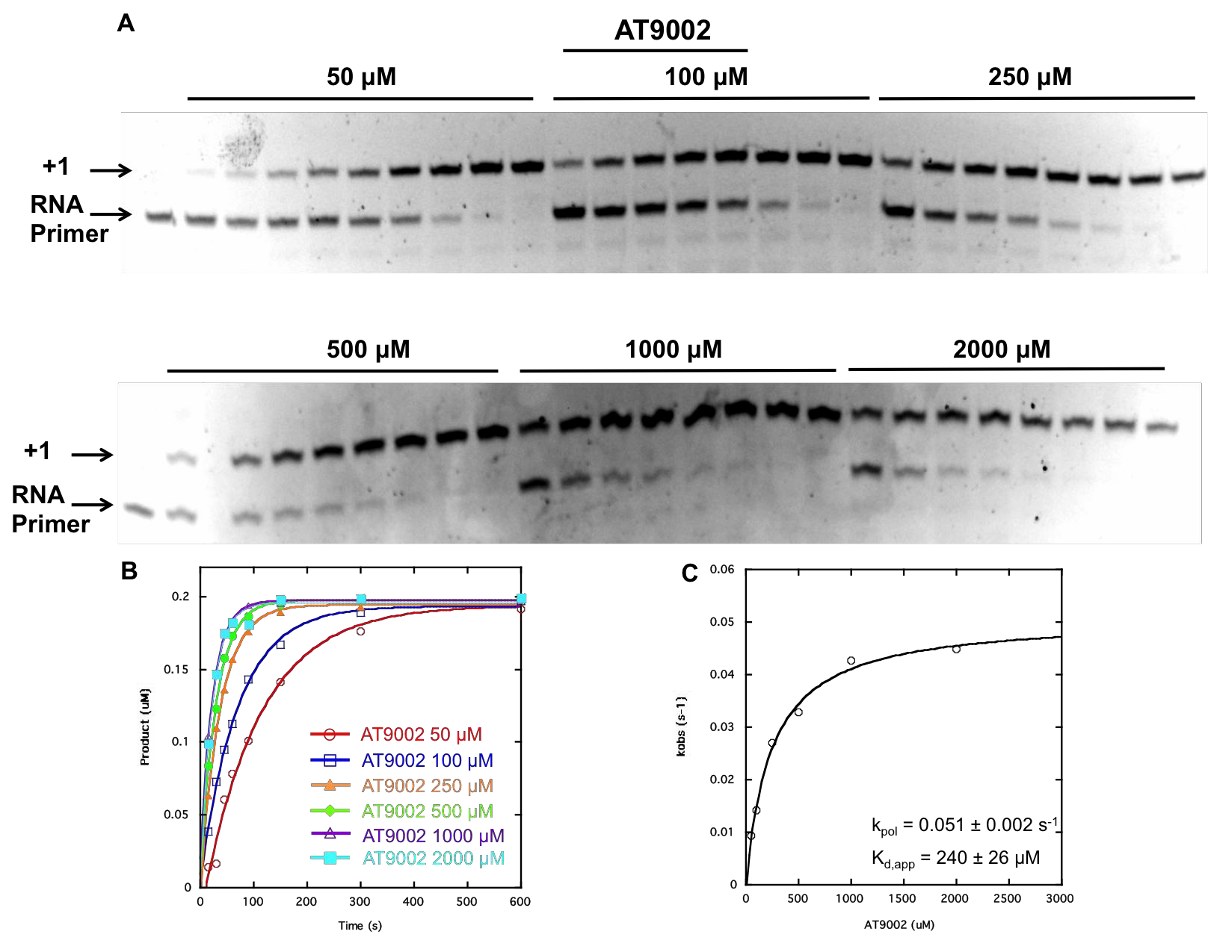
S3 Fig. BMS-986094 TP (AT9002) incorporation catalyzed by POLRMT. (A) POLRMT (0.5 µM) was incubated with fluorescein-labeled-RNA/DNA scaffold (0.2 µM) for 1 min and then rapidly mixed with BMS-986094 TP (50-2000 µM). Reactions were quenched at various times with EDTA (50 µM). (B) Quantitated RNA product was plotted as a function of time and fit to a single exponential equation. (C) Values for k_{obs} were plotted as a function of BMS-986094 TP concentration and fit to as hyperbola, yielding a k_{pol} value of 0.051 ± 0.002 s⁻¹ and a K_{d,app} value of 240 ± 26 µM).

