S1 Fig. Cumulative Incidence Curves of Length of Stay to Discharge by Infection Type

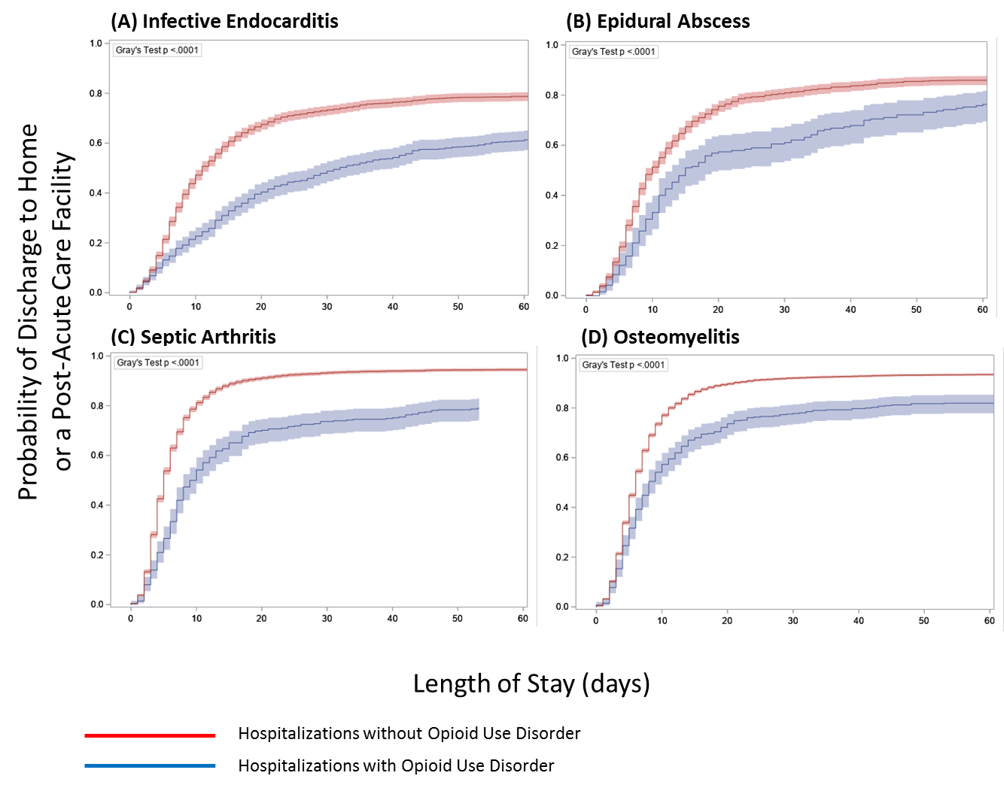

Cumulative incidence curves of length of stay to discharge estimated using a competing risks survival analysis model. The event of interest was defined as discharge to home or a post-acute care facility. Competing risks were defined as discharge against medical advice, transfer to another acute care hospital, or in-hospital death. Gray’s test was used to assess for statistically significant differences in cumulative incidence between the 2 cohorts. Shaded regions indicate 95% confidence bounds.

