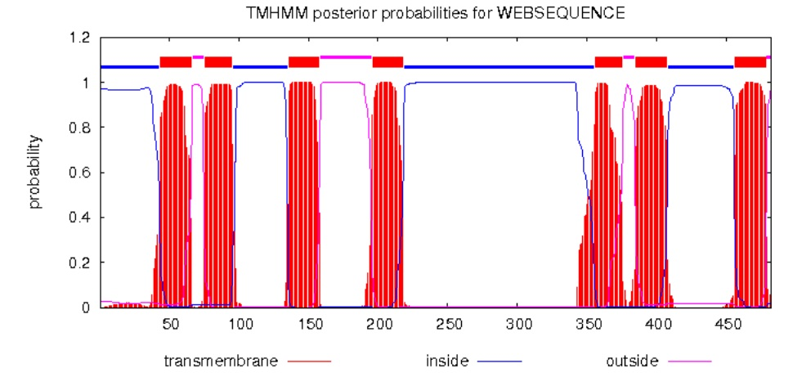
S1 Fig. Predicted transmembrane domain of RferOrco by TMHMM server v.2.0 (http://www.cbs.dtu.dk/services/TMHMM/)

