S1 Fig. Study participants

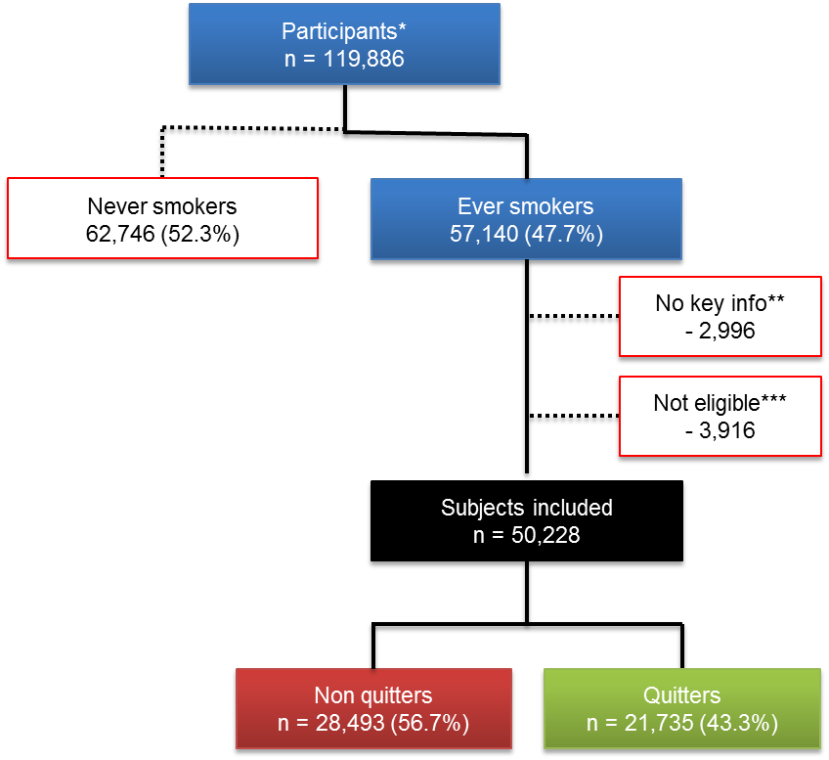

* subjects with complete information on sex, year of birth, and smoking status
** subjects with missing data on age at smoking initiation and/or age at cessation if ex-smoker
*** subjects who quit smoking before the age of 16 (n=117) or before 1980 (n=3,777); subjects who started smoking at age ≥60 years (n=4) or after 2010 (n=2); subjects aged <16 years when surveyed (n=13); or subjects aged ≥60 years in 1980 (n=3).

