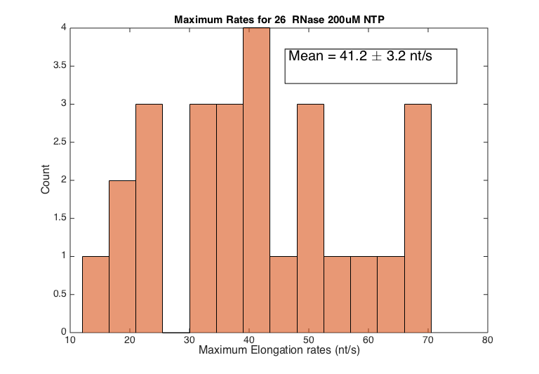
S8 Fig. Maximum rates with RNase. Distribution of the maximum elongation rates in the presence of RNase A/T1 or RNase H.

