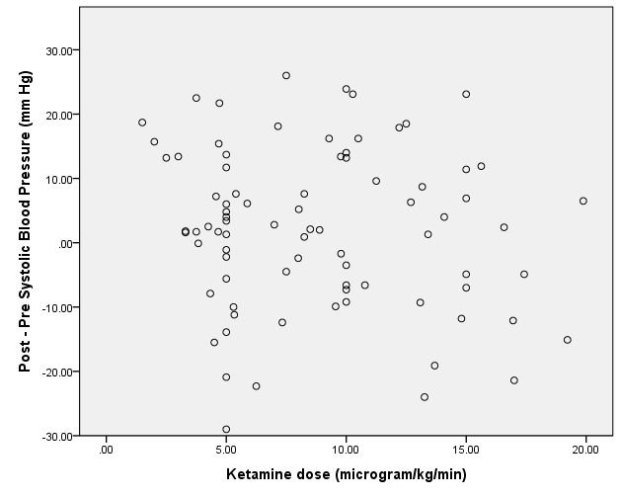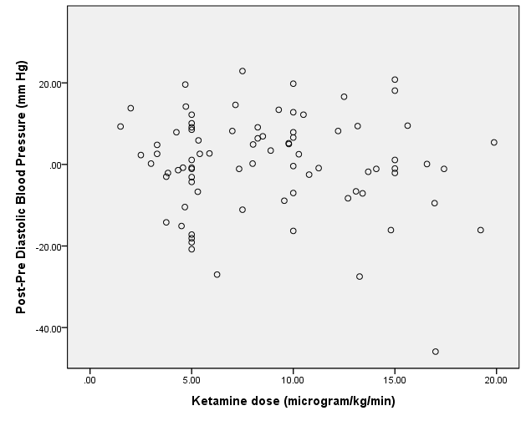
CC: -0.117 (P=0.297) CC: -0.041 (P=0.713)
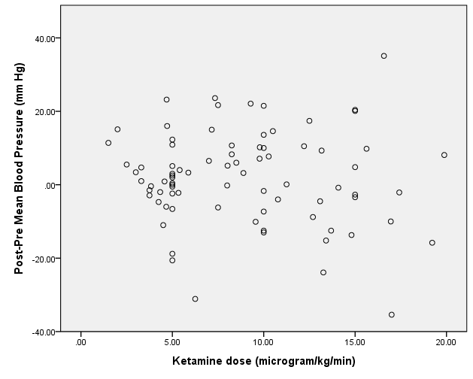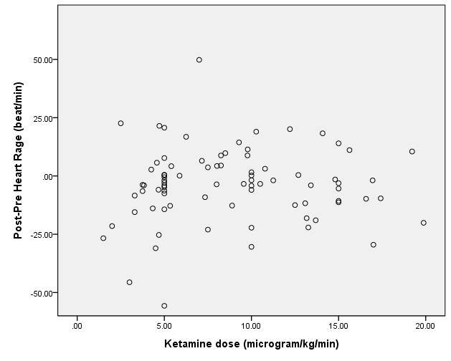
CC: -0.074 (P=0.512) CC: 0.065 (P=0.562)
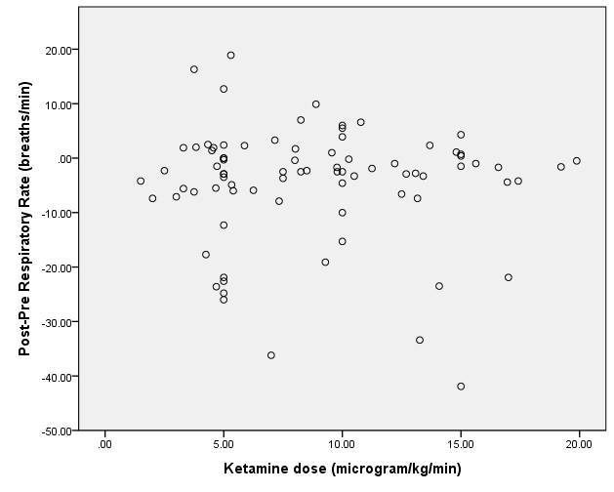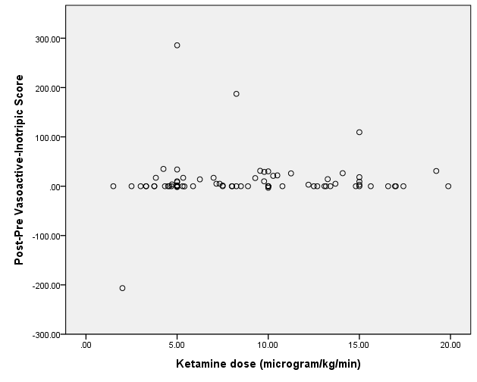
CC: 0.033 (P=0.771) CC: 0.177 (P=0.112)
Supplement Figure 1. Scatter plots of Hemodynamic changes after continuous ketamine infusion and the dose of continuous ketamine infusion. CC: correlation coefficient

